Circumnavigation Completion (CC#2)

Dear Family & Friends, January 13, 2012

It is hard to believe that today concludes the first week of our latest Magic Voyage. How time flies! The weather has been great, the food fabulous, the crew so friendly and most of the passengers pass muster.
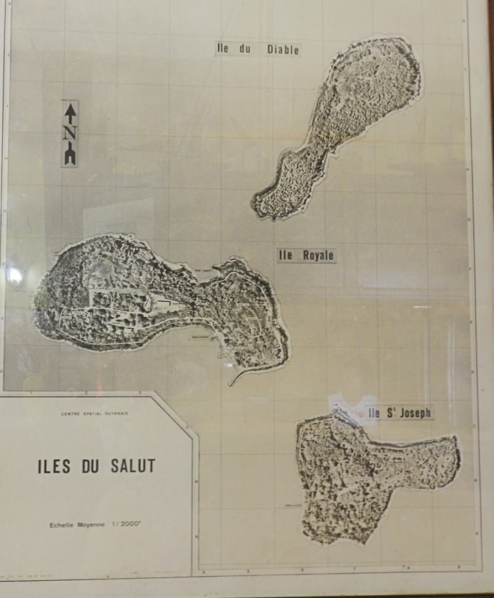
Let’s start with a Factum Flash: wind 40kn from SE with white caps and a very blue ocean; speed 16kn; water temp 75F, air 82F; humidity 67 degrees; depth 3366’; distance from Devil’s Island 313km, to next port of Recife 1100km; total distance traveled 2364km.
Yesterday we went ashore at Devil’s Island (French Guiana)…actually 3 small solid green growth islands with one about the size of Greenings Island in Maine and the other two about the size of Bear Island…with the height of all 3 about 320 Ft.. Clumped close together with smooth, black, many-sized rock shores and no sandy beaches. The 3 islands are called Iles du Salut and they are located 6 nautical miles from the mainland. They were a small part of the notorious French penal colony in French Guiana until 1952. Most of us connect Devil’s Island with Napoleon III, Alfred Dreyfus and Emile Zola and, of course, Papillion with Steve Macqueen and Dustin Hoffman.
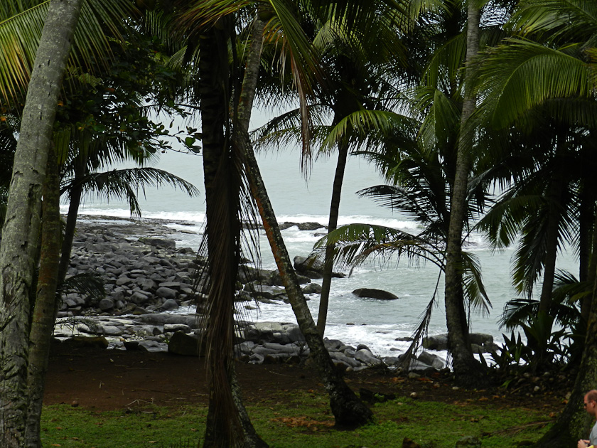
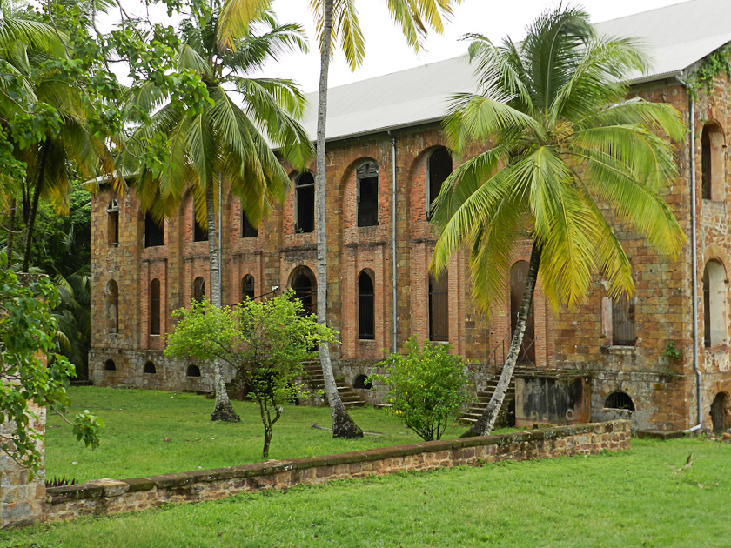
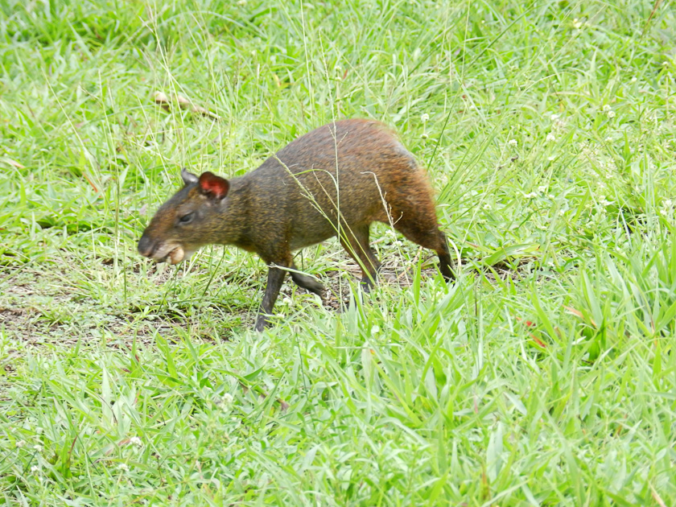
Our walk-around brought surprises: many small stucco houses built around courtyards where the guards and families lived, a large church and huge stone mansion, currently a dilapidated hotel with a bar and restaurant for occasional brave/foolish visitors, and a prison (long stucco building with barred windows that was blocked from entering).
Chickens, beautifully colored roosters, brightly colored parrots, small dogs and funny little animals with pointed faces and no tails that seemed to be scurrying everywhere about. A lighthouse, cell tower and helicopter landing pad.
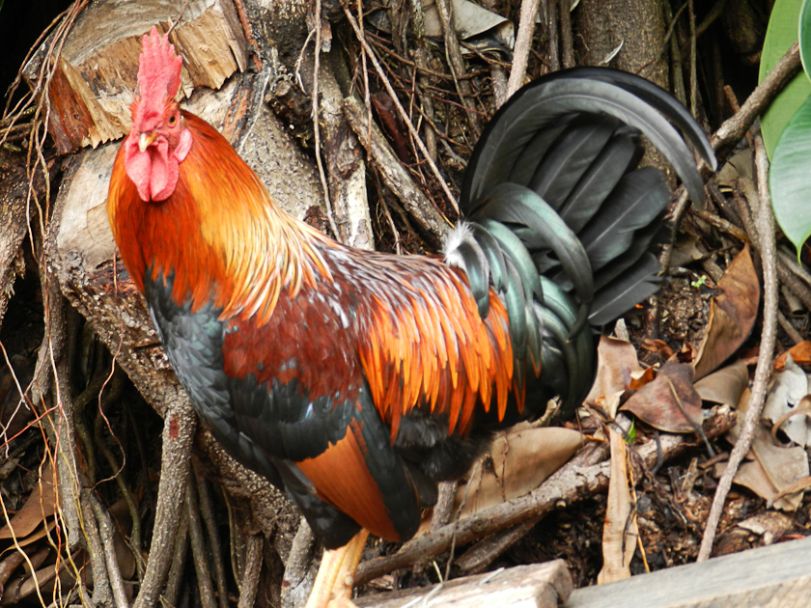
A depressing place. Terrible humidity (and its only January!) and an ambiance that chilled your soul with the thought of prisoners incarcerated here for life…many of whom
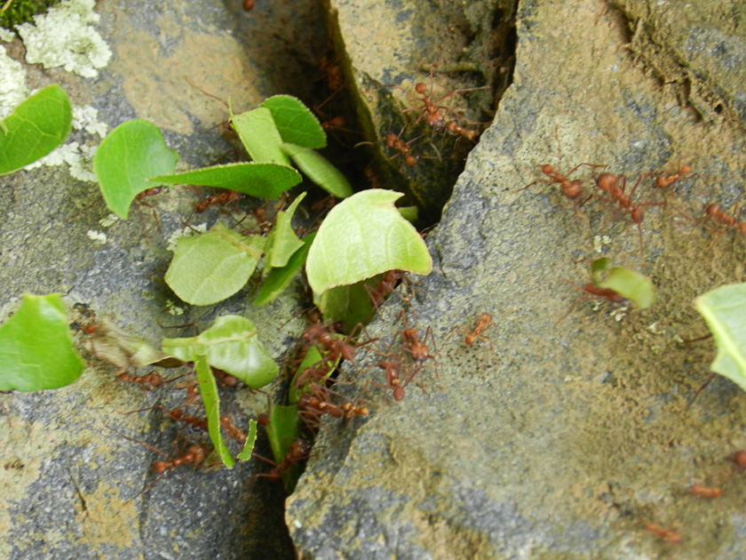
disappeared and were never seen again! Joanie took fascinating pix of millions of fire ants carrying little green leaves along distinct trails… returning empty-mouthed along the same 6” wide bare trail to get another load of leaves. An amazing sight!

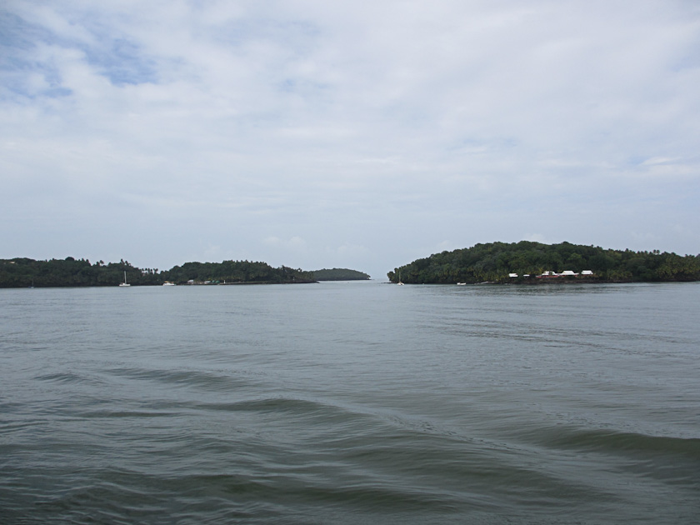

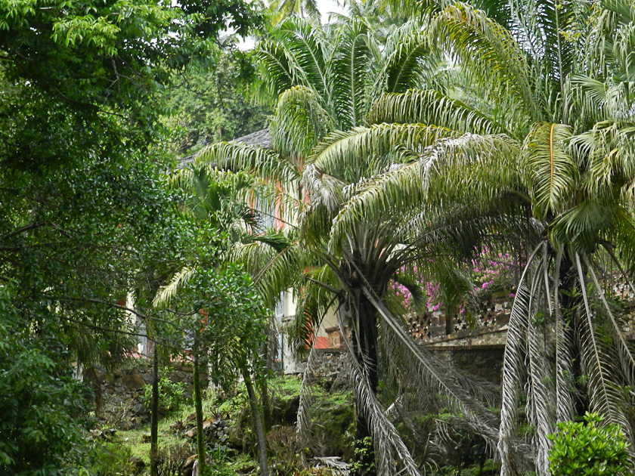

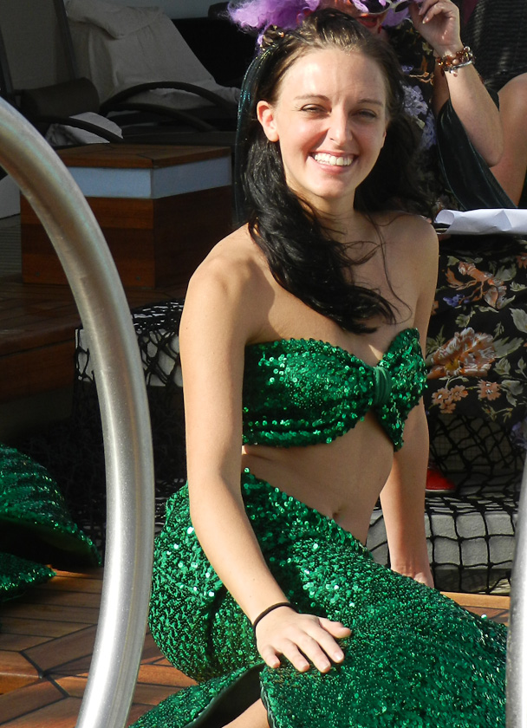
Today we have the crossing- the- equator- ceremony at 3:30pm. We actually cross the line early tomorrow morning. As you may remember from Bali H’ai bulletins this event inflicts all sorts of indignities on those aboard who are crossing for the first time (they are called Slimy Pollywogs). Happily, Joanie and I have now crossed 5 times. And as “Trusty Shellbacks” and true children of Neptune we are spared this ordeal. A brief quote from today’s ship’s bulletin: “…Pollywog’s undergo a number of increasingly disgusting ordeals (wearing clothing inside out and backwards, crawling on hands and knees on non-skid coated decks, being swatted with a short length of fire hose…)”. Our beautiful stewardess “Debbie” is a mermaid. Joanie and I will watch to give her support!
Time for luncheon with good friends from Stratfield Saye, UK that we met on the ship last year. As I sign off I again look out our veranda door onto a bright blue, many white caps to the horizon and an obvious heavy breeze and not a ship or bird in sight. Nor a cloud in a pale blue sky. Quite beautiful, really. Our next landfall will be Sunday and I will join you again.
Joanie joins me in sending hugs and love to all. We miss you!

Pops/Bumpa/Peter

Flash! To our amazement Joanie and I found a couple listed in the Guest List booklet as being from Northeast Harbor, Maine. After much sleuthing they were pointed out to us by a member of the crew. Surprise! We had never seen either of them before! And, after watching them socialize a bit we both agreed we will NOT establish contact with them during the entire voyage. I question “Northeast Harbor” with their listing!!

