Circumnavigation Completion #3

January 15, 2012

Dear Family & Friends,

A quiet Sunday morning when we arrived at Recife (pronounced HE-SEE-FE) Brazil. It is now 2:45pm. We have finished lunch (I had a delicious fettuccini alfredo!) and Joanie and I are now back in our cozy cabin. I had just started this bulletin (and Joanie is doing her needlepoint) when outside our veranda appeared a green oil tanker (the “Serra Nevada”) to start the refueling process of our ship. We can stand on our veranda and look right down 3 decks below us and watch the process…sort of fascinating.
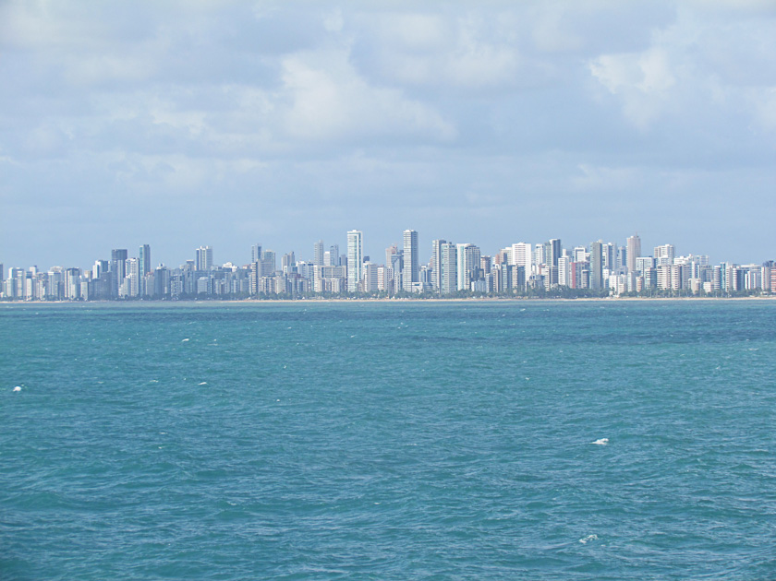
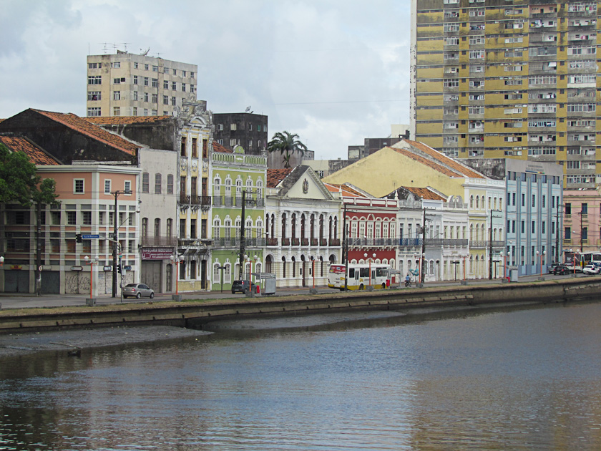
At 8:30 am we boarded our air-conditioned modern bus (a fancy Greyhound type) to explore some of Recife and Olinda (= Oh, Beautiful). Our first early view of Recife as we approached the harbor was quite astonishing. Running down the coast line at least 15 to 20 miles was the low infrastructure of the city along the shore backed up by almost never-ending high rise buildings not unlike NYC. Some truly modern designs with round shapes and much glass. Not expected! However, Recife is the fourth largest metropolitan area in Brazil and is host to one of the main ports on the Atlantic Ocean. The city occupies an important place in the cultural, economic, political, medical and scientific face of Brazil (remember: Brazil is Portuguese language, not Spanish or French). Canals, rivers, bridges, one-way streets have led Recife to be known as “The Venice of Brazil”. The resemblance ends there!!
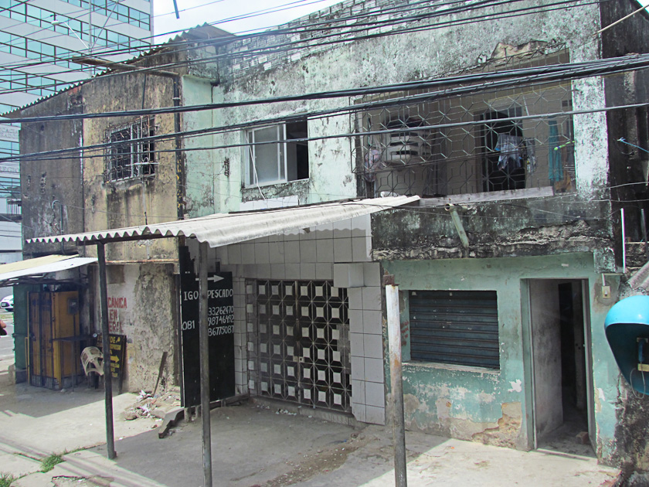
But…as so often is the case, the abject poverty of large sections of the city conflict sharply with its more modern construction. Shiny new buildings surrounded by empty lots full of trash, graffiti almost wherever you look and shacks and stucco little square houses showing decay, filth and lack of concern. I found it depressing.
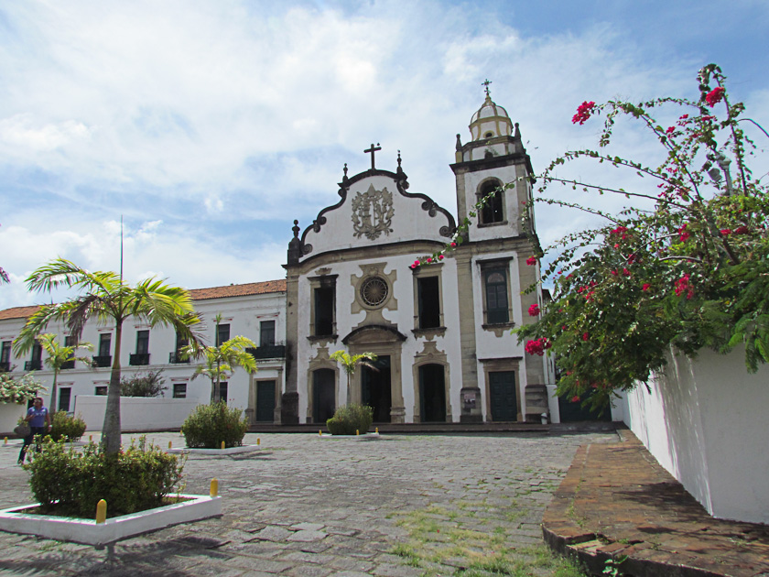
Our bus took us up the coast about 6 miles to Olinda, which is a UNESCO world Heritage site. This ancient colonial capital is the cradle of Brazilian culture. White washed and pastel colored buildings surrounded by lush green deciduous foliage and obviously more attention to upkeep and caring of the community make Olinda quite a contrast with Recife. We visited 3 old and quite beautiful churches (many about!)
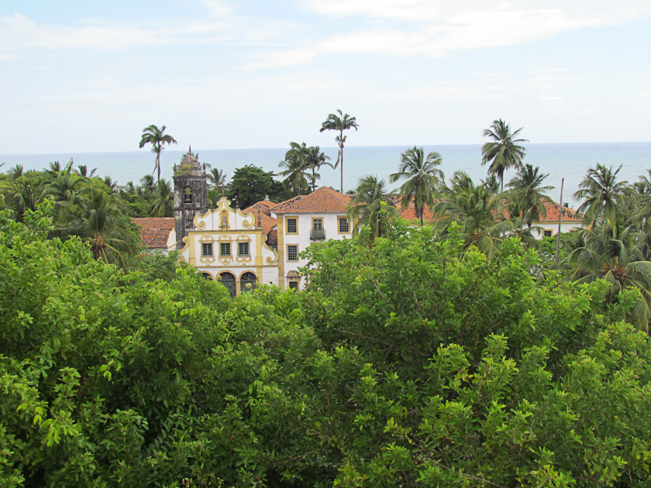
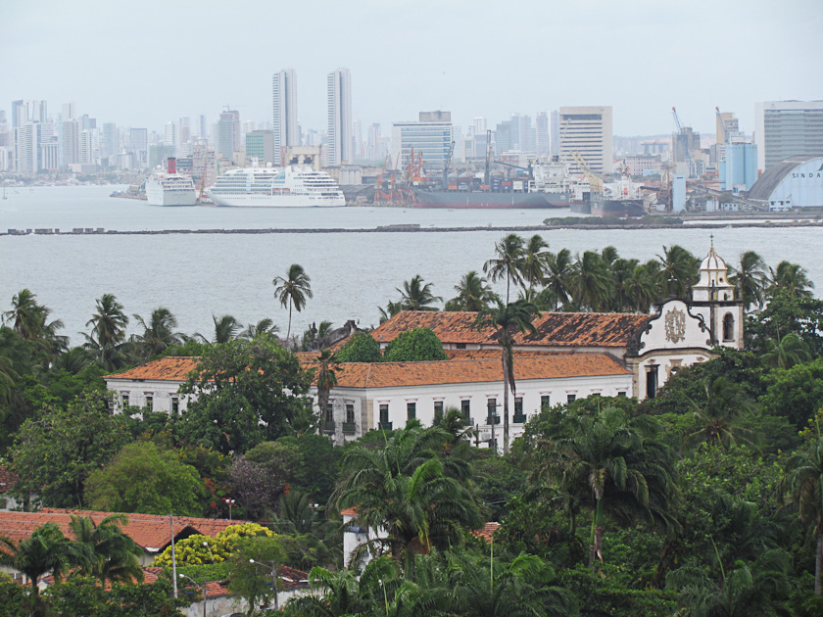

drove back through Recife and passed at least 8 or 9 hospital complexes (the second largest hospital presence in Brazil), continued along a 5-10 mile sandy beach packed with bathers, bright umbrellas, food stands and flying kites and finally got back aboard the Quest at 12:30 pm. The bus was quite cold!
I would rate our shore excursion C-. Joanie agreed. Primarily because of the depressing nature of so much poverty, trash and rubble and because (once again) our guide could not stop talking. This last fact has ruined many a shore trip for Joanie and me on almost all of our trips (now 5 in number!). Sadly if only the guides (paid to talk, I guess) knew one of my favorite true stories about the barber in The Philadelphia Club…who turned to the gentlemen in his chair and said: “Sir, how would you like your hair cut?” (the member was almost totally bald). To which without batting an eye came the answer “In silence!” Alas, silence is in short supply from shore trip guides!
Clear, lovely day. But hot when in the sun and very high humidity. Much talk as would be expected about the Italian Cruise ship tragedy. Seabourn has no Italian Captains!
Cast off at 5pm. At sea tomorrow and dock Tuesday am at Salvador da Bahia, Brazil. More anon! Hope all are well…sounds like it’s a bit chilly! And Brady of the Patriots knows how to win football games…a skill totally foreign to Andy Reid! Joanie joins me in send hugs and love to all!

Peter/Pops/Bumpa

