CC#4

Dear Family & Friends, January 18, 2012

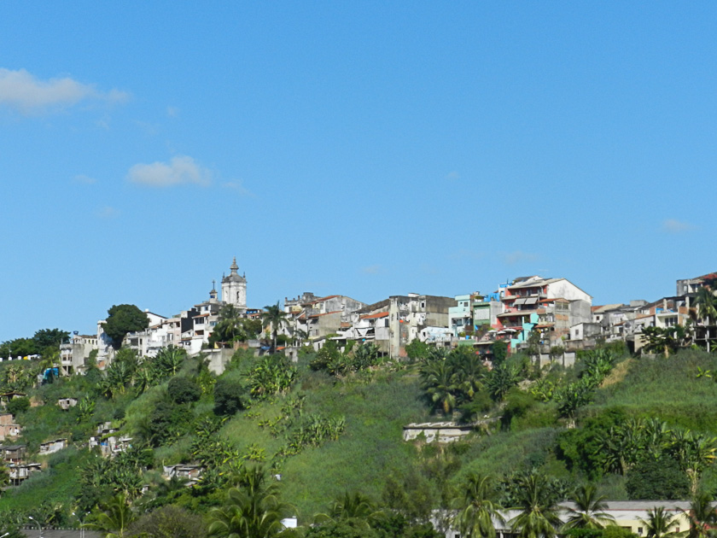
We are now on our way to Rio, with about 500 miles to docking at 1800 hrs tomorrow. I must wait until the end of this bulletin for my miscellaneous factums…especially the nautical items because the ship’s TV is down and it broadcasts this information. Hopefully it will come back up before I finish (I type sorta slow!).
Yesterday we visited Salvador de Bahia (the de Bahia is the state in Brazil – of more than 20 states) – wherein the city lies. Salvador is the largest city on the Northeast Coast of Brazil and is noted for its easy going life style, its carnivals, its food, music and architecture. It was the capital of Brazil (Brasilia – with an “s” - now holds that title) and is the 3rd most populous Brazilian city, after San Paulo and Rio de Janeiro.
Parts of the city are renowned for its Portuguese colonial architecture with historic monuments dating from the 17th through the 19th centuries, which were declared a world heritage site by UNESCO in 1985.
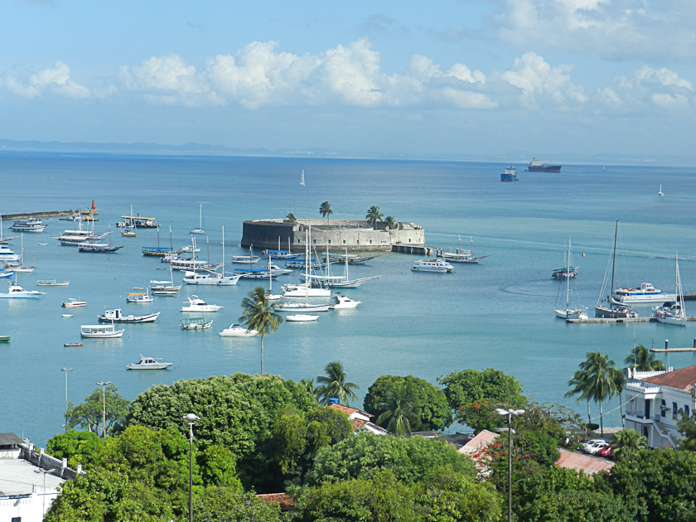
The city borders on a large and beautiful harbor with a bustling dockside holding many freighters and the occasional cruise ships. An unusual feature of Salvador is that it is built on an escarpment that separates the upper and lower parts…the upper part approx 280 ft above the lower. The city’s cathedrals (of which there are scores!) and most of the administrative buildings stand on this higher ground. A huge elevator (first installed in Brazil in 1873) connects the two parts, along with a funicular and many very steep roads!
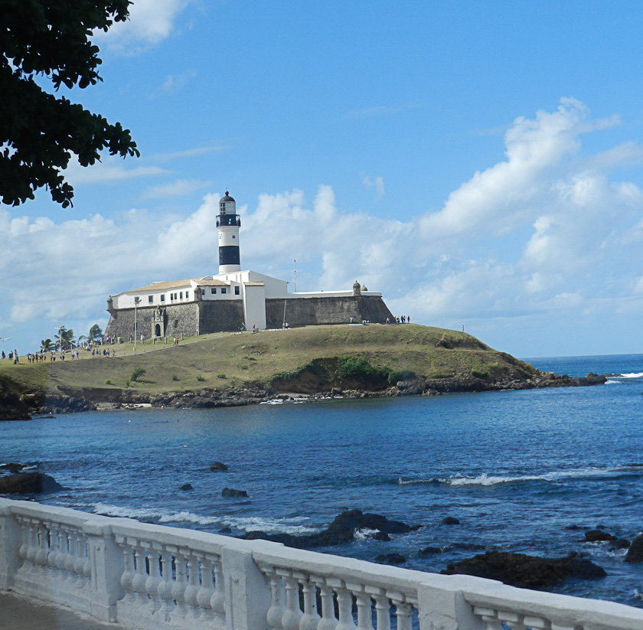
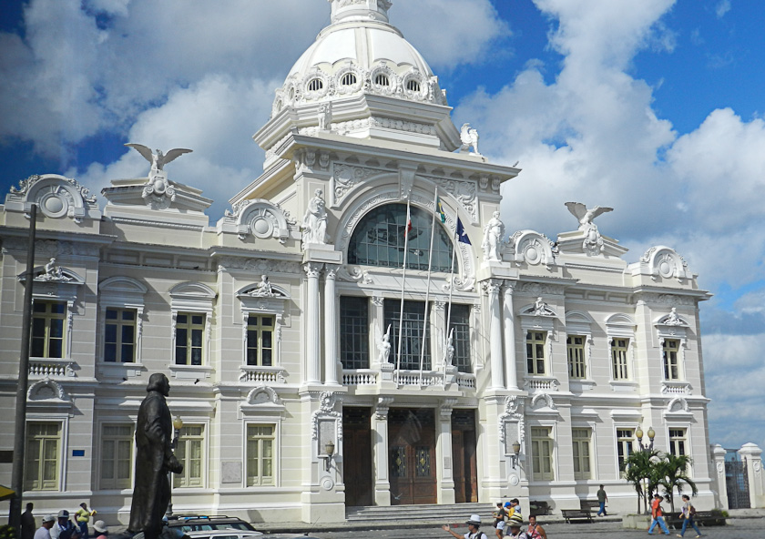
Joanie and I took a 2 hr motor coach ride to get a feel of the place. Quite extraordinary. A beautiful City Hall, close by a small section of lovely homes, embassies and tall, modern apartment buildings. Quickly dissolving into impoverished sections of ugly, squatting small homes and shops, surrounded by trash and filth and graffiti. Many, many car dealers, with Fiat and VW very much in evidence. The shore is lined with forts and lighthouses.

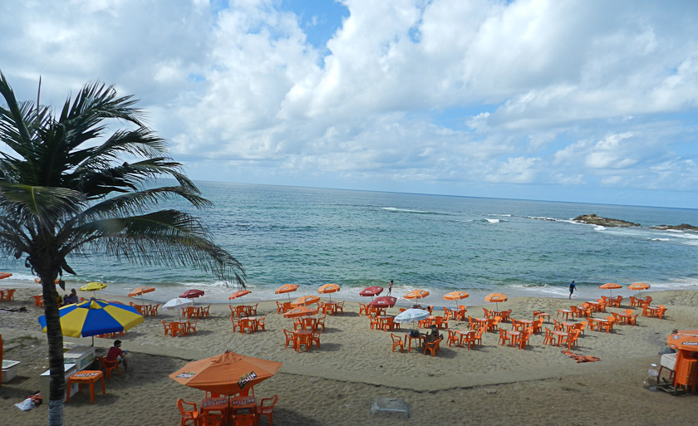

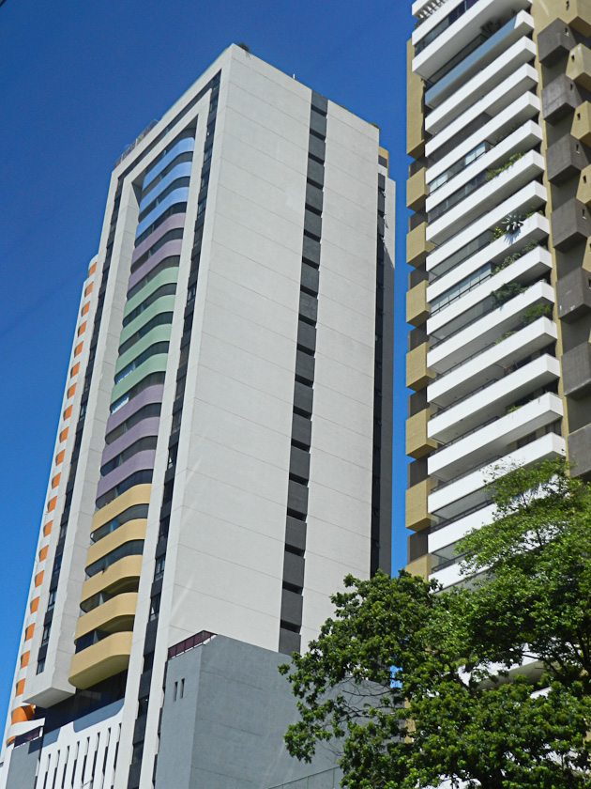
We drove beside a long coast-line of beautiful sandy beaches (many sunning and swimming), into an area of much construction of new high rises in the middle of which a 70,000 seat football stadium is being built. Once again what strikes the viewer so forcibly is the total absence of “city planning”. Build whatever you want, wherever you can find space to put it on…even if the front entrance to a Ritz hotel abuts on both side – with virtually no space in between – squatters graffiti covered shacks and tiny shops. And we have seen this time again in the cities we have so far visited in South America. Always overshadowed by the stultifying sight and sounds of poverty.
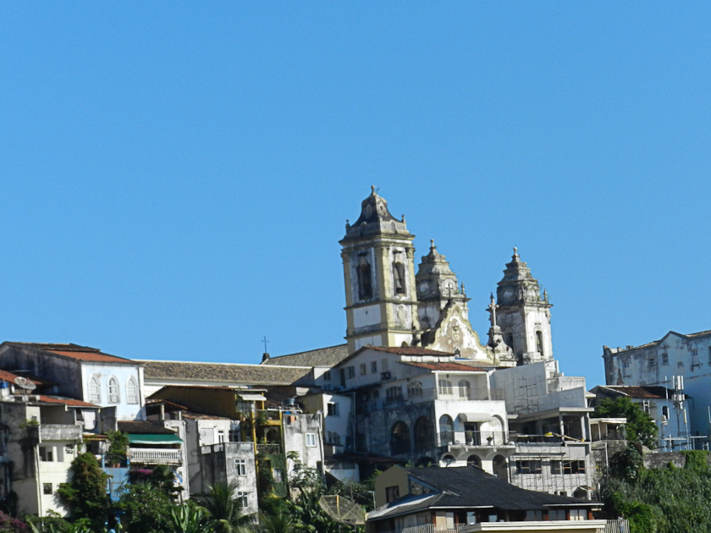
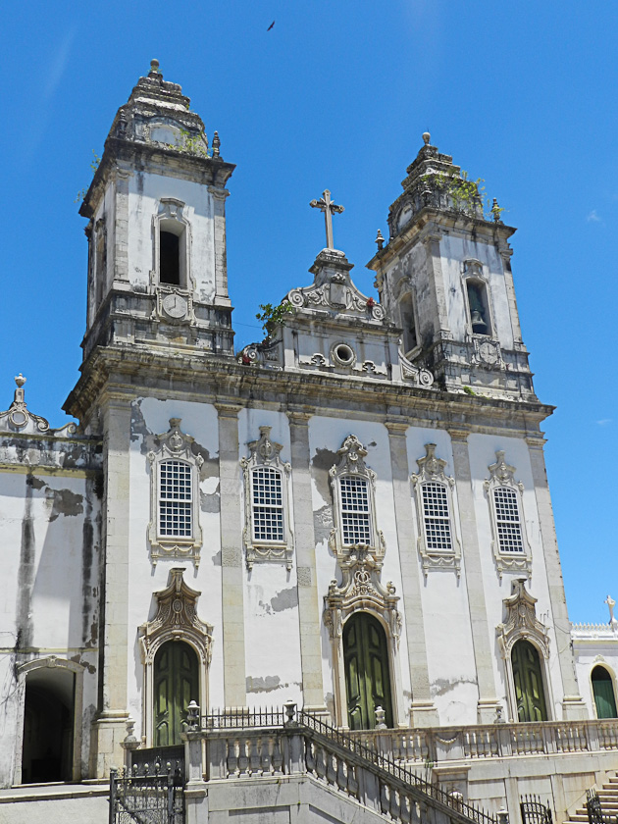
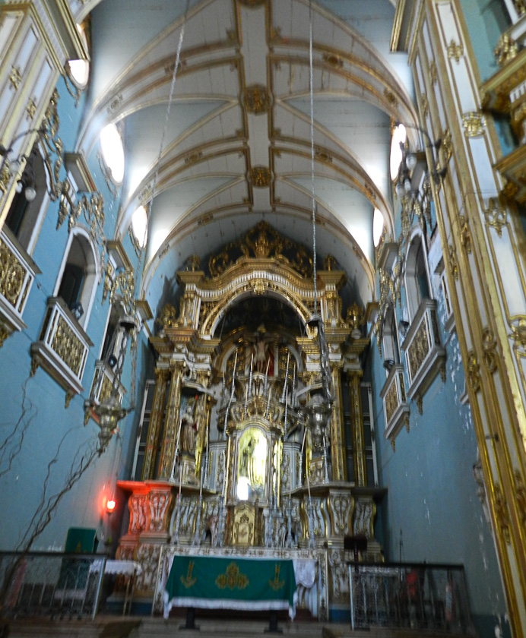
In the afternoon Joanie and I set out from the ship on a walk through the upper, old parts of the town. We rode the funicular (very steep and free because we did not have any reals (the local currency), attractive, very narrow cobblestone streets with colorful tiny shops and homes. We visited several cathedrals…quite lovely inside and very old, mostly Baroque in style. Salvador is heavily and vigorously Roman Catholic. The people we passed on our walk were very pleasant, would smile and say hello…but all leaving the ship were warned to be careful of pickpockets and hide wallets, watches and jewelry. The police were in evidence wherever we walked

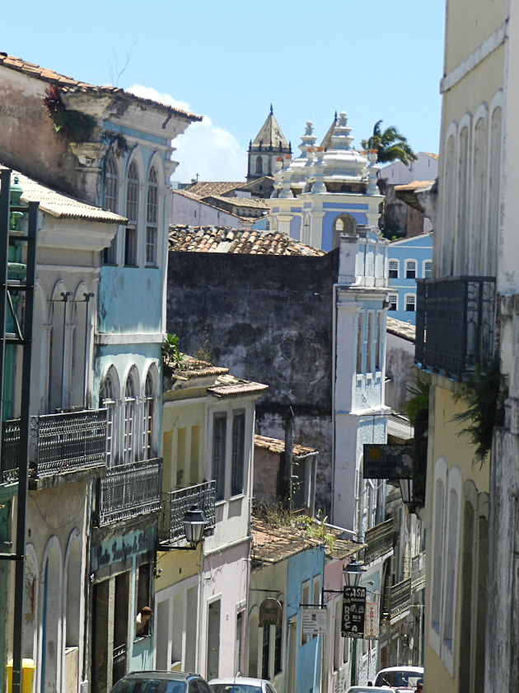

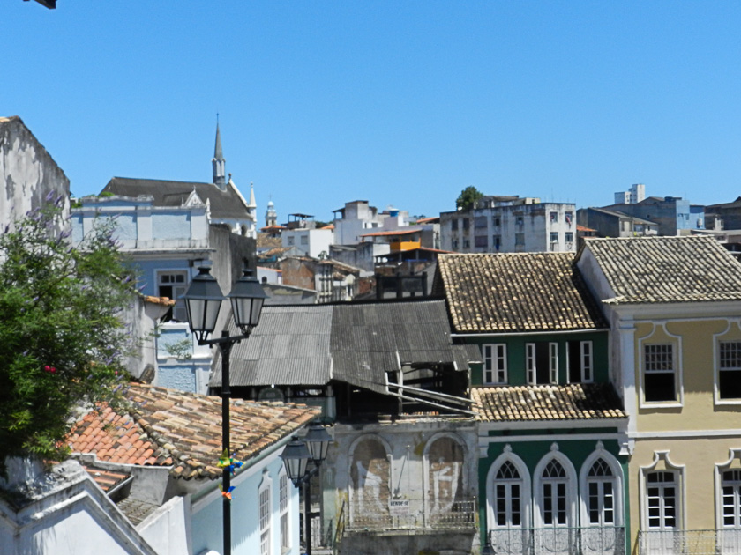

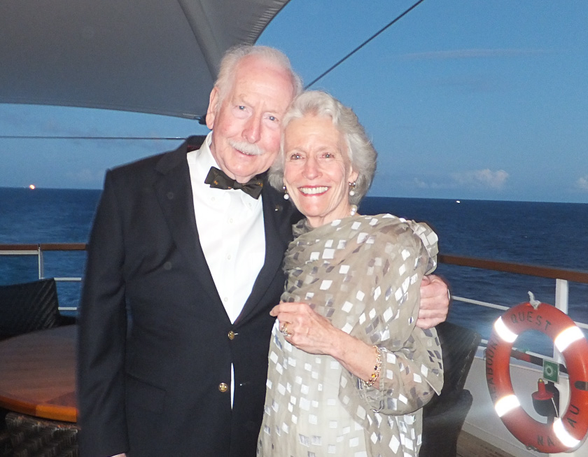
Last evening on the ship was “Brazilian Night” in food, drink and entertainment. Scantily clad virginal maidens with amazingly limber pelvises gyrated about on the open deck while the band played throbbing, loud rhythms. Caviar and drinks flowed and we all moved on to our Brazilian buffet dinner well lubricated and in a happy spirit.
Factum Miscellanea. I have not previously mentioned the weather. Devil’s Island – almost on the equator- was hot and humid. As we have traveled down the coast of South America the sun seems to grow brighter and truly hotter, while the humidity drops with each passing day. Combined with a nice breeze if one stays out of the direct sun the climate is really very pleasant…with the main salubrious improvement being the falling humidity.
Ahead of us at the dock was a very new, very large white cruise ship named “Costa Pacific”. Looking at it up close you forcibly were struck by the enormity and inexplicably stupid sinking of the Costa Concordia in Italy. Again I do not understand why modern cruise ships have not modified their lifeboat design. Without thought we all know that the more a ship heels over in one direction the less likely to be able to launch the lifeboats on the other side…they will be above the slopping hull instead of over the water! Why not have a mechanism that will run the lifeboat out on a rail to remain above the water as the angle of the hull increases…surely in today’s world of high tech such a design would be feasible and would potentially save hundreds of lives!

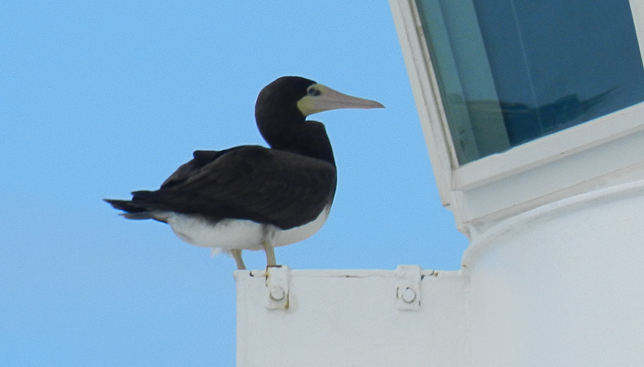
As I type this Joanie came in from our veranda and said there was a medium sized bird that is dark with a white tummy resting on the ledge right outside the bridge window. We don’t yet know what it is. Apparently there were about 7 of them following the ship. We are way out to sea and birds certainly must get exhausted with no place to land!
Beautiful day. Smooth ocean with few whitecaps, scattered clouds and little breeze. Ship speed 13 knots, course 198 degrees, 450 nm to Rio, have traveled 4215 nm from Ft. Lauderdale, water depth (shallow) 100 ft; air temp 81F; water temp 72F; wind 8 km from NE; humidity 66%.
Thanks to all for nice emails .It’s great to hear from home. Congratulations to Nora’s team on winning hockey game against #1 team in Vermont…well done! Hope weather not too cold or snowy. Joanie has a little eye irritation which the doctor is trying to pin down. I have not lost weight…and the meals are fabulous! All for now. More after Rio. Hugs and love to all!
Peter/Bumpa/Pops

