CC #8

Dear Family & Friends, February 4, 2012

It has been longer than I planned since my last Report. So here we go in covering the highlights since our departure from amazing St. Helena.

Walvis Bay, Namibia

The approximately 1200 miles from St. Helena to Africa was pleasant and uneventful. As always (we have had almost no rain since leaving Ft. Lauderdale) our great ship carried us onward in comfort and style. The never-ending Atlantic Ocean a symphony in blue, with dancing white caps, a modest swell and an almost cloudless sky painting a picture the greatest artists would be unable to recreate on their canvas. And our daily gastronomic triumphs have made any of my thoughts of reducing my abdominal dumpling totally laughable.

We approached our first landfall on Africa (Namibia) at Walvis Bay. Namibia has only been independent since 1990. Before that it was ruled from South Africa, but for three decades at the turn of the 20th century it was a German colony. Sausage, sauerkraut and beer predominate the eating/drinking experience. Sparsely populated, Namibia is about three-quarters the area of South Africa, and about 10 times the size of Austria. The coast stretches for more than 900 miles, yet Walvis Bay is its only proper deepwater port. The country speaks a dozen languages, of which English, German and Afrikaans predominate.
The country has a population of 2 million; 80% to 90% profess Christianity with Lutherans easily in first place. Diamonds are its principal “crop”.

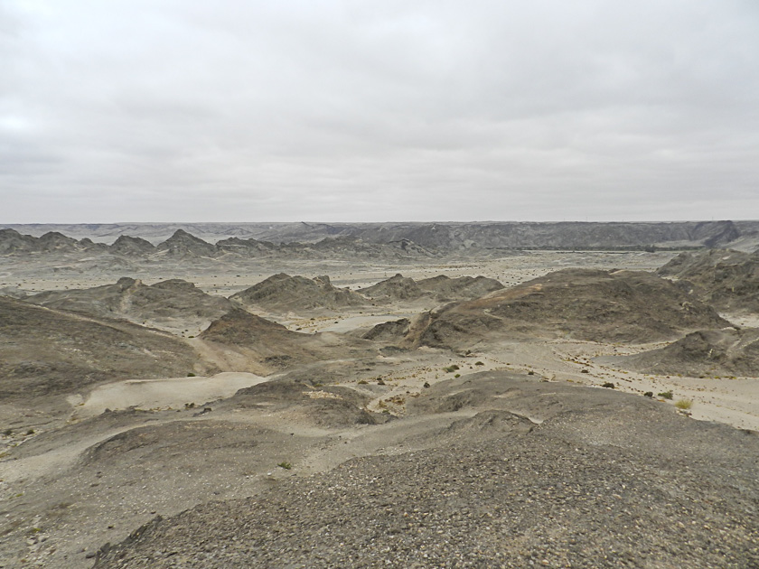
Joanie and I signed up for the “Desert 4X4 Adventure”. It turned out to be a mixed blessing. We were in the rear seat…the wrong place for what became an extremely bumpy, noisy ride…made worse by almost losing our back wheel; while we were travelling it popped off 3 out of 5 of its lug bolts and consequently the wheel was rather ‘wobbly’! A seemingly endless drive along an absolutely flat and rather uninteresting coastal road finally led us to a side road to the “Moon Mountains”. This turned out to be a very rugged area of scattered multi-shaped rocks (the “moonscape”!) with stops to inspect an amazing plant discovered in 1859. It produces its first “flower” after about 20 years and is believed to have a lifespan of 1000-3000 years…making it the oldest living plant in the world. From time-to-time in the middle of this sandy, barren landscape a house would appear. We learned that this area gets less than 1” of rain a year, but in some miraculous way there is water not too far below the desert surface which is tapped into by the hardy souls who want to build a home in this bleak, but curiously beautiful, surrounding. On the way back to the ship we stopped at “Dune 7”…a steep, high sand dune forming the border of the ever-encroaching vast desert whose sand was extremely fine and hot from the bright sun’s rays. Just before the close of this land exploration we stopped along the shore to, hopefully, see flamingoes. “See” we did, but they were too far off shore to get a really close look and sharp pictures.
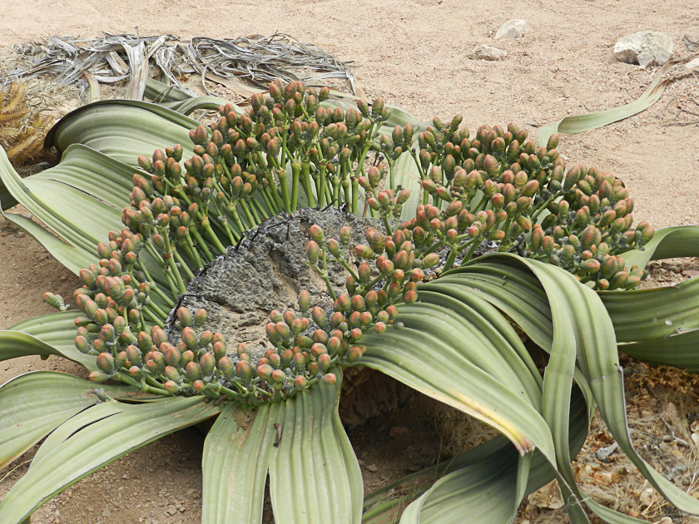
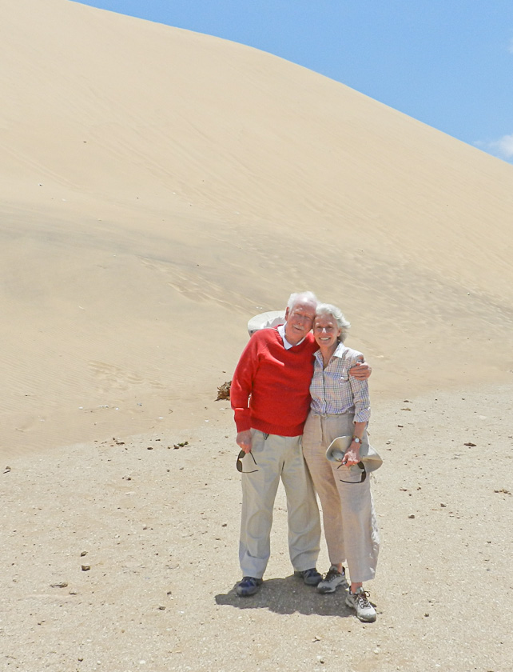
On a scale of 1 (worst) to 10) I rated our shore trip a 5. Not helped by having lost my hearing-aid case (aids safe in my ears!) when I pulled Kleenex (and I now believe my case) from my pocket to give to “Willie” our driver to help stop bleeding from a cut in his hand which happened when he tried to tighten our wobbly wheel. As Joanie often says: “No good deed goes unpunished!” Also the very upsetting discovery earlier that the ship has lost my yellow Government health card, with my 25-30 year record of every shot I have had going all the way back to polio! Could be worse, I guess.

The best still lies ahead!

Cape Town

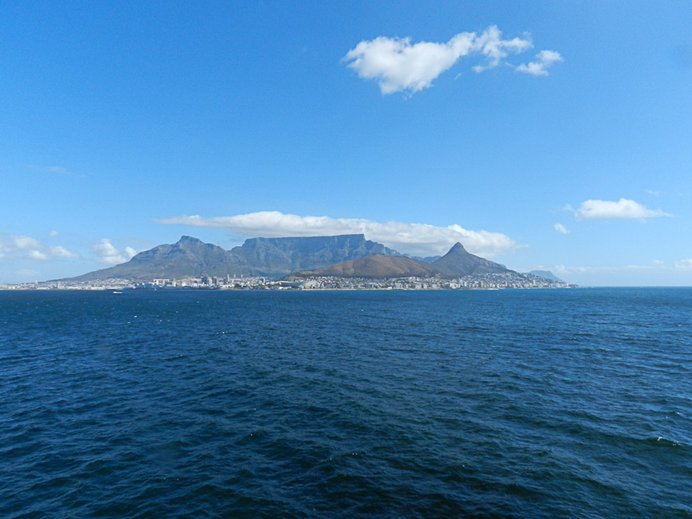
After an uneventful, lovely day “at sea” on our way down the west coast of Africa, Joanie and I – as we did at Rio – arrived in Cape Town in the early evening of Feb. 1st. As the sun set around 5:30 pm and still at a distance of over 50 miles from shore Cape Town and Table Mountain came into view. The sight was breathtaking!

During the summer here (now) the steady southeasterly wind produces the distinctive “tablecloth” on this flat-topped sandstone massif…and you can watch the wind begin to lay down the white tablecloth as it gradually blows across the mountain top. An amazing sight!

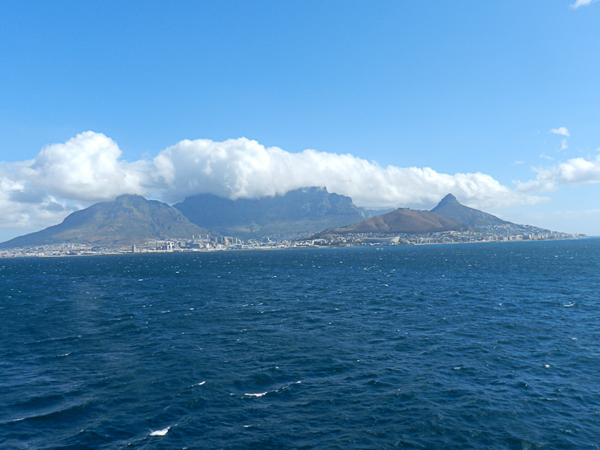

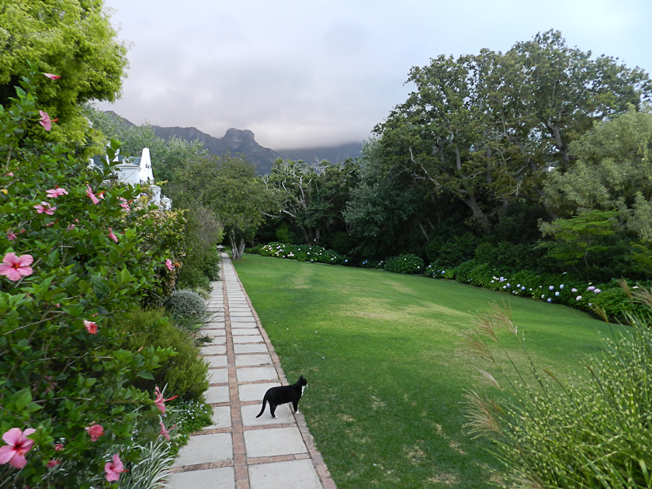
We finally docked around 6 pm, and in doing so were struck by the very strong SE wind (about 40-50 mph) which blew almost steadily during our entire 3 day stay. That night we took the ship’s shore trip with a group of about 15 on a ½ hour drive through the city to a delightful suburb for a dinner and wine at a gorgeous Dutch Manor House, now the Cellars-Hohenort Hotel with its adjoining vineyard founded almost 350 years ago. As we got off the bus the welcoming greeter for Joanie was “Socks” a black and white adorable and friendly cat (who also followed Joanie to the bus when we finally departed!). The ambiance, the food, the company and the wine all came together to make it a truly magical and welcoming evening to Cape Town.

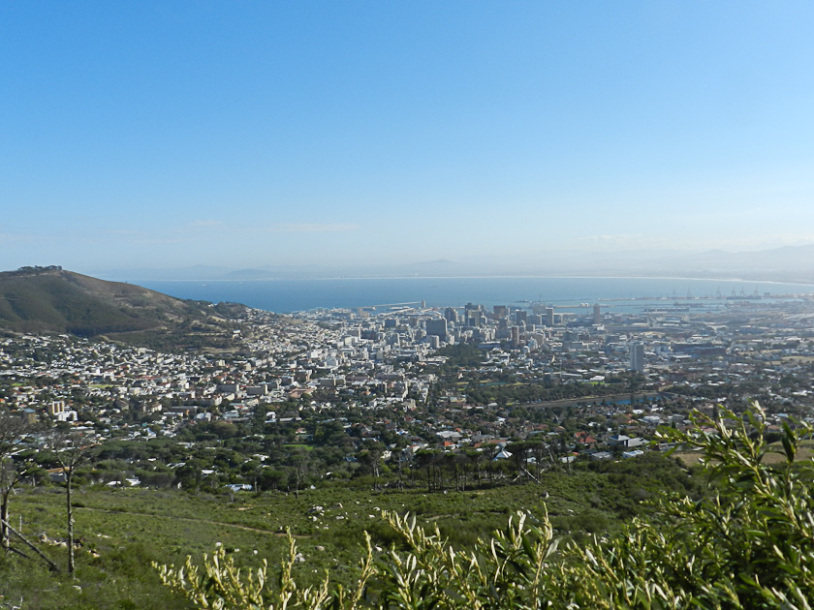
Happily – as has been true for almost the entire voyage – the dawn broke bright and clear. Cape Town’s famous Table Mountain forms an unsurpassed backdrop for this gorgeous city. On our first day we travelled by bus to Table Mountain to take a cable car to its top. Sadly, the wind was so strong the cable car was not running. We learned that during the summer here (the 6 month’s opposite from summer at home) the constant, strong SE wind often keeps the cable from running. Plus the fact that during this time of year even if you make it to the top the “tablecloth” cloud covering is so thickly you can’t have a view down over the city. We then proceeded to Signal Hill where we had an incredible view of the city and its environs. Maybe even a better view than on top of Table Mountain. We then proceeded to have a lovely bus tour of the city, with a fascinating stop at a remarkable Maritime Museum...with life size models of almost every sea creature you can imagine, plus ancient rocks with prehistoric drawings covering their surface. All beautifully exhibited.

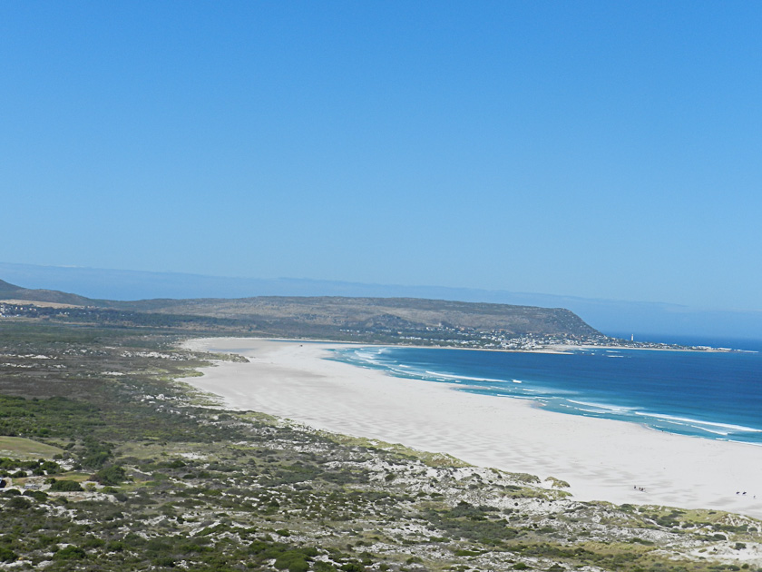
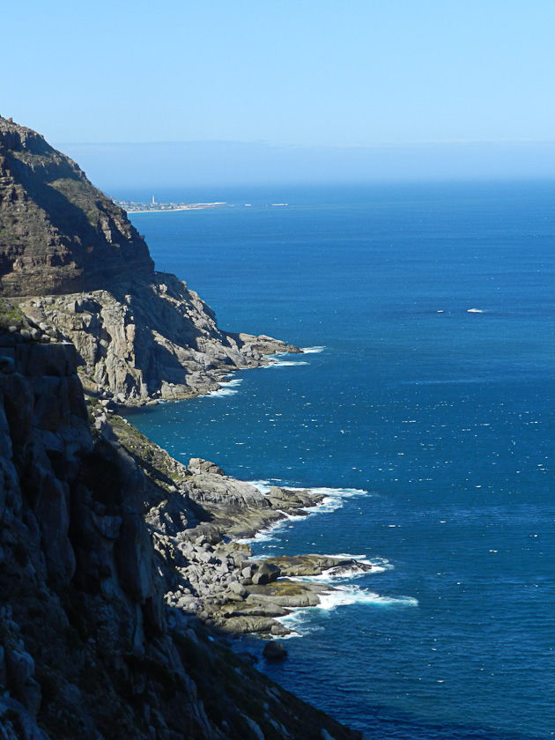
Day Two was a 7.5 hour bus ride down and back to Cape Point Peninsula, the furthermost point of land on South Africa’s coastline with it lighthouse high on a promontory trying to protect ships rounding the Cape of Good Hope from running aground in its treacherous waters where the Atlantic and Indian Oceans come together…in the opposite directions. Sparkling pure white sand beaches accentuated by the pulsing Caribbean colored azure blue ocean. Breathtaking! On this trip we saw Baboons running freely beside the road, Ostrich Farms and finally a luncheon stop where we visited a beach full of Penguins. The animal diversions were fascinating…especially the Penguins which were pressed against the sand all facing away from the very strong winds so that the sand wouldn’t blow in their eyes. We returned to the ship at about 4 pm as it prepared to leave that evening (Feb 03) for our next stop on Feb 05 at Port Elizabeth.
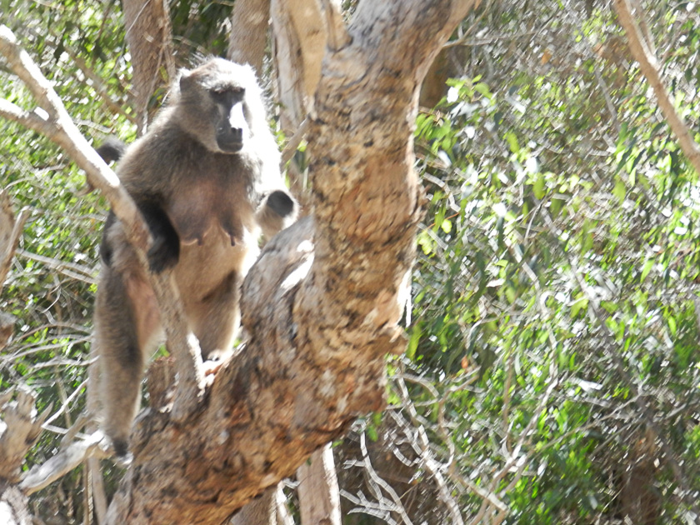
A final word about Cape Town. A beautiful, modern, truly cosmopolitan city…clean, well laid out, no graffiti or trash and friendly people. Well landscaped pocket parks, and not too many high rises. It is easy to understand why it is such a popular tourist destination, even though it is very expensive to visit. Certainly a spot (like Rio) where you would like to stay for 3-5 days to get a real feel for and a better understanding of its history and culture. Joanie took a long walk around the city in the afternoon and was greeted with a lovely smile by everyone she passed on the street. Thoroughly enjoyable!
Final Factum. I have previously forgotten to mention all the time changes we have had since we left Florida. So far I believe 5, each one to advance our clocks by one hour or sometimes at 2:00 pm by ½ hour. None of us ever know exactly what time it is on those days and find that we are always asking our friends what time they think it is. All of our responses are quite hilarious as we are all totally confused. As I type this it is 5 pm, I think) and my guess is that it is 11 am or noon your time. And as we continue our eastern voyage toward Hong Kong I suspect we will have many more advances until we cross the International Date Line and change an entire day. Lots more confusion to come!!

The present weather is gorgeous. As we sail comfortably toward Port Elizabeth (to arrive tomorrow, Sunday the 5th) conditions are as follows: air temp 68F, sea temp 62F, wind 15kn from East, 67% humidity, speed 14kn, sky clear and cloudless, sea 8’-10’ swells (slight “rocking” to ship), sea depth 346’, distance from Cape Town 517 miles, distance to Port Elizabeth 516 miles, total miles traveled so far 9024 km.

Much love and hugs to my family, and hearty greetings to Joanie’s and my dear friends. We miss you all! I was looking forward to a Super Bowl TV/hot dog and beer party tomorrow put on by the ship (like last year)…until someone reminded me this won’t happen because it will be 2am our time! I am rooting for the Giants. More soon.

Peter/Bumpa/Pops

