CC #10

Dear Family and Friends, February 10, 2012

A different “tone” this time, and darling Joanie may well wish to add a contrary point of view. But we all must keep in mind that the world is a very complicated place which has generated such well-known truths as: “How lucky we are”; “It takes all kinds”; “There but for the Grace of God go I”; and other sayings you are familiar with. Our subject today is Maputo, Mozambique.

In my last CC we were at Durban. The ship set sail at 6 pm with the usual departure pleasantries and salubrious partaking of champagne and caviar. An uneventful first night, a sunny and smooth next day and one more night (with an hilariously funny magician as the evening’s entertainment) took us further up the coast to cross the border from South Africa into Mozambique, where we docked at 8 am, Thursday the 9th.

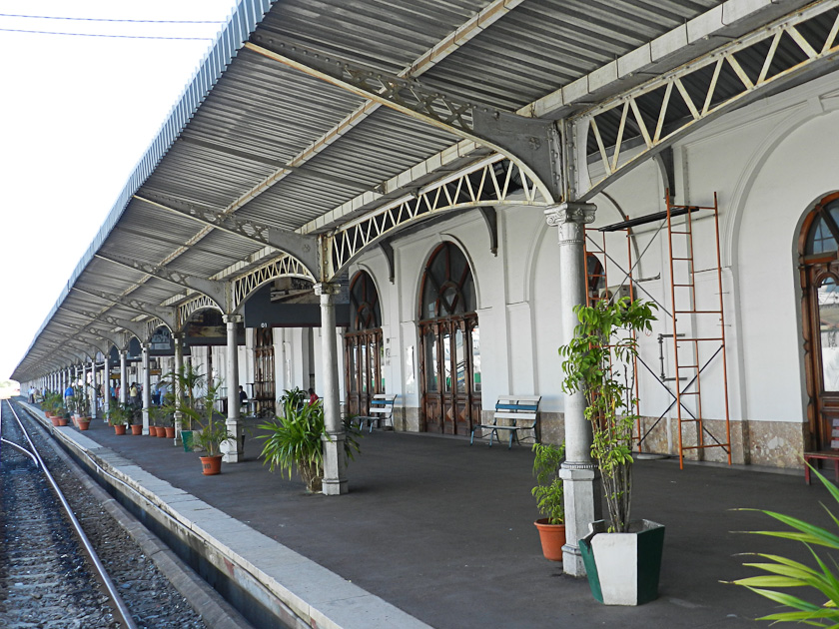
Maputo is the capital and the largest city in Mozambique, and “houses” approximately a million and three quarters souls, 80% of whom live in slums without running water or electricity. The capital was founded in 1544 by the Portuguese, and today has little money to invest in its infrastructure. The consequences of which I will now briefly describe. Let me emphasize I obviously can only comment on our brief experience in this city…the rest of the country may be a far better and beautiful place, albeit with quite rampant malaria.

Joanie and I had`signed up for the morning shore trip billed as “Maputo Highlights”.
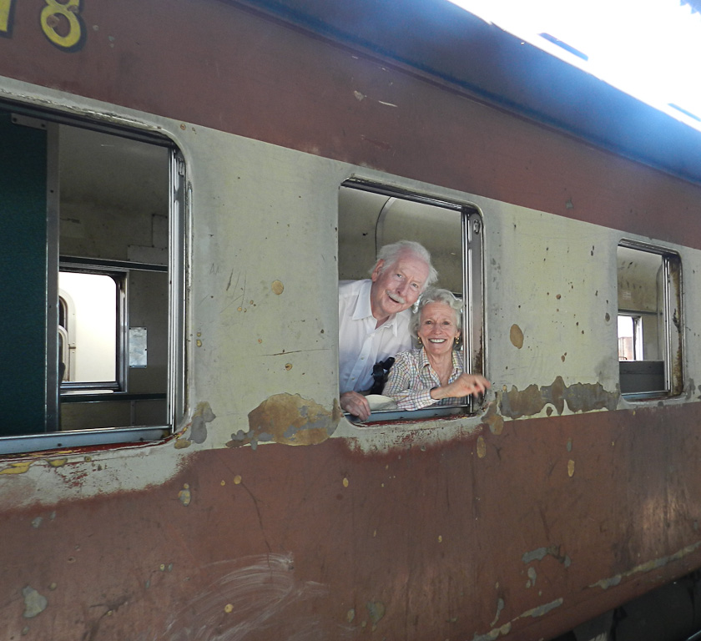
Our first stop in a small, broken air-conditioned hot bus with a guide who spoke almost no English was a handsome railway station built in the early 20th century by Gustav Eiffel of the Paris tower fame. The trains the people take are not as glamorous as the station.
Then on to the Central Market, a vast open - air bustling area of every kind of food, vegetables, bric-a-brac, old and young men, women and children all praying for customers to help them survive. The not uncommon around the world “you can take my picture for a dollar” hands were out. Then to a huge modern in appearance Catholic Cathedral built around 1930. To reach the church one had to climb many steps being careful not to squash broken glass scattered almost everywhere up the various landings. Quite beautiful stained glass windows bathed the church interior with their play of color.
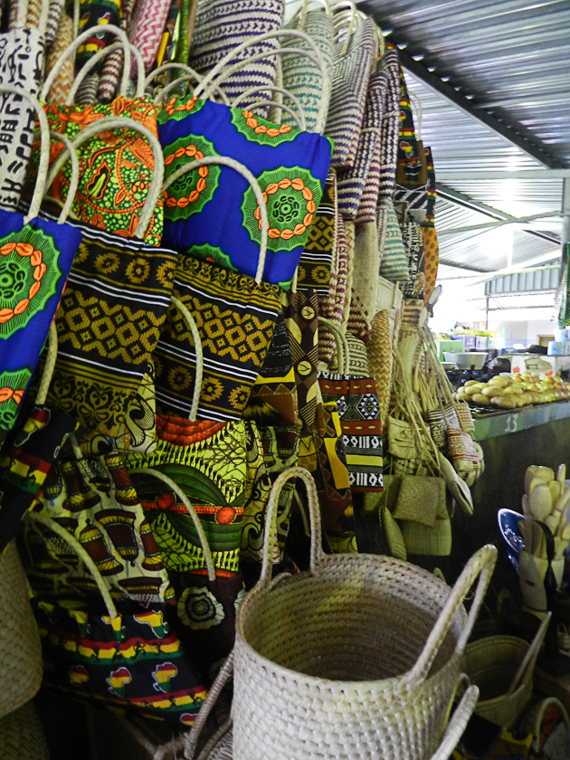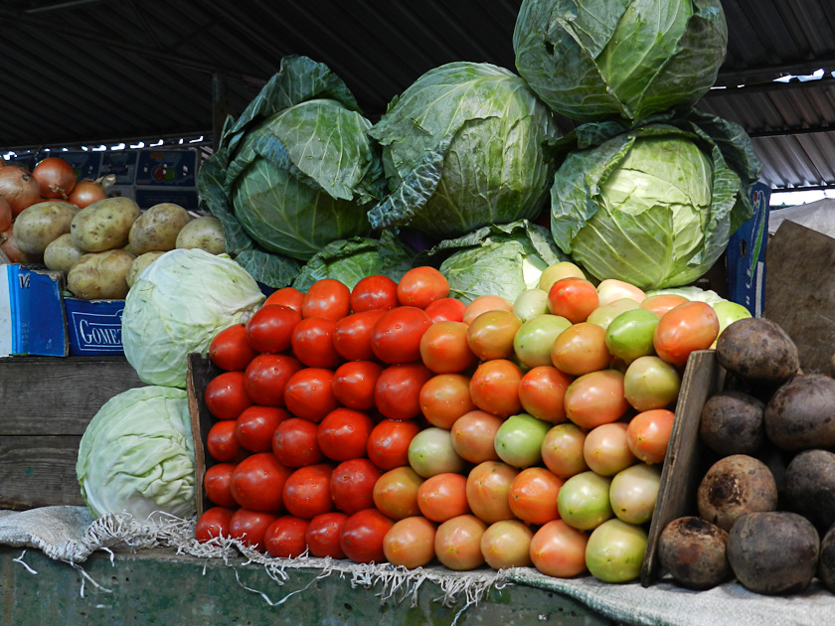

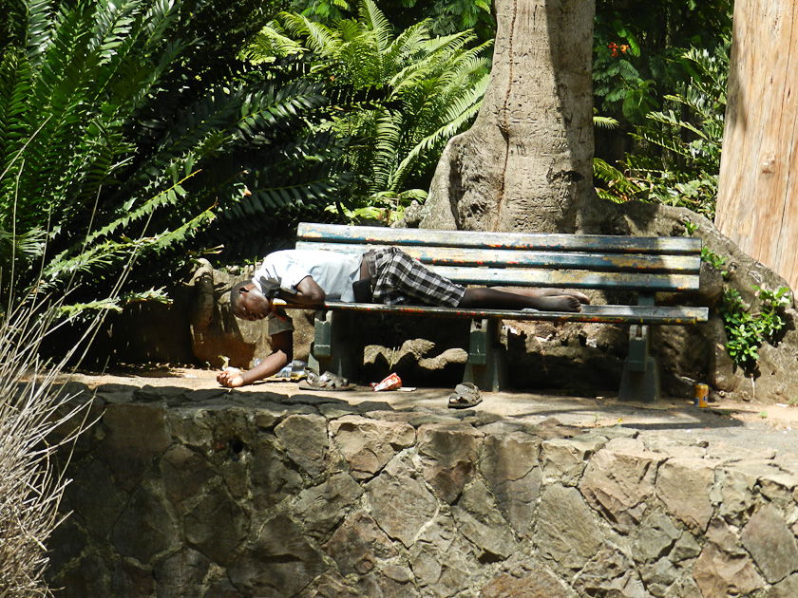
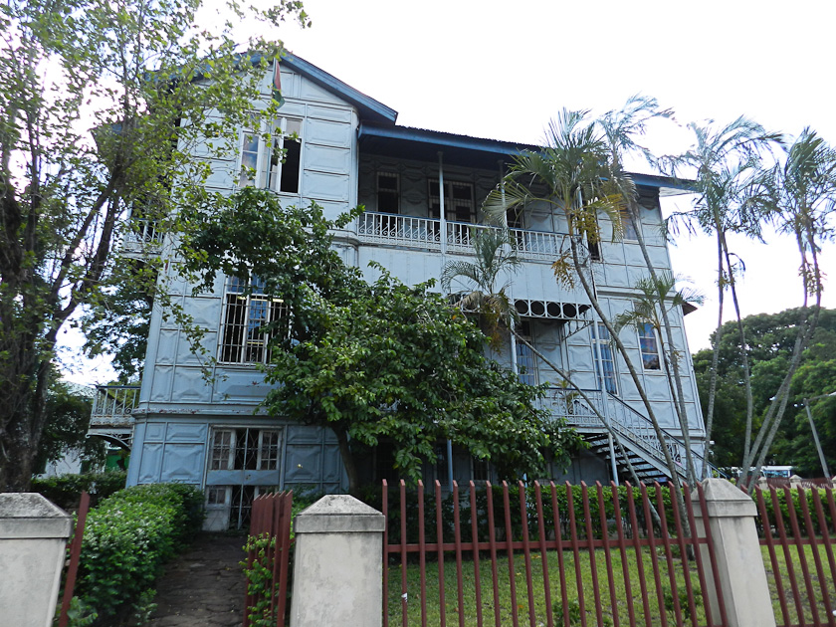
On to the Tunduru botanical gardens, a run-down, dying trees and broken walkways square which in its day was probably very attractive. Trash and empty plastic bottles everywhere you looked. Nearby a decrepit-looking “House of Iron”, a 19th century colonial residence built in Europe and reassembled here using steel plates that proved uninhabitable in the hot, tropical climate of Maputo. A halting, slow, engine-almost-stalling- drive through the Town past sad-looking people, run-down and unfinished buildings interspersed with the unexpected and rare nice-looking newer structures and homes, endless trash and a final brief stop at a wide trash-strewn sand beach followed by a haltingly slow trip back to the ship after about 3 hours. I was very depressed by the entire experience. And was forcibly reminded that living in third-world countries is a daily life and death struggle against huge odds…with government spending/wasting scarce money on unnecessary buildings, boon doggle projects, etc. while its citizens are starving and the illiteracy rate is 75%. There were some bright spots in Maputo which Joanie’s ever-present camera captured. Back to the ship to air-conditioned comfort, a lovely lunch and a quiet afternoon reflecting once more on how lucky and blessed we are. I am now writing this at noon as we voyage onward toward the bottom of Madagascar to our next stop on Monday, February 13 at Le Port, Reunion Island.
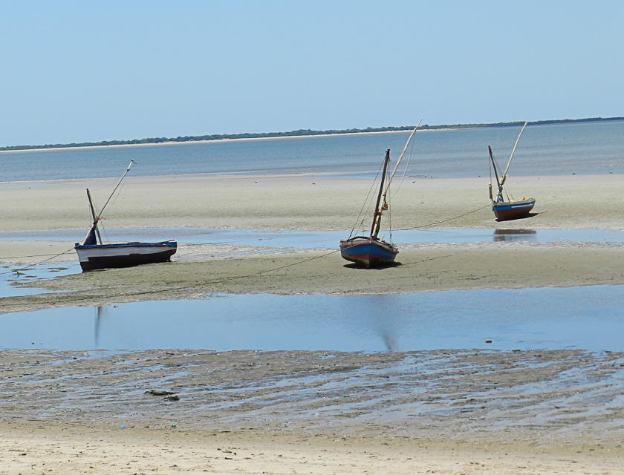

Fearless Factum: Air temp 79 F; water temp 71 F; water depth 9800’; wind 12kn NE; 67% humidity; ship speed 21 mph; 305 nm from Maputo; 1048 nm to Le Port; 10, 275 nm travelled since Ft. Lauderdale; sky pale blue with scattered puffy clouds; sea calm with slight swell and no white caps; in sum: another gorgeous day!

Love and Hugs. Joanie and I are well (with slight weight gain!) and miss you all!

Pops/Bumpa/Peter

