CC#16

Dear Family & Friends, March 5, 2012

Up at 6:30 am yesterday to prepare for our last shore trip in Viet Nam…billed as “Imperial Hue and the Perfume River”. I called Hue “Huey” until corrected by Joanie into “Whey”…like in curds and whey.
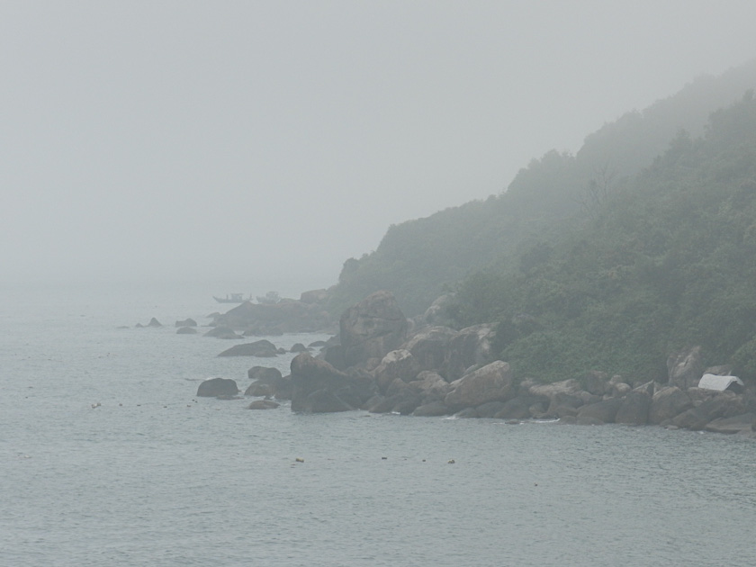
We looked out over our veranda to see Maine…thick fog! The trip (8 hours) was to start at 8am, but because the fog did not clear until 9:45 am so the ship could reach the pier. Our busload did not leave until almost 10am. Off we went for our 1&1/2 hr ride through endless little villages and past countless rice paddies. I do not understand why with rice growing and water everywhere…even muddy pools in front of shops and shanties…all this wetness does not bring with it hordes of mosquitoes and malaria. It is what it is.
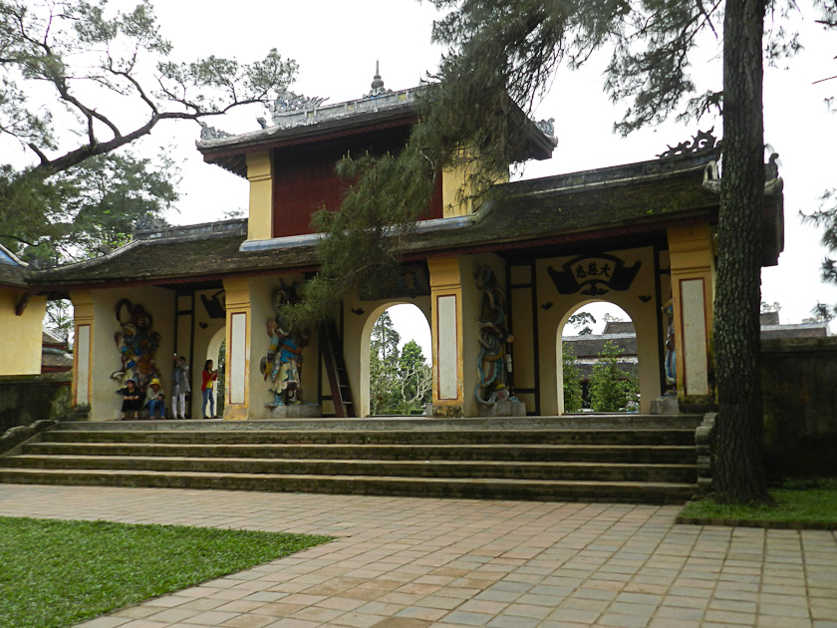
Again the visual experience of a “third world country” reminds one of the extreme differences in living and life of the less fortunate souls. I have described this before, so I will not repeat again here. Our first stop was at one of the holiest Pagodas in all of Vietnam, sitting on a high spot up from the banks of the Perfume River. Inside there were Buddhists at prayer while a young monk stood impassively and every 2 minutes struck a deep sounding gong… all the while remaining absolutely expressionless!

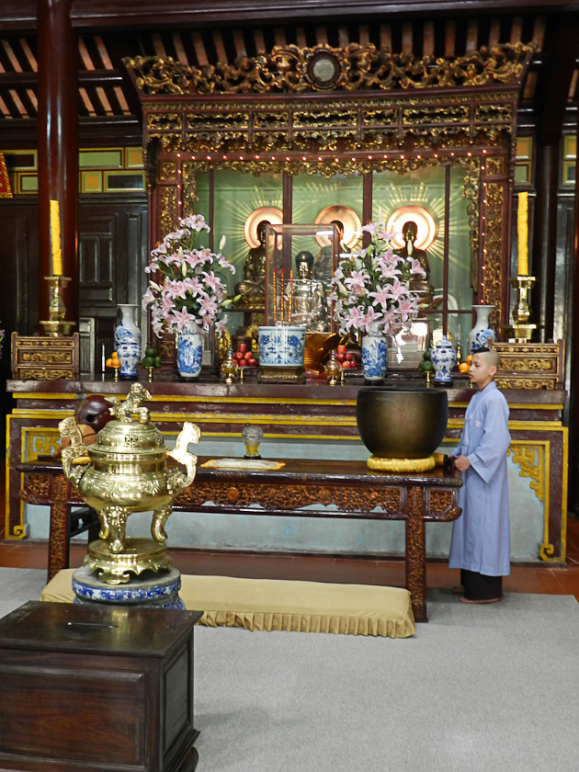
We then drove to an area of shops where Joanie got a gorgeous pale green silk sheath and then a few steps to the river where we boarded a “dragon boat” for a leisurely cruise down the Perfume River. We were among the last to board so only inside seats were available on light plastic moveable chairs. Not to be outdone, I carried two chairs (with the permission of the helmsman) to the bow platform and we both ended up with the best seats in the house! On board were the ever-present “peddlers” from whom Joanie bought a striking pair of silk(?) pajamas. A lovely cruise of about 1 hour, with grey overcast skies to keep us from the usual heat of an extremely hot sun.
On to an imposing Tomb and grounds, followed by a short drive to a large and modern hotel which put on a very impressive and complete buffet and welcoming entertainment for all of us from the Seabourn. Then to a huge marketplace with fresh produce and an almost endless variety of merchandise. Followed by another stop that I have now forgotten. And finally, after a long day we started our bus ride back to the ship.
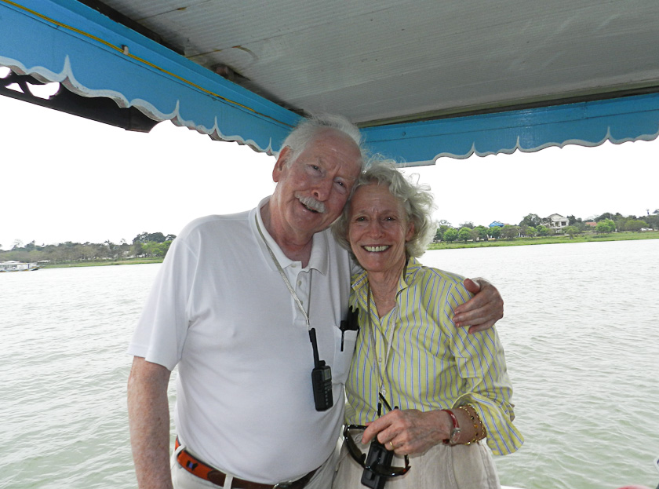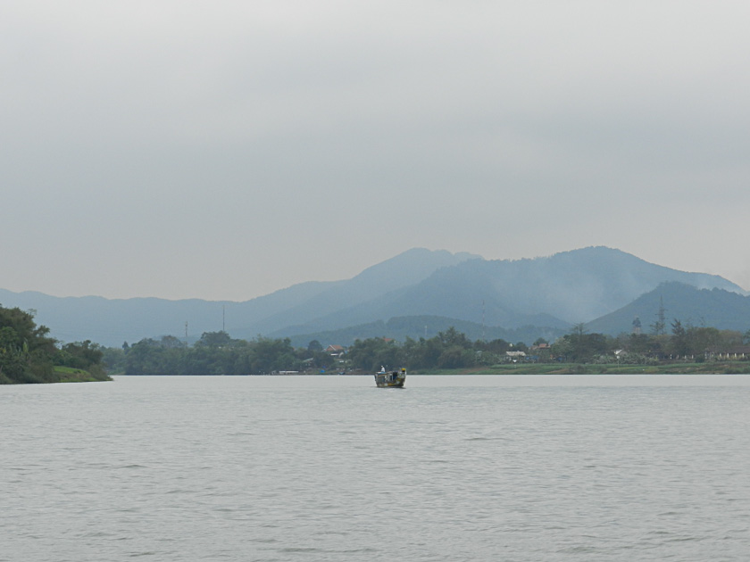

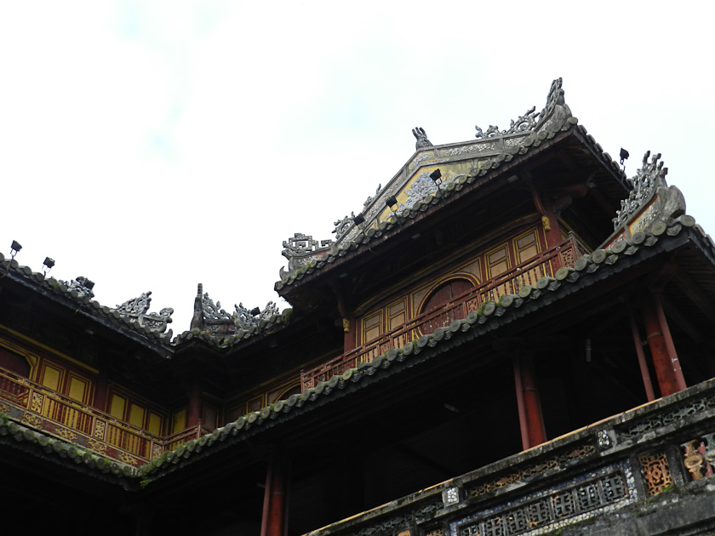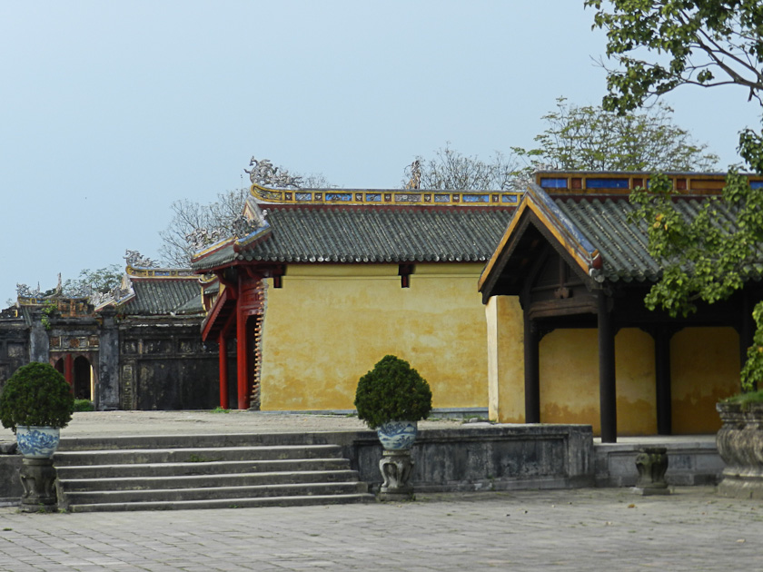

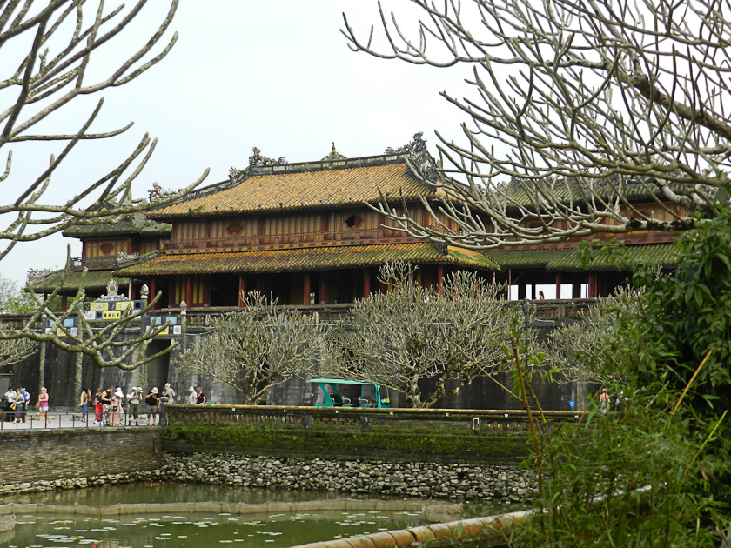

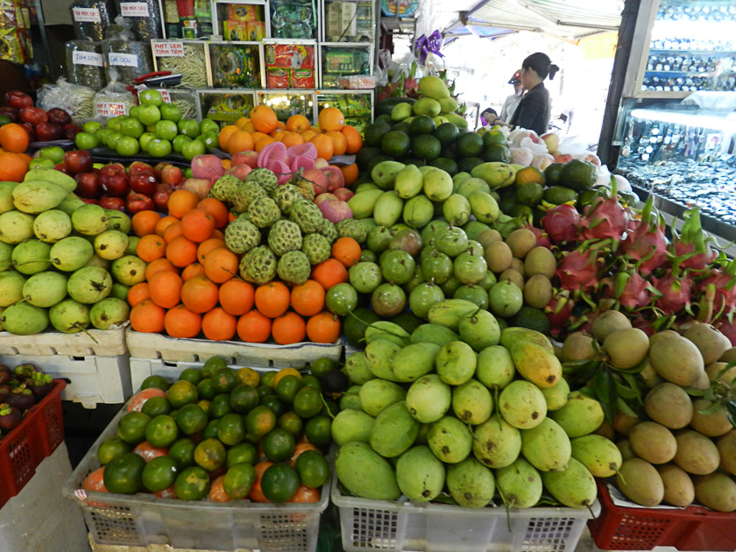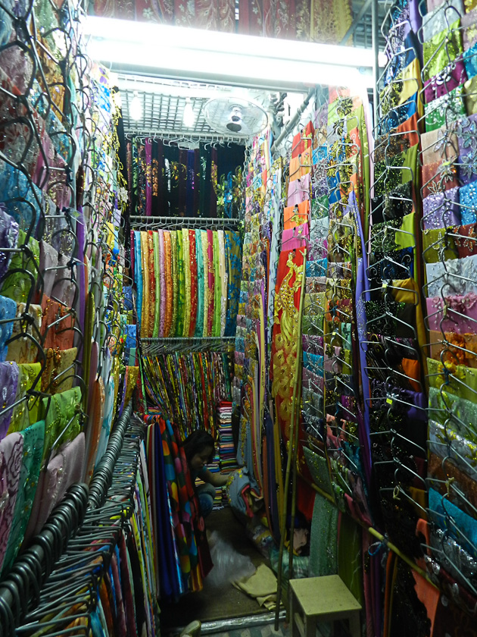

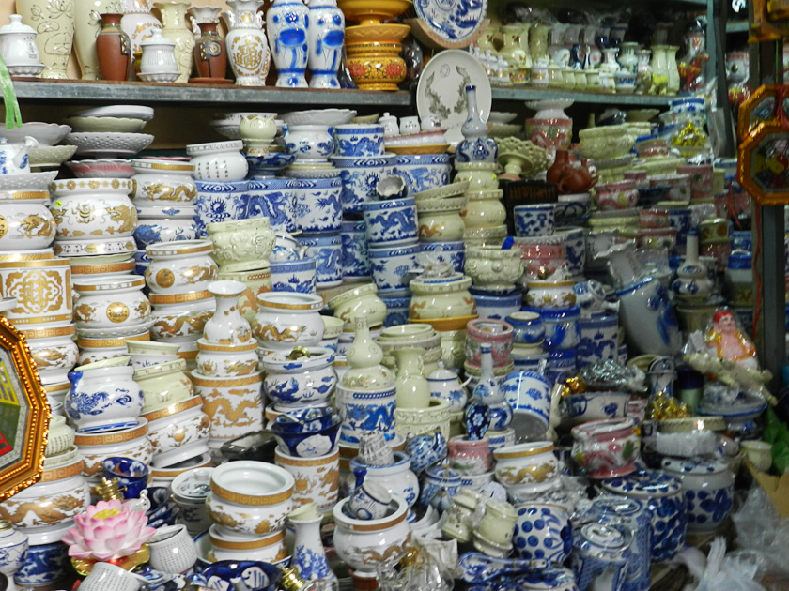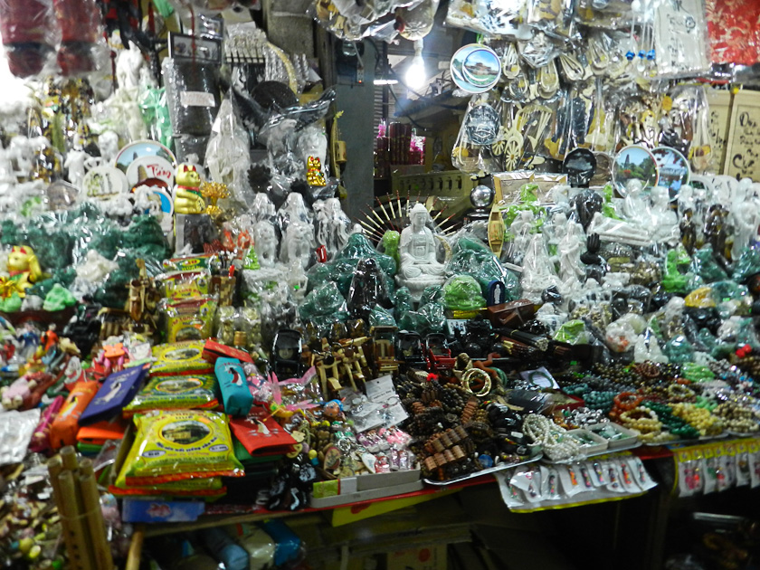

I must again comment on the vehicular profile of Viet Nam. Cars are very expensive, so they are few in number. Buses and trucks everywhere. But more noteworthy is the fact that at least half of the country’s 10 million population drive motor scooters and bicycles. It is hard to imagine the experience of being in a large bus on narrow roads trying to pass riders who are slow to move to the side while oncoming traffic of riders, trucks and busses hurl at one. The injury and traffic mortality must be huge! And not enough can be said for the skill of our various drivers who got us safely out and back – with much horn blowing – and not a bump or collision. Unsung heroes…who often are ignored by the passengers when tips are passed out at the end of the trip and only given to the guide.
A closing word about Hue. Although its region has been inhabited for more than 2000 years, most of its grandeur was contributed by Vietnam’s last royal family who ruled for almost all of the 19th and half of the 20th centuries. The center of their world was the Imperial City (The Royal Citadel, which I forgot to mention above)…2 square miles cut off from ordinary people by mighty walls, moats and cannon. Its layout was based on the plan of the Forbidden City in Beijing and consisted of over 50 structures of various sizes and functions. Hue was one of Viet Nam’s most beautiful cities, but various disasters, culminating in the 1960s war inflicted much damage. Still an impressive place to visit…with several surprisingly large, modern and luxurious hotels.
A long ride (and day!) back through gathering nightfall, with not much illumination from homes and shops, returned us to our ship at 6:45pm. Joanie and I were exhausted and had a nice dinner with wine in our room. This morning an early visit to the MD because poor Joanie now has a bad sinus infection and cough and is on the same medication the MD put me on 3 days ago! What a way to end a Magic Journey!

Brief Factum: beautiful day, cloudless, seas calm, water temp 66 F, air 74F, humidity 60%; depth 850’, distance from Hue 280, distance to next – to - last stop, Shanghai 1230
Speed 16.2 kn, wind 15 kn NE.

Hugs and love to all. Peter/Bumpa/Pops/Joanie/Pumba

