CC #7

Dear Family & Friends, January 27, 2012

It’s been a few days since my “Sunday Reflections” and I would like to thank those of you who sent me kind words about my modest effort. As a start to this Bulletin let me quote from a genuine, fabulous poet – John Masefield – so appropriate for our latest voyage. The last stanza of his famous “Sea Fever”:

I must go down to the seas again, to the vagrant gypsy life,
To the gull’s way, and the whales way, where the winds like a whetted knife;
And all I ask is a merry yarn from a laughing fellow rover.
And quiet sleep and a sweet dream when the long trick’s over.

Oh, to have written that magnificent poem…and to have the talent to make words sing! My “laughing fellow rover” and I are joyously experiencing “Sea Fever” every day…until my “long trick’s over”.

As I previously reported it was sad leaving Rio to start our 5 days “at sea” to St. Helena. Underway again with the days fun and full: chance meetings with new friends, fabulous food, a lecture or two, the gym, evening entertainment if we want to attend…and a constant unfolding of great weather. A rare rain shower at night, the endless rolling ocean whose color changes daily from brilliant blue to a more green/blue mix, with its pallet accentuated by frothing white caps from steady winds out of the NE/SE. Daily temp about 73 F, humidity at 67 %, wind 20-35 kn, 10’ swells and ocean depth around 11,000’. Ship speed 15-20` kn. St. Helena is truly “in the middle of nowhere”…approx 1800 miles from Brazil and 1200 miles from S. Africa. With a happy heart we press on to this remote destination.

Thursday morning 01/26/12 Joanie and I got up at 6:20 am to watch our approach to St. Helena. A clear, bright morning we were immediately struck by the stark beauty of this rocky, mountainous brownish grey island whose mighty cliffs rise sheer from the ocean with little green vegetation to be seen. St. Helena can only be reached by ship and it only as one small bay sheltered enough for anchorage and disembarking.
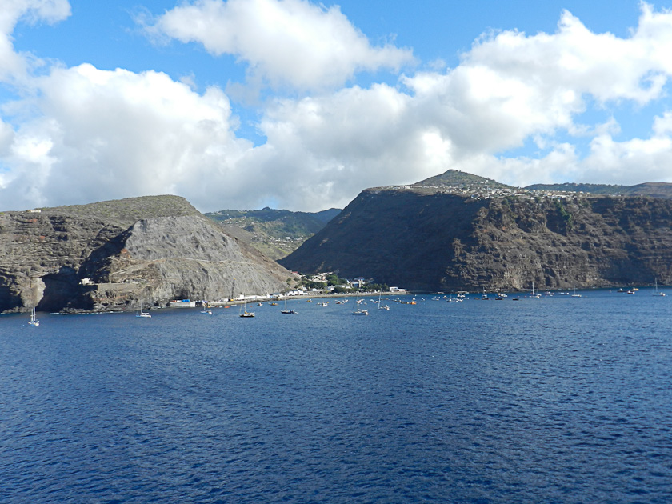

But first impressions from the sea are very much misleading. 4 million years ago an active volcano occupied part of the island, with its small size of only 47 square miles. The landscape turns out to be amazingly diverse: sharp, steep cliffs (rising to smooth and jagged peaks of 2500’-3500’ height straight out of the ocean), bizarre, barren, igneous rock formations transform to the islands interior with wooded hills and deep valleys, fertile high plateaus and lush green meadows giving way to subtropical vegetation and flowers. Truly a feast for one’s eyes! Water is primarily from rainfall.
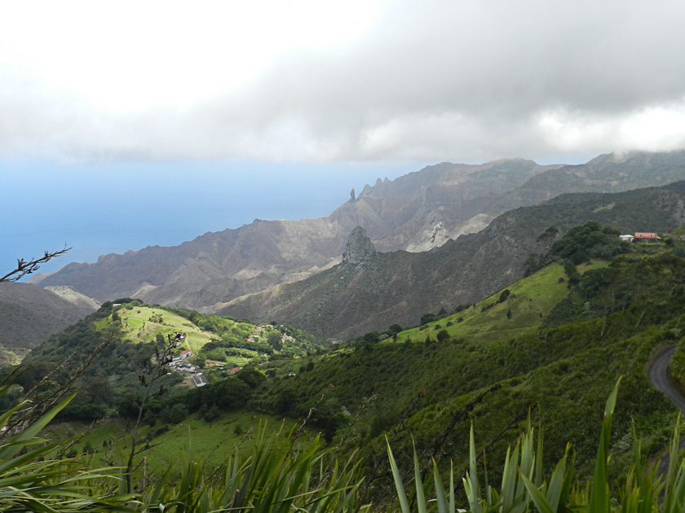
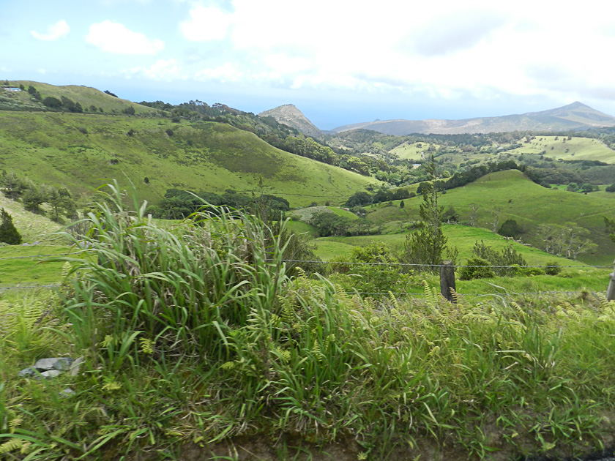

Around 4250 “Saints” as the residents call themselves live on the island. And just over 700 of these in Jamestown (the capital and principal town on the island) and the historic chief settlement of the island, founded when the English colonists settled there in 1659. Other small settlements dot the high ground, and the rest of the island is scattered with little houses surrounded by gardens. Roads are narrow, steep and present a real challenge when cars (few in number) and small pick-up trucks try to pass one another. The islanders are warm and friendly folk, mostly the descendants of British Colonials, Africa slaves and Asians. They are primarily farmers and fisherman. Limited tourism brings in additional income. Children under 12 are less than 1000, and declining. A major problem facing the future viability of St. Helena.

With all of the above the shocking fact is that the island is not self sufficient and is totally dependant upon supplies brought in mainly from Africa for its survival. Now we come to the madness of man. About 10 years ago the islanders voted to increase tourism for their survival by building an airport, a 300 acre luxury hotel and a golf course…for about 350 million British pounds. If constructed, per head of population the airport would be the most expensive ever built…anywhere. All paid for by the UK government. 10 years later nothing has started. If a vote were taken together for the same projects, the islanders we talked with said it probably would not pass. And yet the UK, out of money, instead of taking a new vote stubbornly blunders on to go ahead with this insane project. The only certainty: if undertaken this boondoggle will cost twice as much as originally budgeted and take years longer to completion…now scheduled for 2015. It will forever destroy the islands timeless character; disrupt its extremely sensitive ecology and its profile as a unique, historic, beautiful, peaceful paradise. And the project assuredly will fail in its purpose…because of its extreme remoteness it is almost a certainty tourism will not significantly increase.

Now a word about “historic”. Founded in 1659 by the English East India Company, today it is the second oldest remaining British territory, after Bermuda. Ascension Island, Tristan da Cunha (its far away lonely neighbors, check your map) and St. Helena today together are all a dependency of the UK. 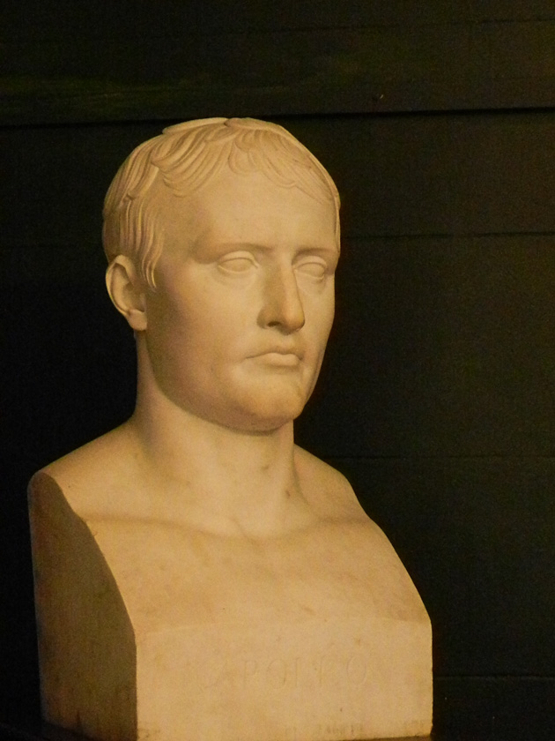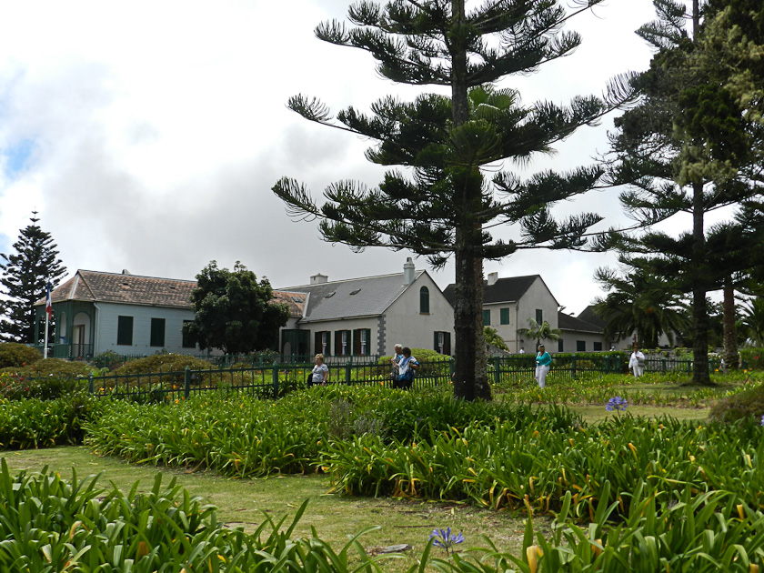 But the real history lies, of course, with Napoleon Bonaparte. After his defeat at Waterloo he appealed to the British for protection. They sent him into exile, far from his friends, enemies and ambitions…to the remoteness of St. Helena. For the last 6 years of his life in lived in a simple but beautiful house with garden called Longwood House. He was allowed to move about anywhere within a 5 mile radius of his home, with permanent guards outside the house and warships patrolling the shores to prevent his escape. Today the house has been beautifully restored and furnished with exquisite period pieces, furniture, paintings, documents and mementoes of the time of his imprisonment on St. Helena.

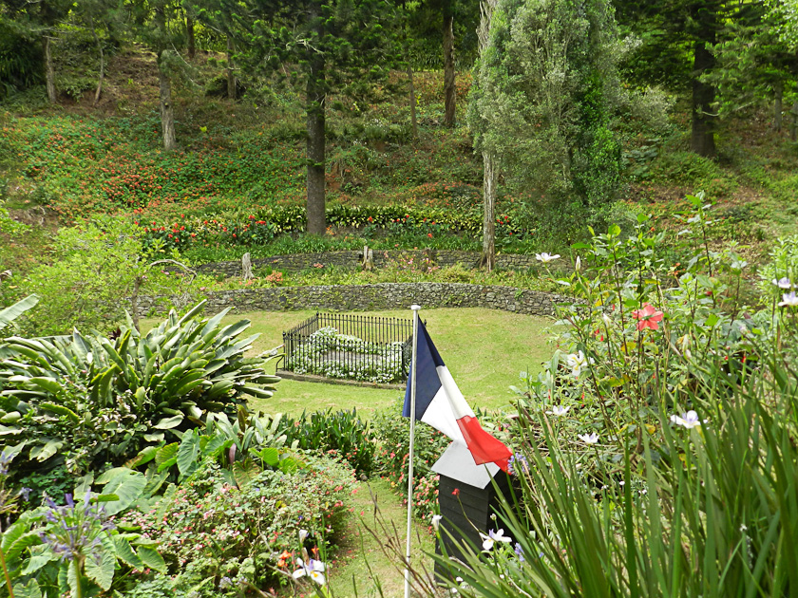
Napoleon died on the island…death listed as from cancer; but many believed from a long slow administration of small doses of arsenic by his enemies. Before his death Napoleon selected the spot for his burial, where he lay in peace until his remains were removed to the Invalides in Paris in 1841. His burial plot on St. Helena is extraordinarily beautiful and peaceful. Located in a spot known as Sane Valley, it is about a mile from Longwood House, down a grass covered long slopping path reaching the end of a gully surrounded by high ridges with multi-colored flowers and tall gorgeous evergreen trees. Today the house, its gardens and the idyllic burial place remain properties of France with the French Flag proudly flying over them in the gentle breezes.

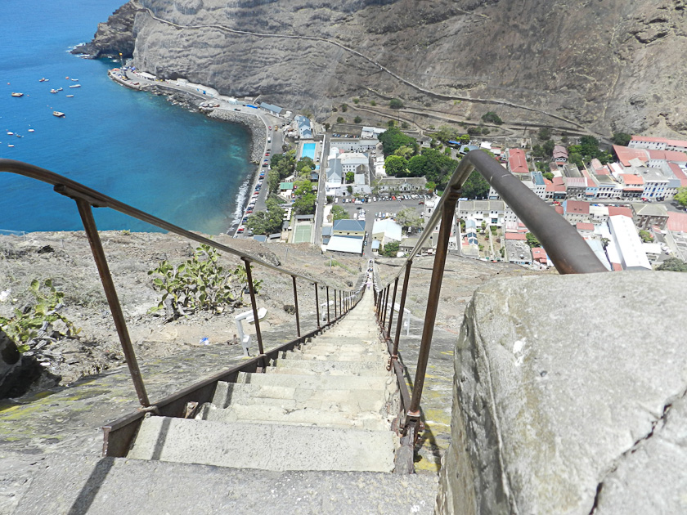
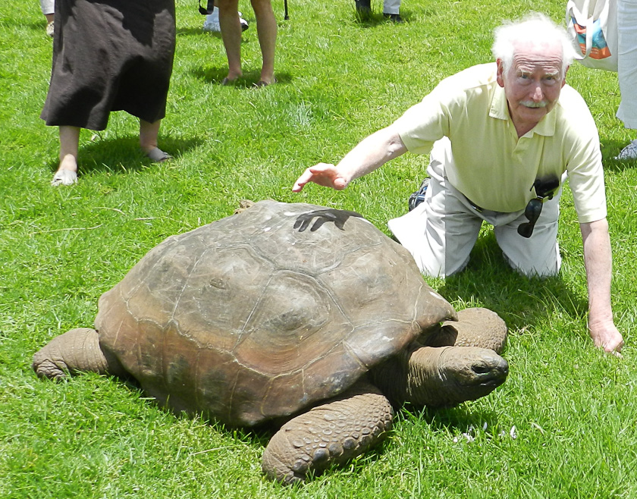
I should mention two more historical tidbits of this remarkable island. To access one of the forts on the top of so called Ladder Hill, in 1829 the British hewed out 699 steps into the cliff's side, known as Jacob’s Ladder to the top of Ladder Hill. An ever-present challenge to the athletic and young in spirit and of vigorous lungs. A second spot is the British Governors House, named Plantation House and built in 1792. Several times restored it is a most handsome structure with beautiful gardens and the oldest by far resident of the island: Jonathan the turtle…calculated to be 175 years old. Jonathan and his 3 friends – not related turtles with the youngest being about 35 years of age – happily slowly move about the large lush green lawn slowly pulling out and chewing clumps of grass. An amazing sight…and the turtles are LARGE!

Fragmented Factum. As always, I have gone on far too long. I hope there might be an item or two in CC #7 that you might find amusing or of interest. It is now 4:00 pm; I close with the following current voyage conditions: Course 112 degrees, 326 miles from Jamestown, 972 miles to Walves Bay, Namibia, arriving Monday 8 am; total miles so far travelled 7172; ocean depth 14,310’; air temp 72F; water temp 70F (guess); wind 15 kn, 18 degrees; ship speed 15kn. Gentle swell of 4’ with scattered whitecaps, pale blue sky with occasional puff ball white clouds. Very peaceful and pleasant. Darling Joanie in Laundromat for a dose of reality. Tonight joining a nice couple from Holland for dinner for a “Tasting” in main restaurant.

Joanie joins me in sending hugs and love to all. Please remember: all the pictures are taken by my remarkably talented Joanie. Like in everything else, she is sensational with a camera.

Peter/ Pops/Bumpa
