CC#14

Dear Family & Friends, February 29, 2012

I am writing this as the ship presses on to our next landfall tomorrow at Ho Chi Minh City (formerly Saigon), Vietnam. I am enormously grateful to those of you who have made the effort to respond to my CCs with acknowledgement and a kind word. Hearing from you helps make the whole process worthwhile. We have had fun, and also made a great effort to capture for posterity – and for those whom we thought might be interested – a highlighting of our magic ride around the globe.

Unfortunately, for the past almost a week I have been dealing with a bad cold…stuff out of my nose and coughing up what I will not dare to describe…plus a racking, spastic cough that sounds like a death rattle. I am taking antibiotics, a host of pills and going through at least a box of Kleenex a day. Poor Joanie…I have not been very good company, but she has remained her usual kind, loving, cheerful, uplifting self. I mention my health only because it will explain my coverage below of the past two landfalls.
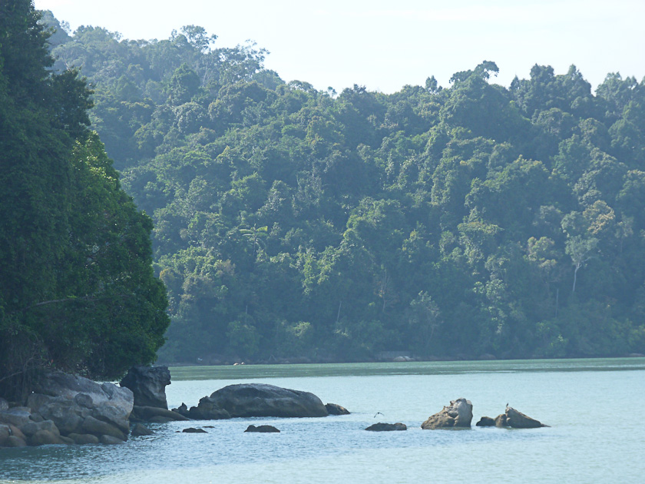

Penang Island

The ship spent the day here this past Saturday, Feb 25. I did not go ashore (see above) so Joanie’s pix will give you an overview while I add a few historical facts. And we will talk about “Sam”.
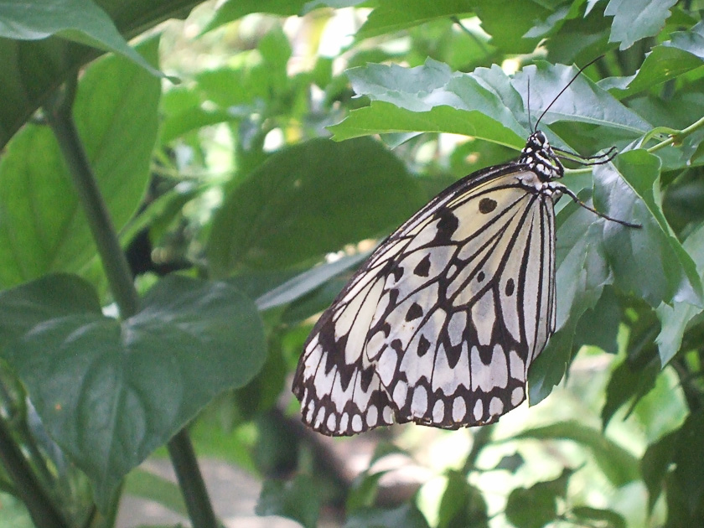
Penang is a compact island (you can circle it by car in half a day) with a colorful microcosm of Malay, Chinese, Indian and Thai cultures. Jungle-clad hills dip down to palm-studded golden beaches bordering brilliant blue seas. Its population is approximately 1.4 million, swelled daily by thousands who cross Asia’s longest bridge from the mainland. Its capital city of Georgetown with its unique architecture and cultural profile of an old colonial center was recognized by UNESCO in 2008 as a World Heritage Site.

Now “Sam”. On our cruise last year across the Pacific, Joanie met a lady
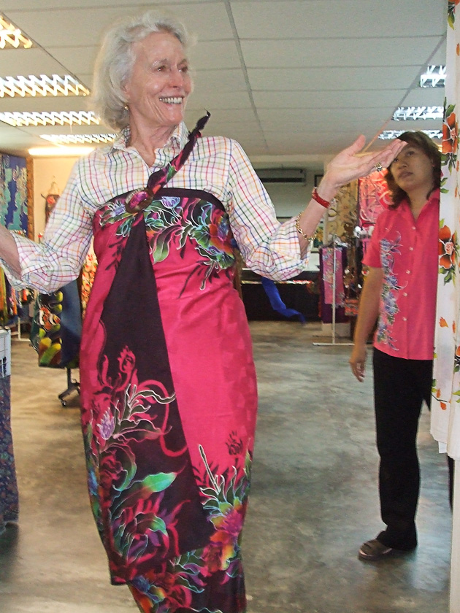
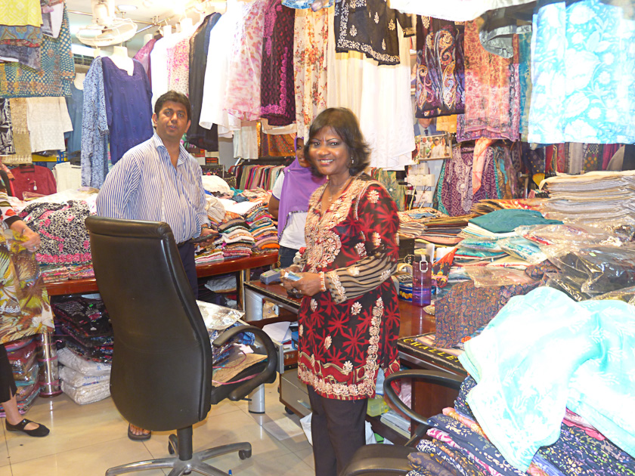
wearing a spectacular colored patterned blouse. Joanie struck up a friendship and the lady reported that her blouse came from “Sam’s” in Penang. Joanie never forgot. So this year Joanie and 3 others rented a taxi, saw some of the island, which included a wonderful butterfly farm, a batik factory and a drive along the lovely coastline, but ended up at “Sam’s” to spend adequate time to shop before returning to the ship with large collections of absolutely gorgeous blouses…which Joanie will enjoy - as will all who behold her in these colorful creations – for years to come. The taxi group arrived back on the ship in the late afternoon with glowing faces and smiles a mile wide. “Sam”, I am sure, also had a mile-wide smile as he closed early to celebrate one of his better days!

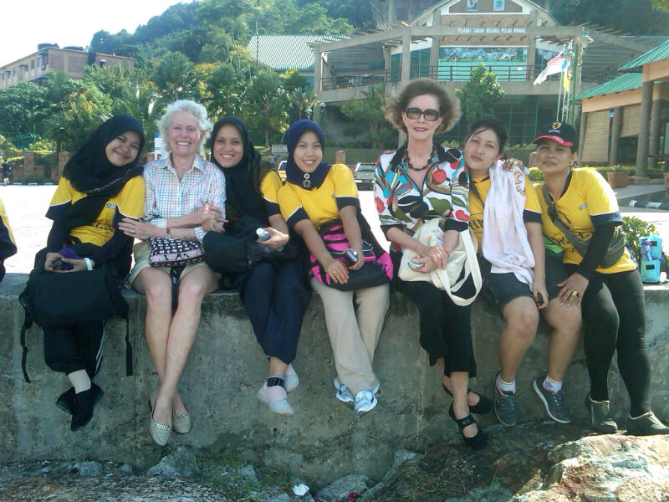

Joanie’s favorite part of the day was becoming acquainted with some Indonesian ladies who are factory workers in Penang. They were adorable, charming and very friendly. A great deal of sign language was attempted and many hugs exchanged!!!

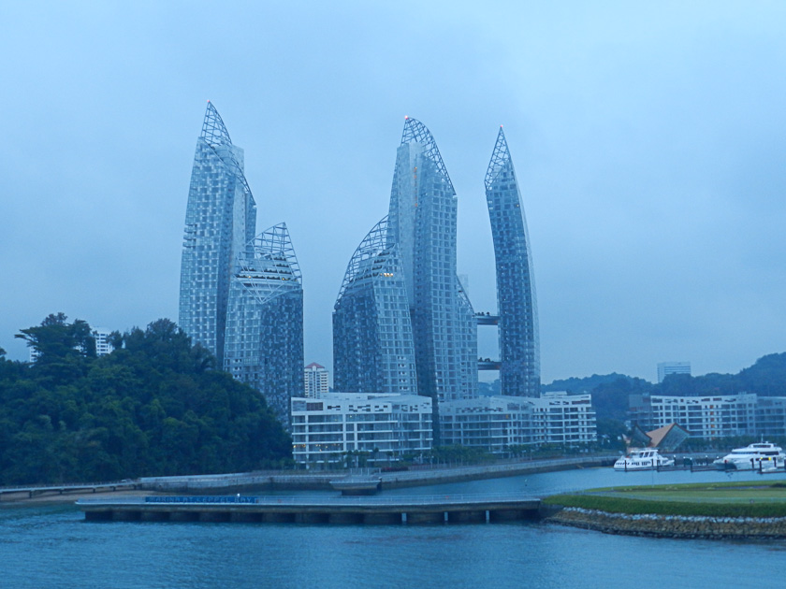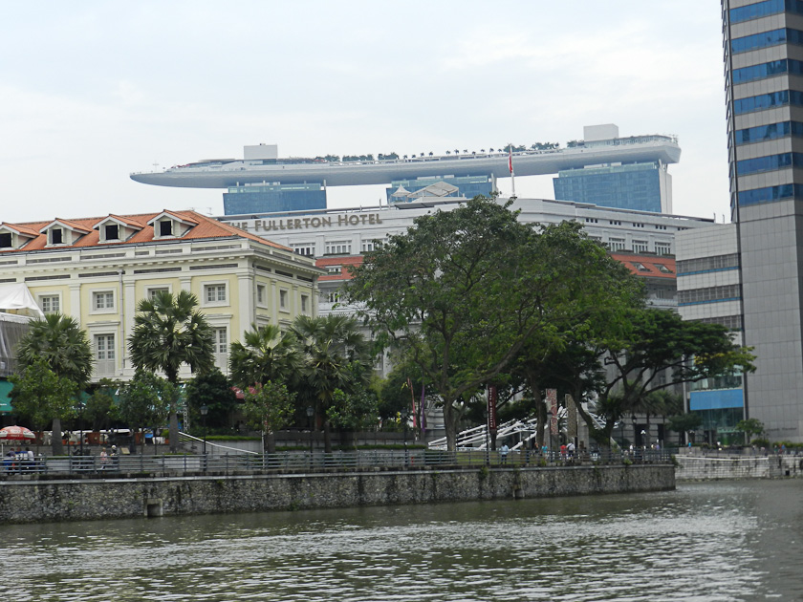

Singapore

Like many on board on Monday, Feb 17, we arose early (6am) to see our approach into Singapore harbor. What a spectacular sight! Located just 1 degree of latitude north of the equator this high-tech city state is a mixture of soaring office towers of extraordinary architecture, modern attractive office buildings, wide clean streets, excellent landscaping filled with greenery and flowers…and just simply a city that is pleasing, happy and bustling in every direction one looks!
Singapore is an island republic, with great prosperity, covering an area of 245 sq. miles. Singapore City holds most of the islands 5.5 million people, it is a thriving financial center for Southeast Asia and it has earned the name of the “garden city”. Its culture is a unique mixture of races, languages and religions. Malay, English, Mandarin Chinese and Tamil have official status, while Buddhism, Taoism, Islam, Hinduism and Christianity are the major faiths. Crime rate is among the world’s lowest, standards of hygiene the highest; it is the world’s 4th leading financial center, the 3rd largest oil refinery center and the 2nd biggest gambling market. Its port is one of the 5 busiest in the world and the country is home to more US millionaire households per capita than any other country…with the World Bank saying it is the easiest place in the world to do business. Unemployment is virtually zero and prosperity abounds.
Our day trip was billed as “3.5 hrs iconic Singapore”. I will let Joanie’s pix carry the day. We started with a brief visit to a gold domed Sultan Mosque, than the bus went through the old colonial section to world famous Raffles Hotel – a fantastic hostelry where we shopped and visited the Long Bar to enjoy their famous “Singapore Sling” (delicious), then a delightful 45 minute boat ride down the center of the city and ending with a brief visit to a Thian Hock Kong Taoist Temple (that’s what it was called!”). Then
back to the ship through a very crowded passenger terminal. I would rate the day a B, with the river cruise the high spot. Joanie’s pix will carry the day.

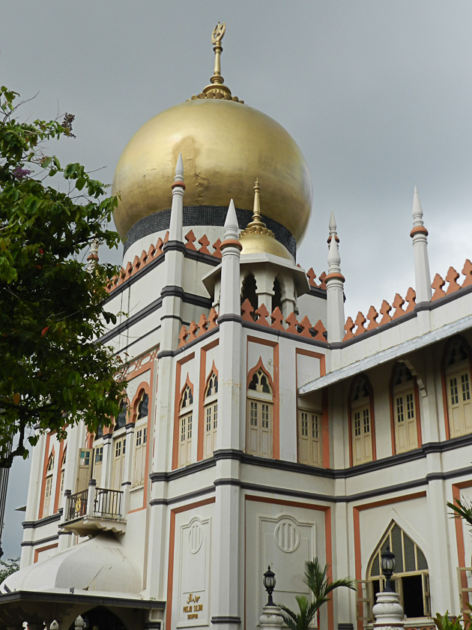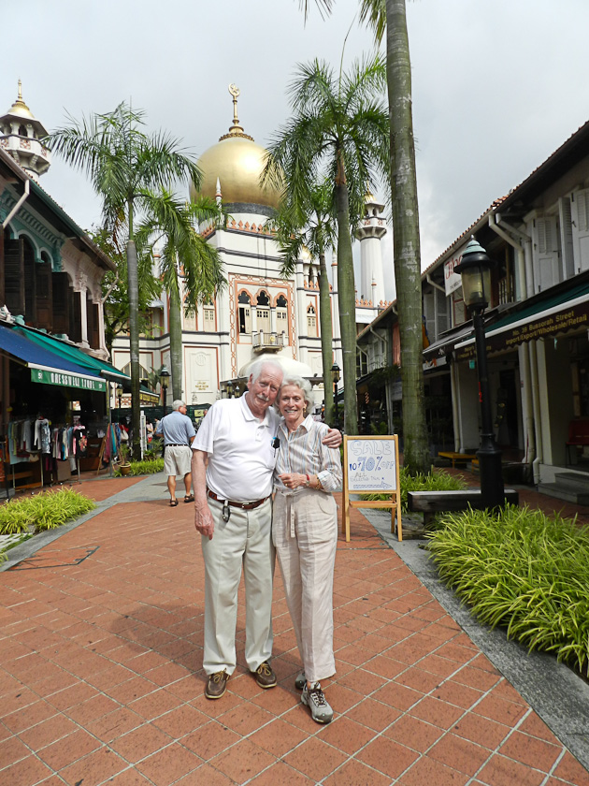

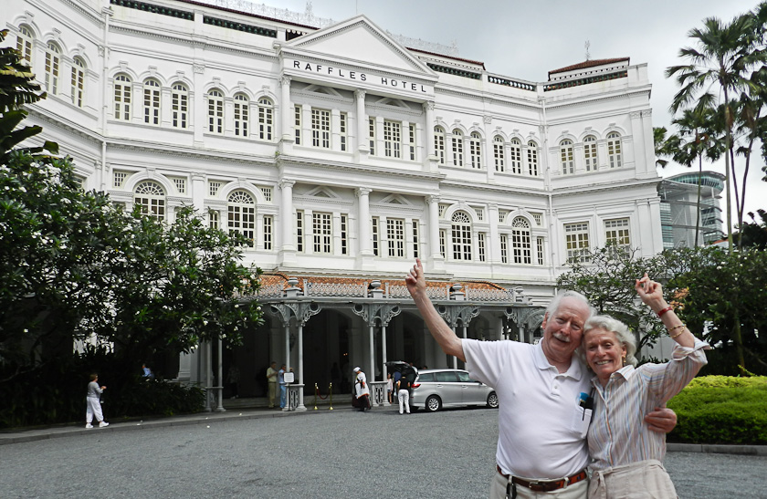

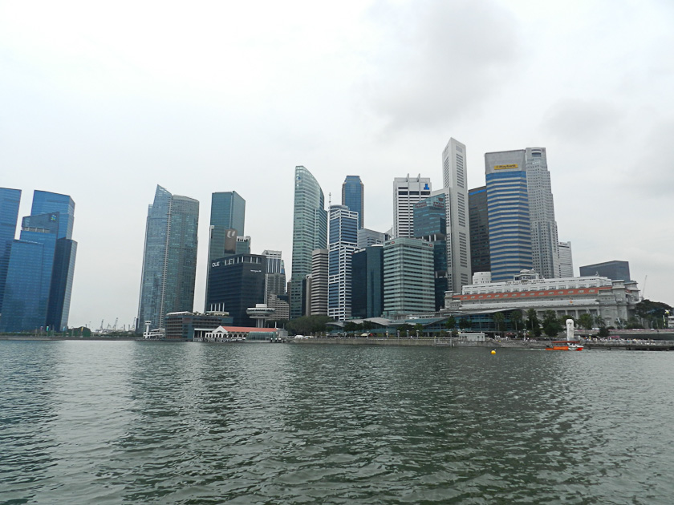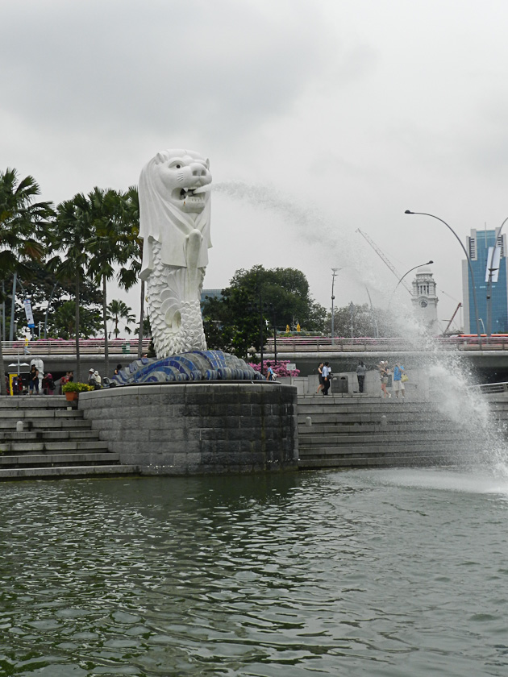

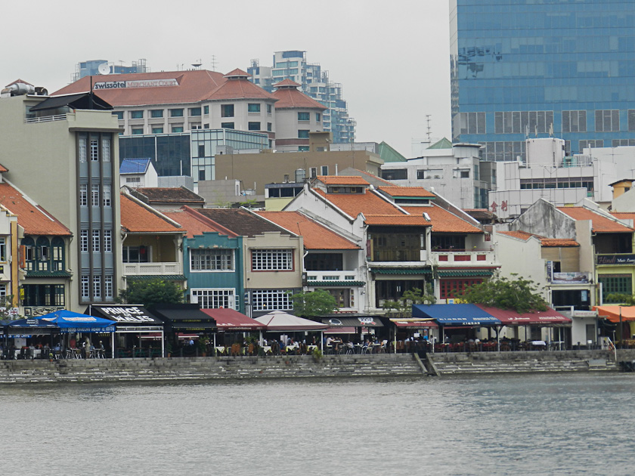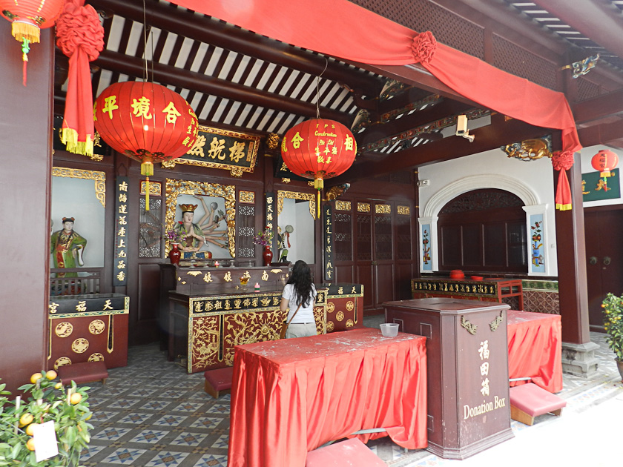

Close to Final Factum: Scattered clouds and clear; course 023 degrees; speed 11.1 kn; Temp 75F; water 71F; wind 10kn NE; ocean depth 180’…all’s well.
Off to blow my nose. Love and hugs to all. Tomorrow the beginning of March and the start of the final two weeks of our amazing odyssey.

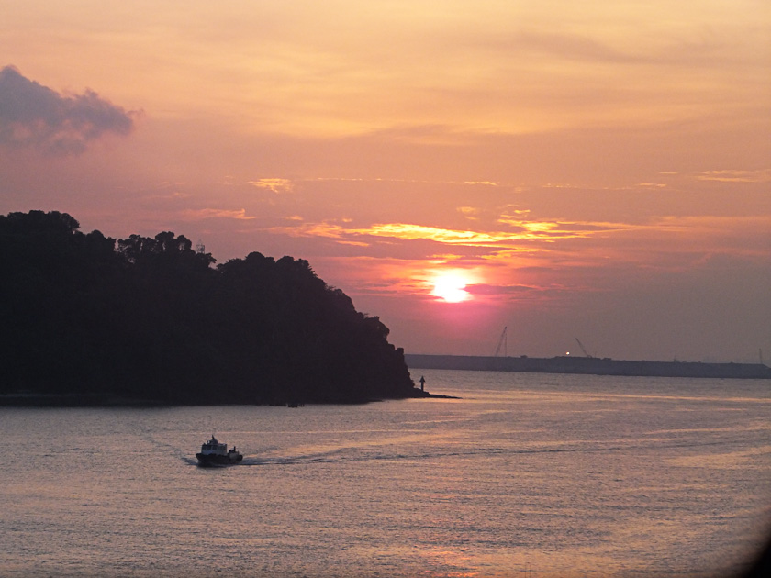
Peter/Bumpa/Pops/ Joanie/Pumba

