CC#11

Dear Family & Friends, February 15, 2012

I’m going to deviate from my normal opening, and start with a mild disclaimer. In rereading some of my Bulletins it now strikes me that some of my readers might consider these reports to be negative and depressing. Far from my intention. My writing is a meager attempt and admittedly wholly inadequate effort to recount only what my eyes have seen, aided and abetted by a very subjective feeling of what I saw. “It is what it is”. So I will press on.

Foreword Factum.

Time of this report 3:30 pm. Sky pale blue with scattered flat clouds. Sea rolling with 5’ swells and occasional white caps. Water brilliant blue. No land/ships in sight to the horizon. 389 nm from Port Louis, Mauritius; 1369 nm to next landfall at Male, the Maldives on Sunday, Feb 19; total distance travelled from Ft. Lauderdale 11,834 nautical miles (passing much too quickly!); speed 18kn; wind 22kn from SE; temp 82F; humidity 67%; ocean depth 13, 560 ft; course 040 degrees.

Onward!

When we were last together with CC#10 the ship had just left Maputo, Mozambique on its 3 days “at sea” voyage to LePort, Reunion Island. Shortly after our evening “5pm caviar and champagne departure” the Captain announced that a cyclone was in the vicinity of Reunion and he was “watching the situation carefully”. The “watching” soon became “because of the cyclone with its threatening high winds and stormy seas we are going to bypass Reunion and continue on to our next scheduled landfall at Mauritius”.
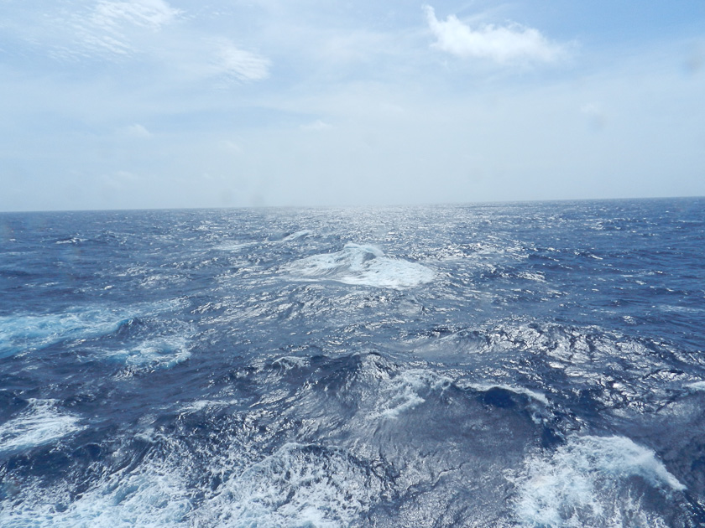
For the next day or two our first “rough weather” occurred. The winds picked up to around 45-50 mph and the ship nobly began to rock and roll and creak as it ably contended with 15’ swells. Not bothersome at night, but made walking a little unsteady as one tried to remain normally upright on a rolling and pitching deck. The ocean was fascinating and hard to adequately describe: small hills and valleys of moving/surging water rushing mightily in the same direction, capped by white foaming wave tops that quickly were blown away in a misty spray by the powerful winds. No rain. The “big picture” as we gazed out over the Indian Ocean in turmoil was one of nature’s forces visibly at work…and it was beautiful, awesome and majestic. Joanie and I had very little discomfort, attended all meals while some, I suspect, remained in their cabins…possibly with “Room Service”, much to the waiters dismay as they struggled to safely bring the trays.

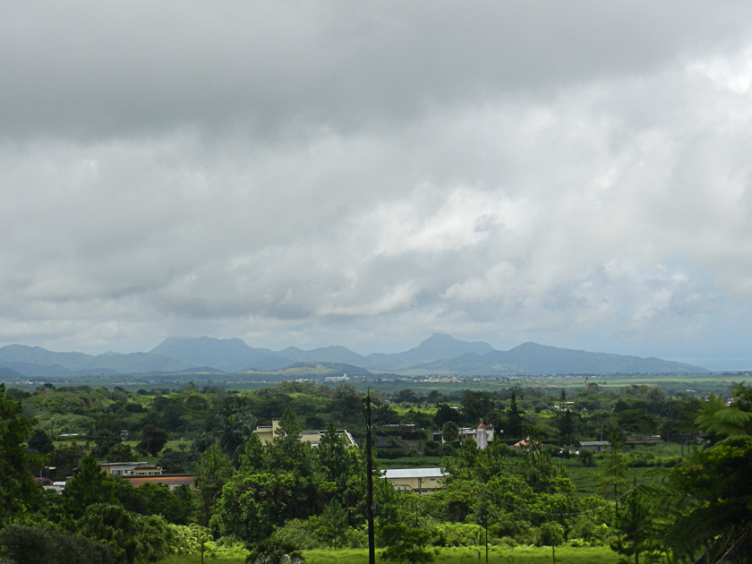
The Pilot boarded the ship at 6:30 am and brought it safely to its pier in the harbor of Port Louis for guest’s departures starting at 8am. Joanie and I had signed up for the 7 ½ hr bus excursion on “The Tea Route”. The enjoyable trip through the countryside took about 2 dozen of us to an historic house, a Tea Plantation, a sugar cane factory (where we had a sit-down lunch at a single long table - we all carefully ate the food which was not all that bad - topped off by a visit next door to a rum factory (with a gentle tasting).

Mauritius is the sugar-cane island of the Indian Ocean. The island is part of an ancient land mass that once united Asia and Africa, Small as it is (770 sq. miles) it is one of the most densely populated places in the world and supports around 1.3 million people, mostly of Indian descent. It also has a large Chinese community and scattered about are numerous Hindu and Chinese temples, mosques and Christian `churches. English is the official language, but Creole (derived from French) is used by everybody with French being the most commonly spoken language. Mauritius has been independent since 1968 and is hard at work trying to control its population and raise is overall income level.

A social, and sad, note. We all are familiar with the expression “Dead as a Dodo”. This unique flightless (no wings) bird was kind and tame and existed only on Mauritius, where early settlers used them as a shooting gallery and killed them all off to the very last one, making them extinct.

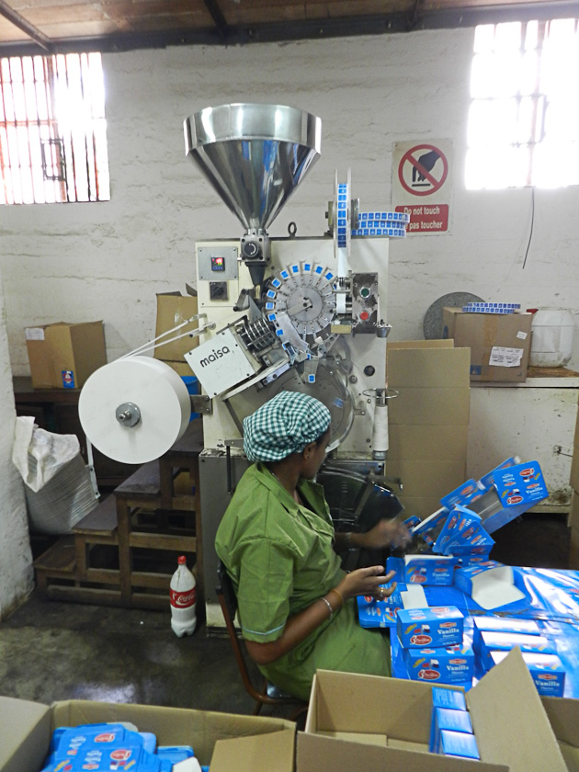
Our travels throughout the island showed a mixed landscape of gorgeous mountain ranges, fertile valleys and endless fields of sugar cane with the occasional tea plantation. Let me say a word about tea. The factory was crowded with countless machines…every one of which shook back and forth or up and down as they processed the raw leaves over a series of belts, through roasters and a flavoring additive stage until the finished tea arrived at machines that filled endless bags which were hand sorted by ladies sitting at their side and counting and packing the boxes and bags on eight hour shifts for the beneficent sum of $250 a year in wages. Imagine!

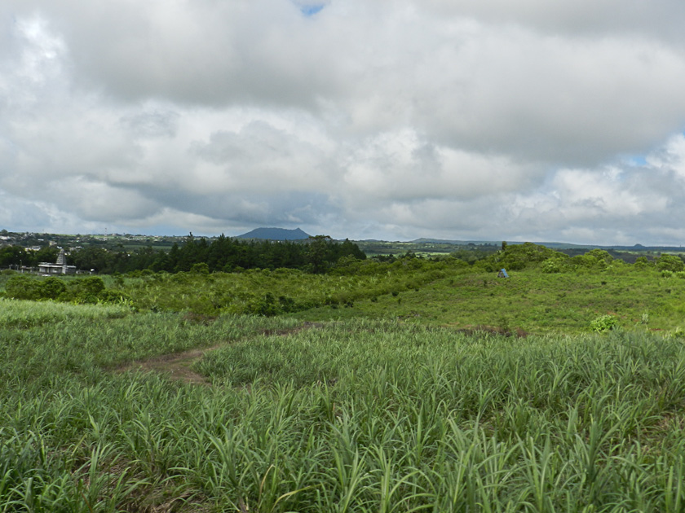

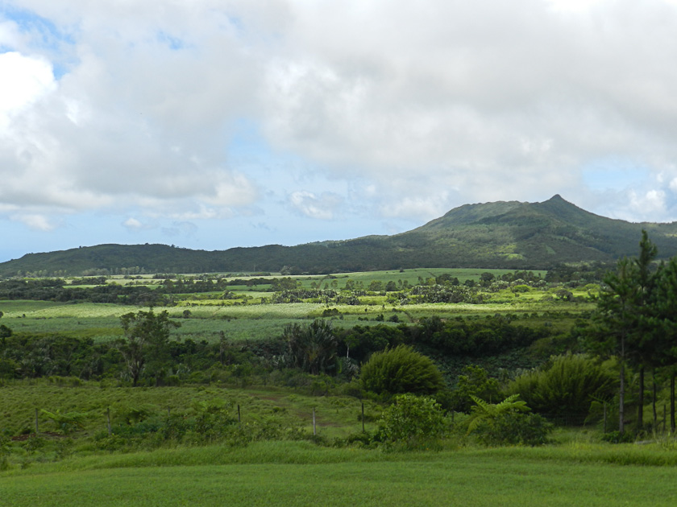

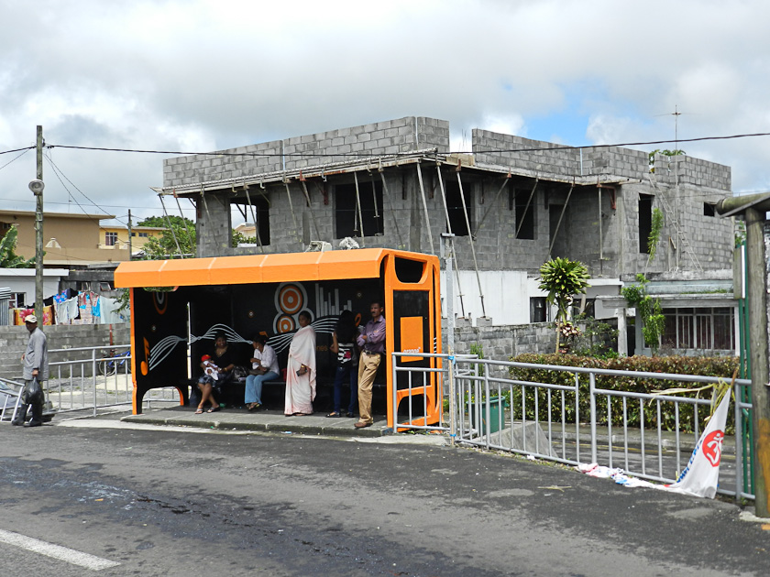
Houses throughout the country were a mixture if cinder block, plaster, masonry with many half finished because the owner was waiting to get more money to complete the job…with a wide variety of bright pastel colored completed houses, standing next to unfinished houses blotted with mold (from the island’s high humidity) scarring the unfinished masonry. Scattered about were structures topped by little minaret shaped towers. People everywhere bustling through the small villages, crowded by countless buses and cars.

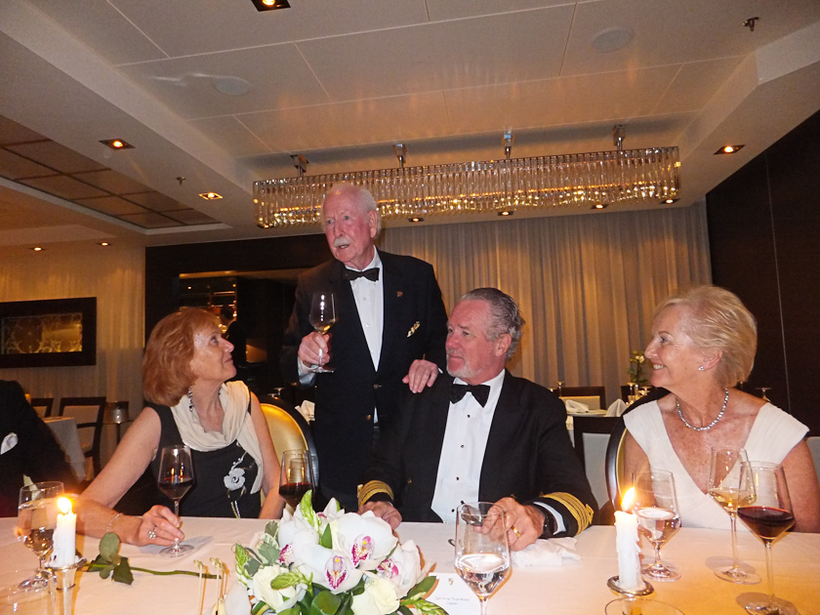
Last evening the Captain invited Joanie (the most beautiful and popular woman on the ship - as always – by far) and me to his table with 9 others for a Black Tie Valentine’s Day dinner. It was most pleasant, and we have become fond of the Captain (who is an extremely skilled ship’s Master, a fine photographer and with a delightful sense of humor) and his beautiful Filipino wife, Juvy. For dessert I had vanilla ice cream with butterscotch sauce…joined in happily by another guest who turned out to be a neurologist from England, who spent a year at Mass General for his residency 60 years ago!! Bon Appetite!

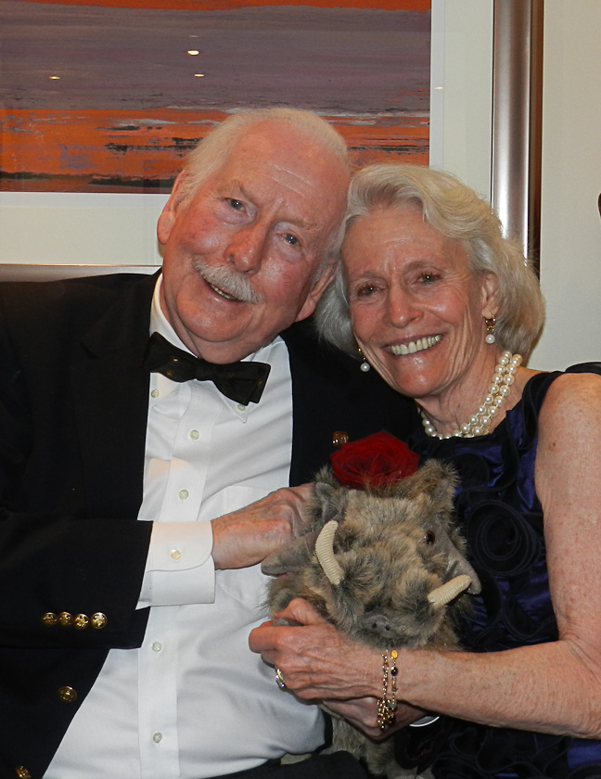
All for now. Joanie and I are blissfully happy and well, but sad the days of this magic voyage are winding down. Our new family member Pumba, who joined us at Port Elizabeth, has brought joy and laughter to us both. We send our love and hugs to all.

Pops/ Bumpa/ Peter
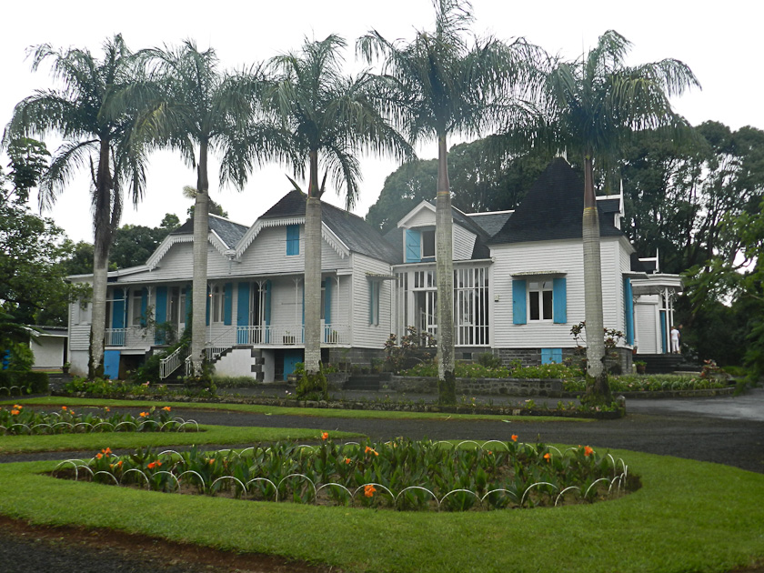

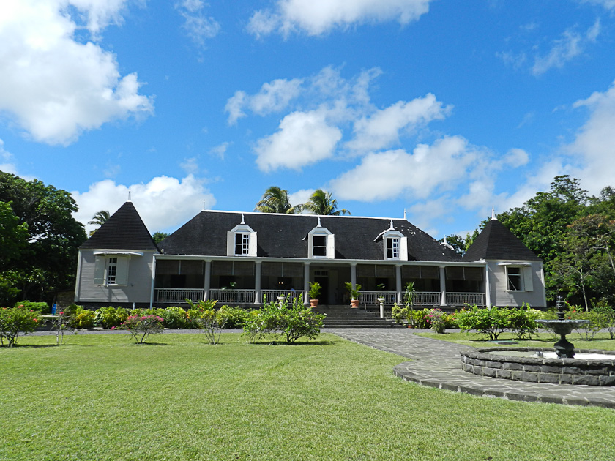

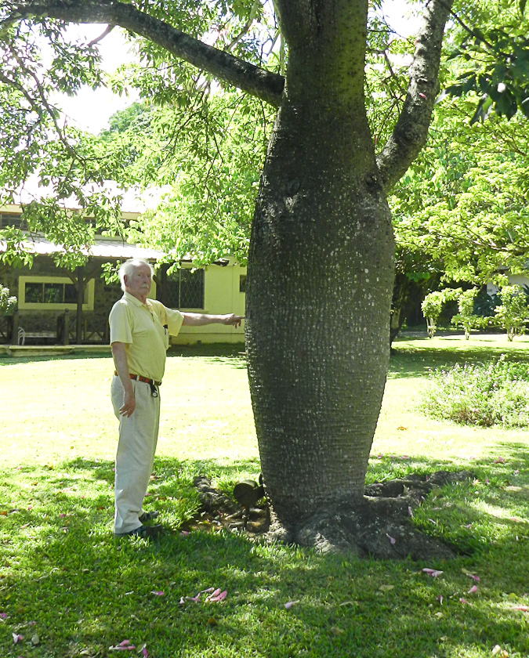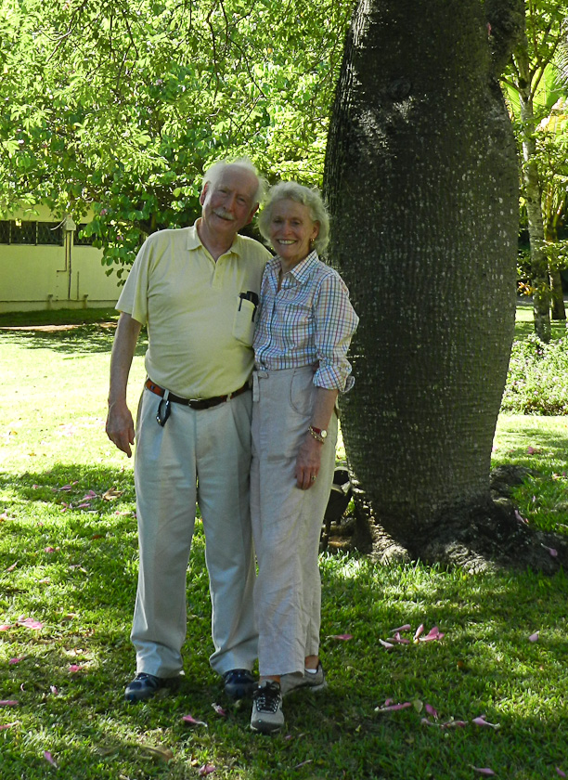

Pumba welcoming us back to our room on Valentine’s Day!!

