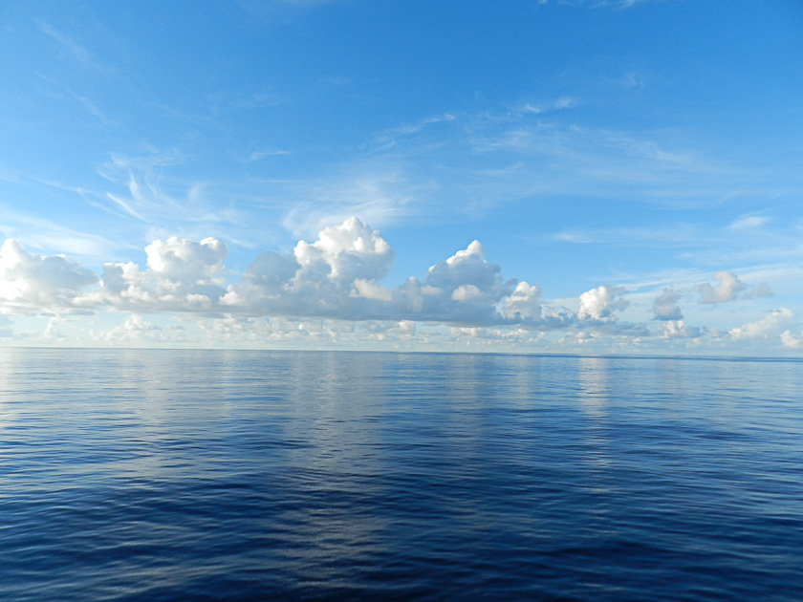

REFLECTIONS II

Dear Family and Friends, February 18, 2012

Our 4 glorious days “at sea” since we left Mauritius end tomorrow when we arrive at Male, Maldives…heralded as one of the world’s most beautiful paradises. The forecast indicates possible showers, of which we have had virtually none since our voyage began on January 5!

This Bulletin (#13) will be another interlude, with a very different format that I hope you will enjoy. Two parts: 1. fish; 2. poem (in the eye of the beholder!)

Fish

Joanie and I were out on our veranda two nights ago spellbound by the beauty of the evening. As we looked down on the brilliantly blue ocean slowing slipping by our ship, suddenly these tiny little creatures popped up from the surface, skimmed across the sea for about 10 feet and then quickly disappeared. In appearance I would describe them as very large dragon flies…about 5 inches long with tiny delicate wings. I had absolutely no idea what they could possibly be…but my suspicion was confirmed by a naturalist among the passengers: flying fish! I had grown up believing Flying Fish were pure fiction and did not exist in nature. What a happy surprise! I then remembered a famous poem and song, which you will recall…, words by Rudyard Kipling, music by several:

On the road to Mandalay
Where the flying fishes play,
And the dawn comes up like thunder outer China
‘Crost the Bay!

This great poem was written by Kipling in 1892. “Mandalay” was the sometime capital of Burma, which was a British Colony from 1885 – 1948. The poem has many verses, of which the above is one of the most memorable…especially for me now that I have actually seen the fish!

During this 4 day period dolphins have been seen, and Joanie and our dear stewardess, Debbie, (and, perhaps, even Pumba) believe they saw the movement in the ocean of a whale’s tail!). A busy “viewing time”!

Poem

Slow motion in the ocean, a sight to see
A mirror stretching to the horizon,
Utter calm and majesty enveloping me.
Gentle waves from the bow’s quiet slip
Bring peace and comfort to our ship.
As the sinking orange sun
Caresses towering shadowed clouds
Thrusting skyward their billowing fists
To an eternity God has kissed. PG 02/18/12

Much love and hugs.
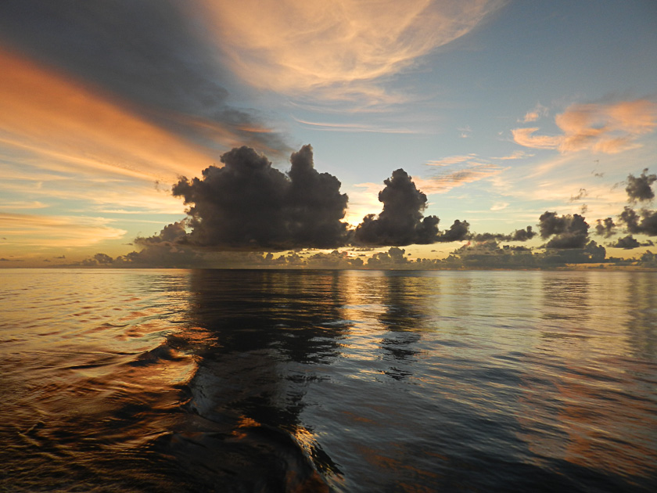
Pops/Bumpa/Joanie/Pumba/Peter

