CC#15

Dear Family & Friends, March 03, 2012

This Bulletin will cover the two days we spent (01&02) in Saigon. As I write we are on our way to Hue (Chan May) up the coastline of Vietnam, where we arrive tomorrow for a one day landfall.
Originally a French colony, Saigon became the capital of the independent state of South Vietnam from 1955-1975. It fought against the communist North Vietnam and the Viet Cong during the Vietnam War, until it was captured by the communists on April 30, 1975 bringing an end to the war and turning all of Vietnam into a communist state. Saigon became Ho Chi Minh City (after the communist leader) but today most residents and visitors still refer to it as Saigon.
Bordered on the north and west by China, Laos and Cambodia and on the east and south by the Gulf of Tonkin and the South China Sea, Vietnam covers a land area of 127,246 square miles with its very long profile in some places being only 31 miles wide. It has a population of 88 million with 53 cultural minorities and a Saigon population of approximately 8 million…5 million of whom have bicycles or motorcycles. The sight of this vast population riding the city streets is something to behold…and fear!
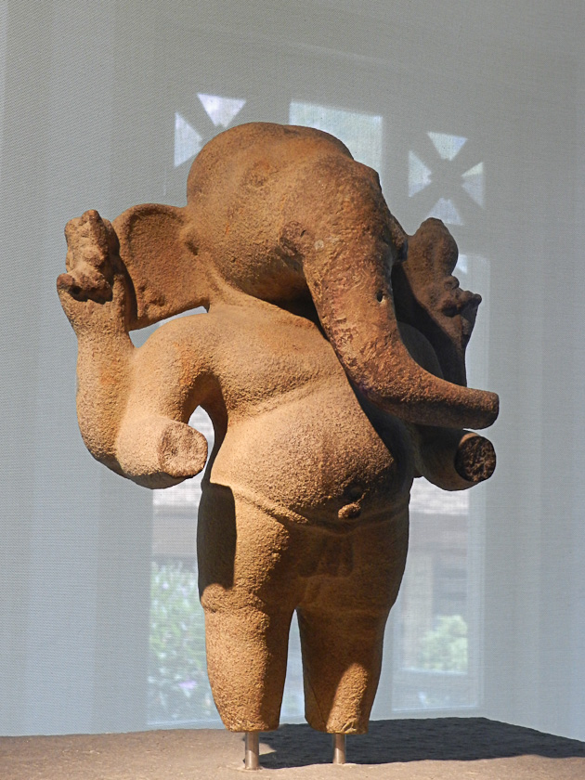
On Day 1 Joanie and I had signed up for an afternoon and evening trip, each of 4 hrs. Afternoon was “The Soul of Saigon”. We got with others in a big bus and visited the History Museum (a B-), a water puppet show (A-), a 20 minute Pedi cab ride (A), Notre Dame Cathedral (A and imposing), the Post Office designed by Eiffel of Paris tower fame (impressive, A-), a lacquer ware workshop (beautiful products, A-), Chinatown (B), a Thien Hau (?) Temple (B-) and the Presidential Palace (B). When we returned to our cabin we were both exhausted and decided to skip the evening event (“A cultural Evening in Saigon”) to save our strength for the next day’s 8 hr. event. 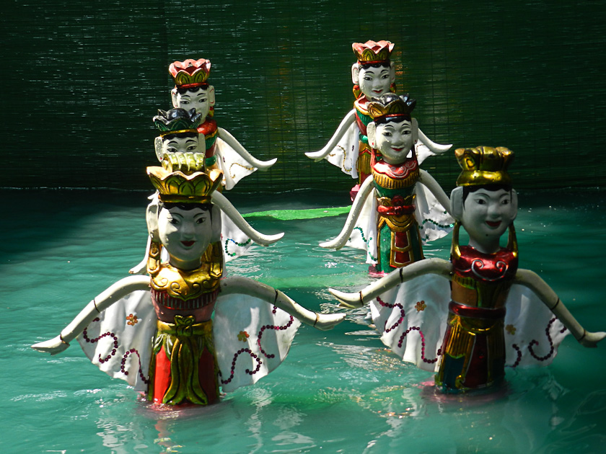

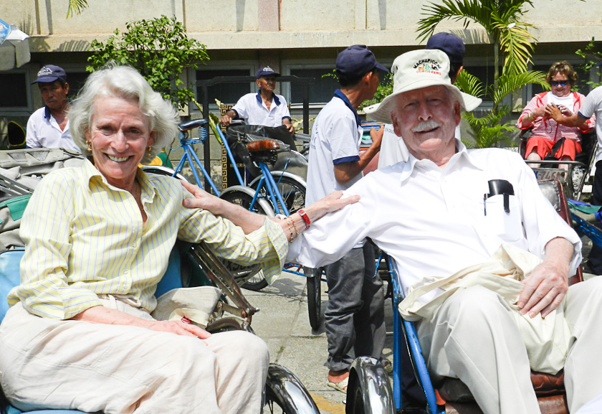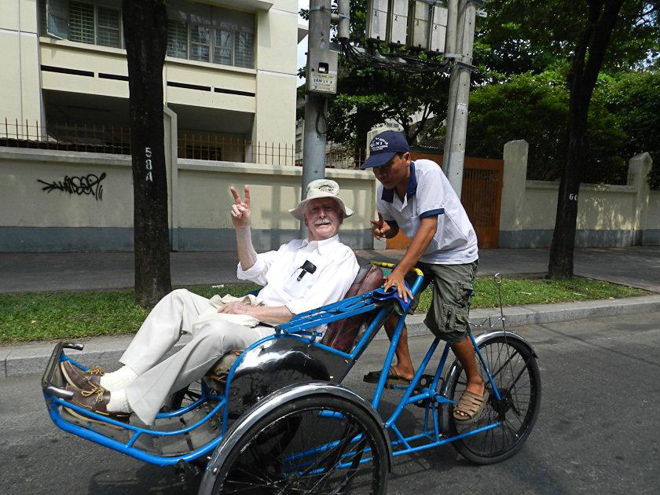

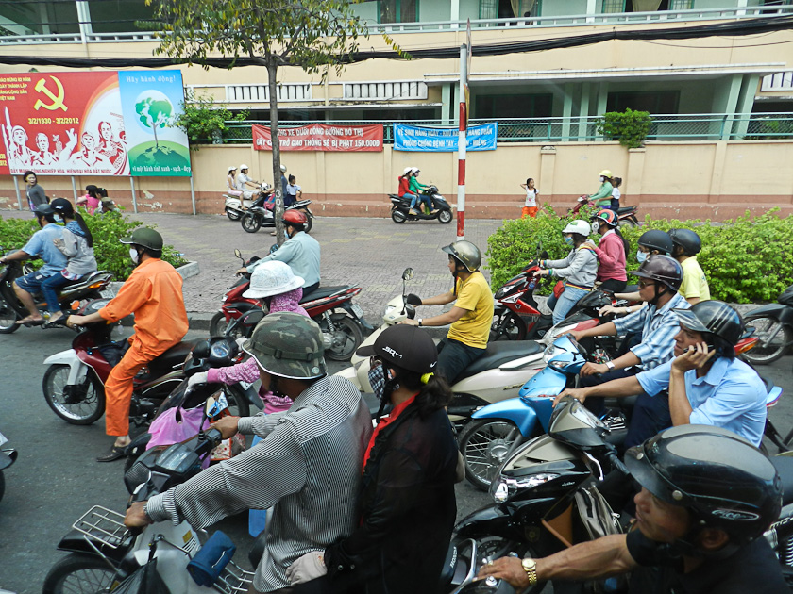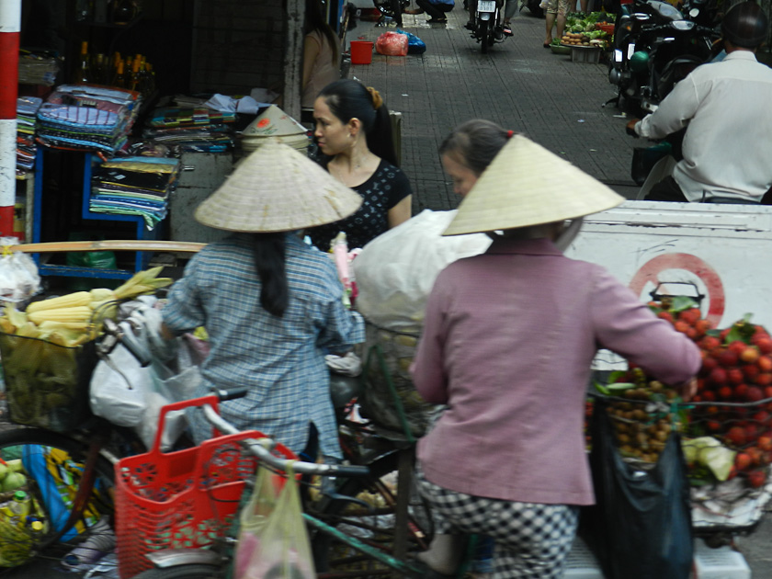

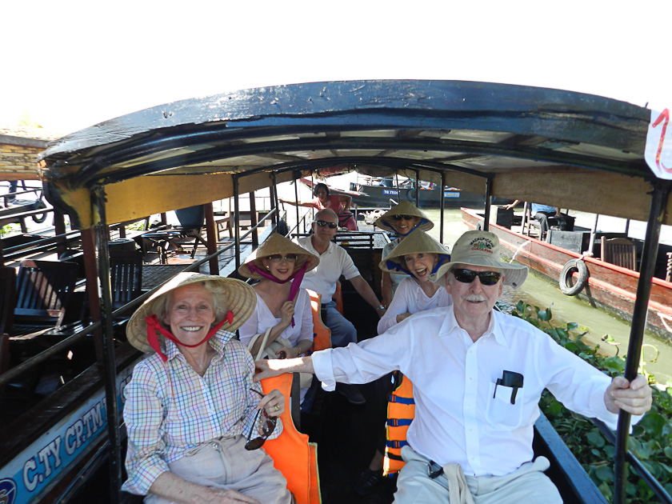
Day 2, Friday, was a clear, hot, humid morning as we began “Journey on the Mekong”. First a 2 hr minicab bus with 2 other couples plus our guide and the driver to reach the Mekong River for a cruise on a “long boat” which held 7 of us (not the driver) plus “Miss Thuy” who drove the boat. The boat was wood, long and narrow with a flat prow we used to get off and on… and Miss Thuy in the stern driving an outboard type engine with a 12 ft long shaft to the propeller…both of which could be swiveled up out of the water if we encountered a weed patch or other water detritus. Along the way we made several stops. One was a farmer’s house. While there we watched coconut candy and rice cakes being made, as well as the process of drying rice. We happened to look at a counter that had many bottles on it. With further exploration we noticed that they were filled with some very specific wine. Also in the bottle was a thin green snake, a cobra or a scorpion. In some cases, all three!!! I asked a woman standing next to me if she drank the wine. She said no, it was for the man to drink and then he would be able to make the woman happy!!! An oriental Viagra! We had some lovely tea with the rice cakes, coconut candy and some other treats. The next stop was a lovely Vietnamese house.
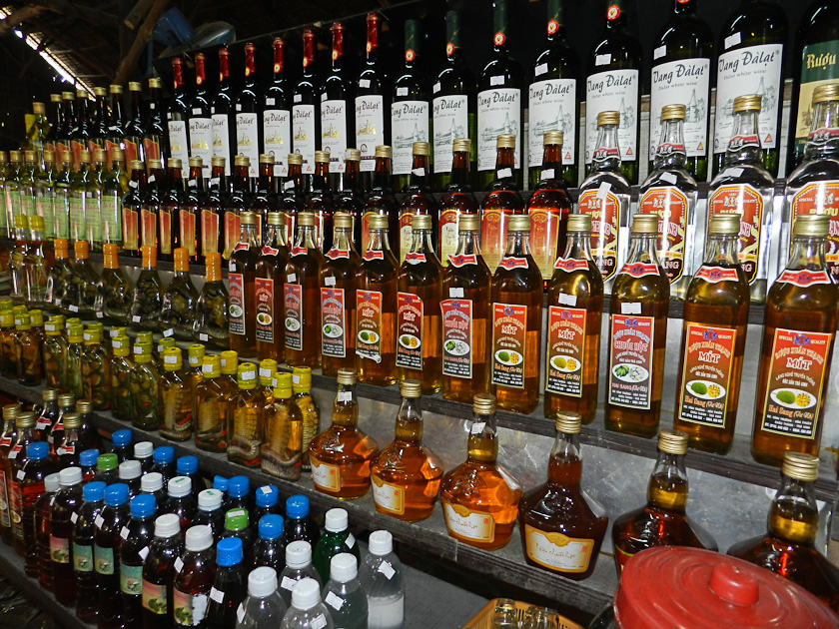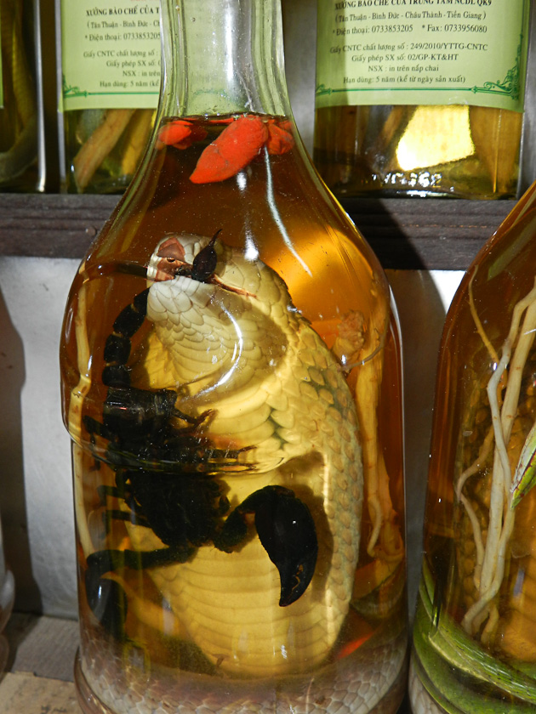

Growing there was every imaginable fruit, some we’d never seen before. We were again presented with tea and all the different fruits to taste. Lunch in a nice river front restaurant (with our group) and then back on the boat to return to our bus. The boat ride was great fun!

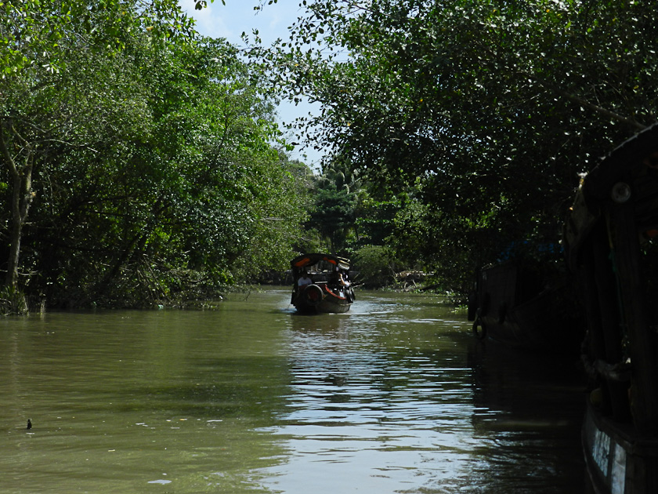
The Mekong river is the world’s 11th longest river (Nile #1, Amazon #2), starts in Tibet and ends up dividing into 9 different tributaries at the bottom of Vietnam making up the Mekong Delta as it flows into the South China Sea. In places it is wider than the Mississippi…a huge river system that is vital to Vietnam. In the South the country is a very flat land covered as far as the eye can see by rice paddies. Joanie and I had a great day…fun trip, good companions, excellent guide and the entire experience first class.
.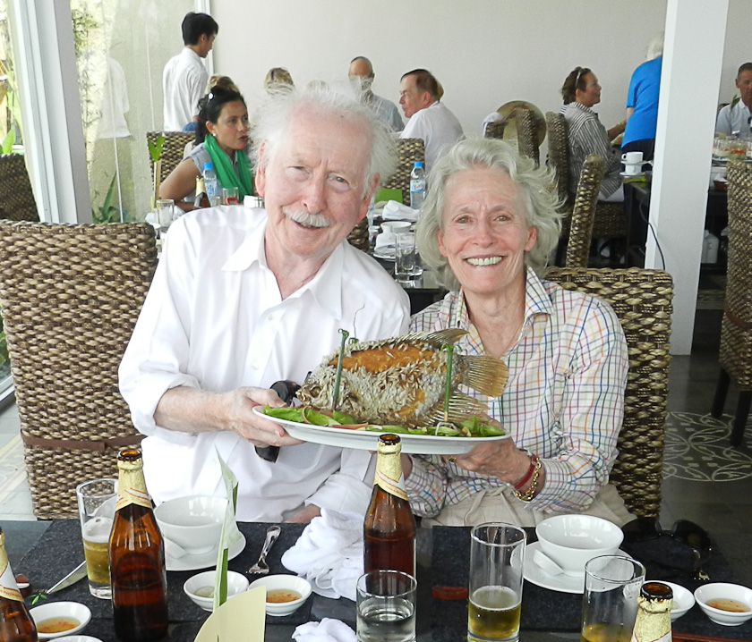

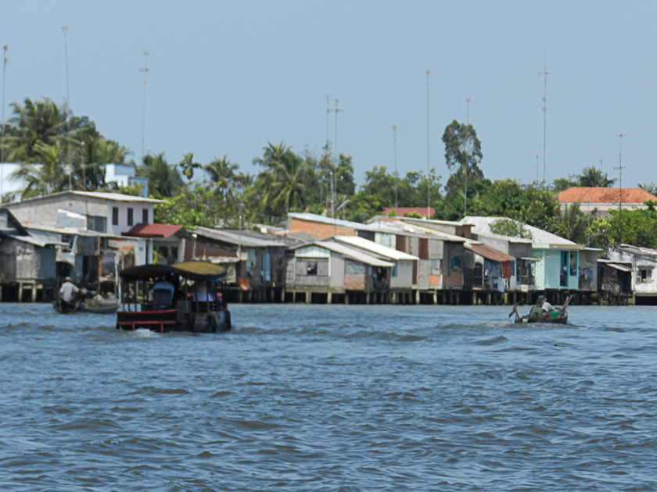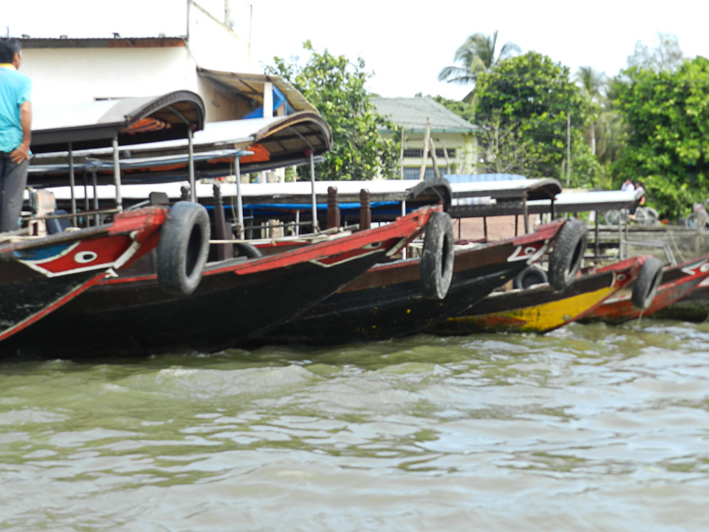

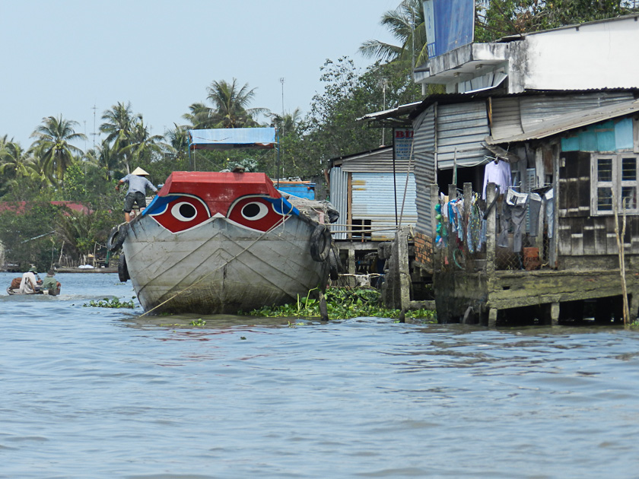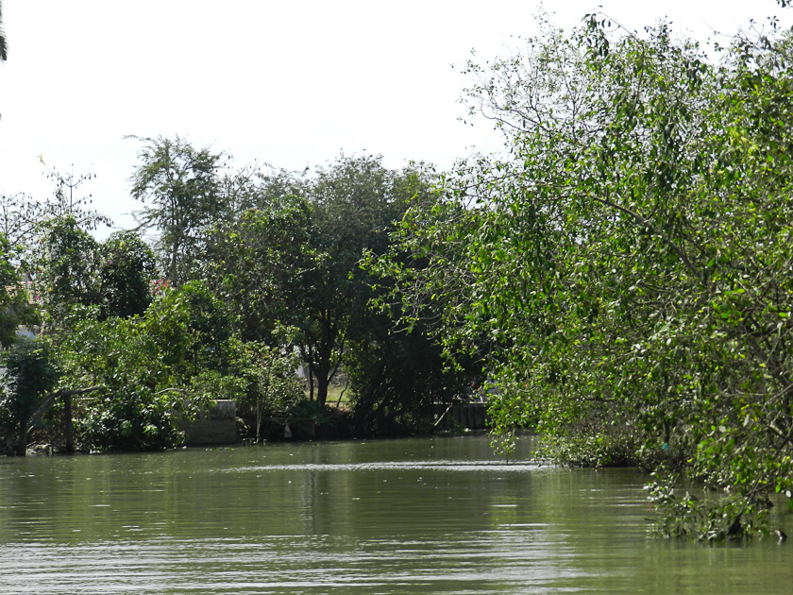
All for now. Still have cough and yellow green glop. Went this am to MD who said I have sinusitis and put me on a new antibiotic for 10 days. Poor Joanie…never complains. Always love and a smile as she has to put up with her slow-to-recover droopy patient. I certainly want to be over this before we start the 17 hour air trip home!

Not precise Factum: Temp 80F; water 78F; depth 180’; miles from Saigon 186; miles to Hue 190; seas calm; winds NW at 10 kn; course 009 degrees; speed 16.5 kn (3 engines because of strong head currents); scattered clouds

Winding down. Miss all! Much, much love.

Peter/Bumpa/Pops/Joanie/Pumba

