Circumnavigation Conclusion (CC#1)

Dear Family & Friends, January 10, 2012

When Joanie and I made our Bali H’ai journey last year I attempted to chronicle our incredible passage…to which Joanie added her magnificent photographs. The final publication appeared to be well received. There were a few suggestions that if we ever made another voyage we should try to repeat the process. So…for better or for worse, here we go again.
This time we head eastward from Ft. Lauderdale, across the Atlantic, around Africa’s Cape of Good Hope, northeastward across the Indian Ocean to Mauritius, the Maldives, Sri Lanka, Malaysia, Singapore, Ho Chi Minh City, Shanghai and ending again – 67 days from our start – at Hong Kong. With the completion of our CC voyage –coupled with BH of last year we will have completed our circumnavigation of the globe. How lucky and privileged we are! And how blessed I am to have The Beautiful One, my beloved Joanie, always at my side to give me her guidance and endless love…and to try and keep me out of trouble and from getting hopelessly lost. So here we go!

Ft. Lauderdale, 01/05/12

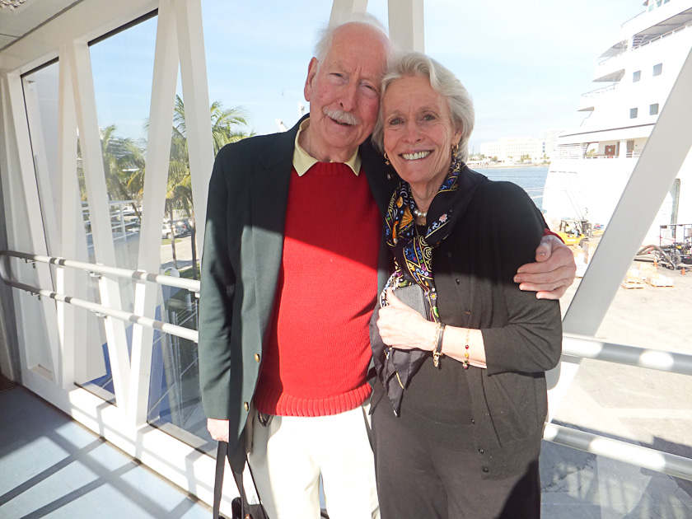
We joined our ship at 3pm. She is the last built Seabourn Cruise Ship (#6), named the Seabourn Quest, and is the sister ship of the Seabourn Sojourn that we took last year across the Pacific. She is on her maiden around-the-world voyage. Identical in every way…EXCEPT we soon discovered that the Quest had under certain conditions of sea and speed a noticeable vibration. This can happen! All ships/boats built to an identical plan do not behave exactly the same way once launched. Interesting.
The check-in with passports, photo I.D. etc took place on the pier, rather than after getting on the ship. While going through this process we spied several passengers we recognized from previous voyages.
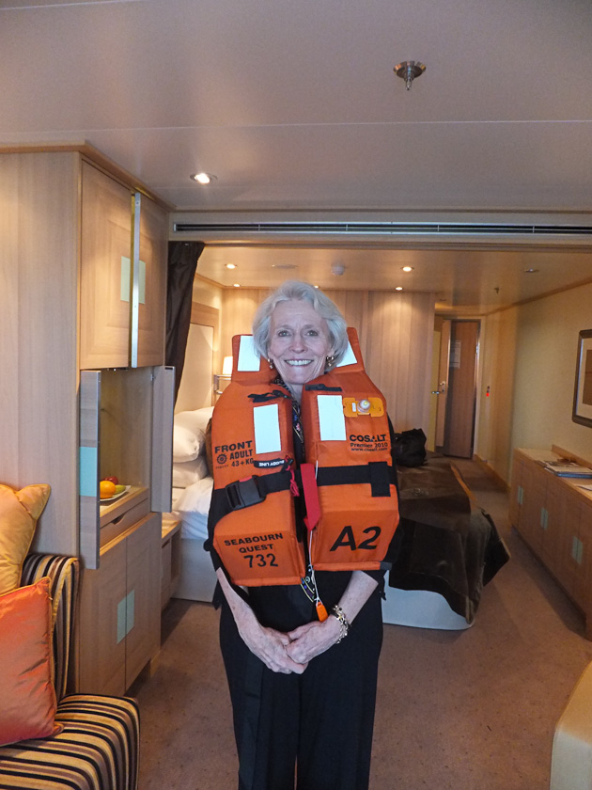
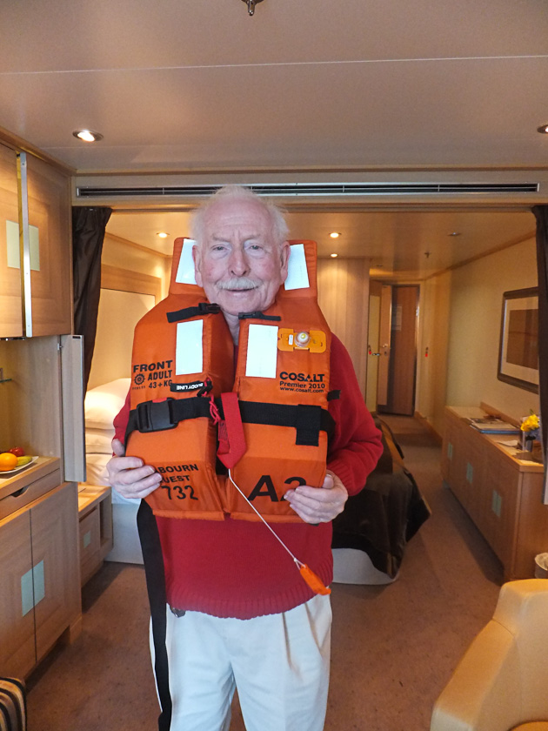
Finally to our cabin #732…slightly smaller than our complimentary upgrade last year but cozy, delightful and Joanie and I like it better. Our dear stewardess is charming, warm and friendly and is named Debbie. We have met over a dozen passengers that we knew from prior trips. Makes the adjustment easier…although Joanie and I jealously guard our privacy and always try to dine alone.
The first 5 days “at sea” headed us toward the Barbados. Time for “settling in” and “looking around”. One night Marvin Hamilsch was the entertainer. He was fabulous…and we had `a chance to chat with him and his wife later and it was most enjoyable. They asked us to have lunch with them ashore…but we were tied up with trips.
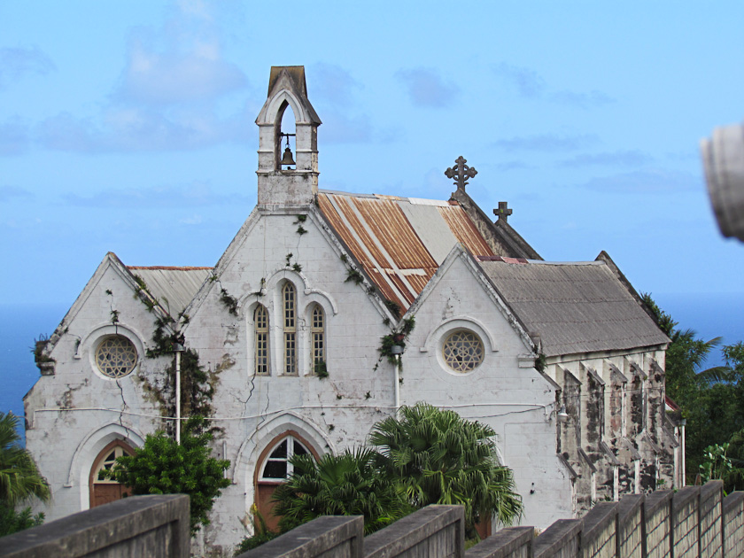
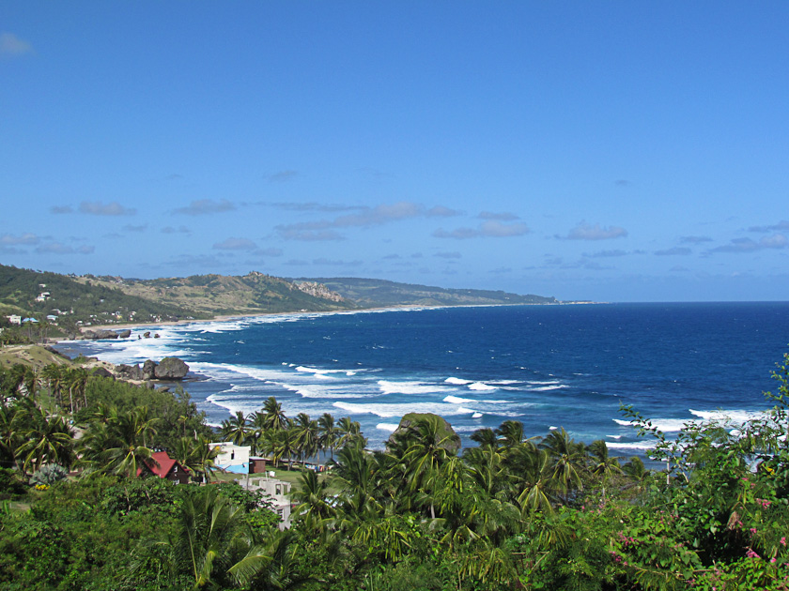

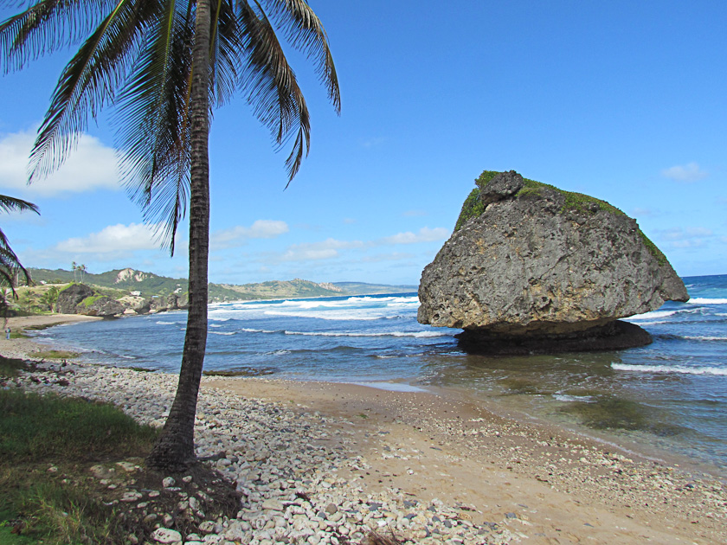
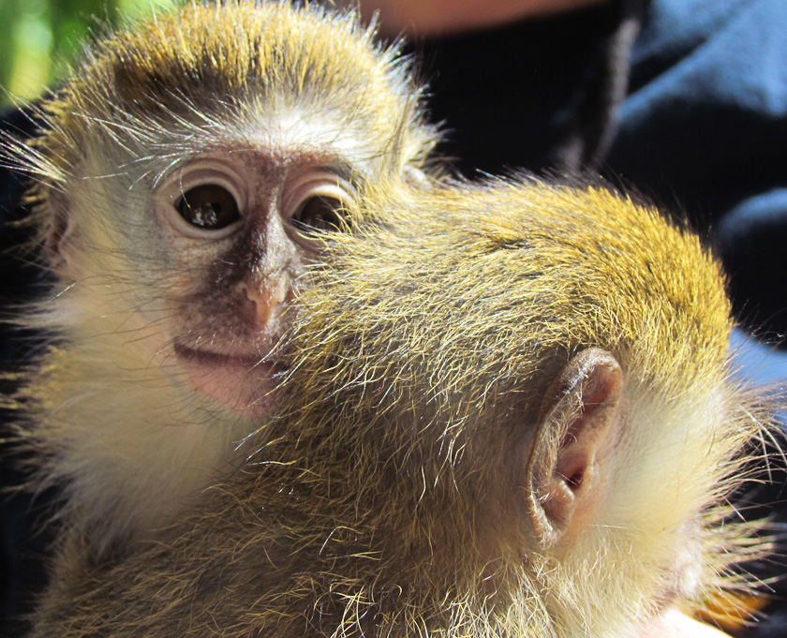
I was disappointed in the Barbados. I would rate it C+. I fear the glory days have passed it by. Ugly, squat, wildly colored stucco houses everywhere, little rhyme nor reason as to where construction was placed, many sugar cane fields, highest point a little over 1,200 feet. The Atlantic eastward side rough surf and fascinating boulders; the Carribean westward side nice beaches and little surf. The high rent district of Sandy Lane, large houses and fancy golf courses. In the morning we took a 4X4 with three other couples around the island. Our driver was talking when he emerged from the womb…and he continued non-stop for the entire 4 hour very rough ride. A disappointment. The best part of the trip was a brief stop to play with some darling little monkeys. Joanie wanted to take them home. 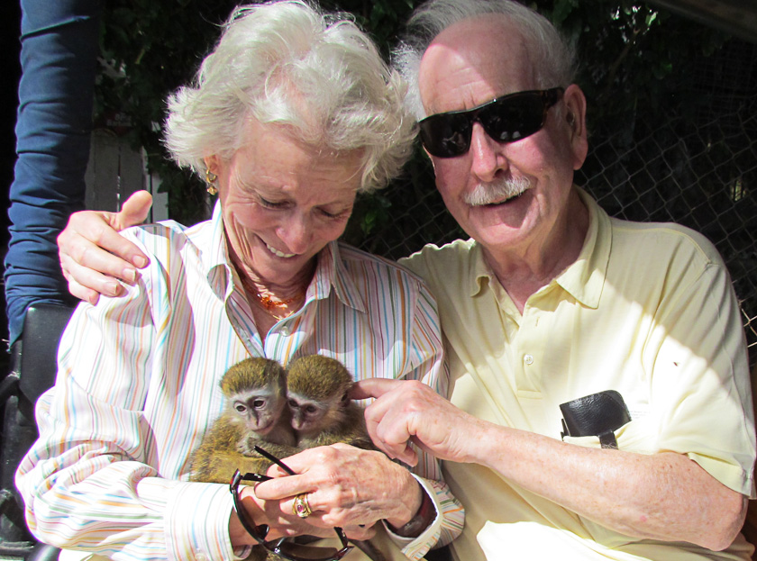

We were going to take a cab ($70) in the afternoon to see if we could go back to the Sandy Lane area and see if we could find Joanie’s Aunt and Uncle’s house. We, sadly, chickened out. We should have taken the cab. The lesson: next time hire a cab or a car and go exactly where you want in comfort.
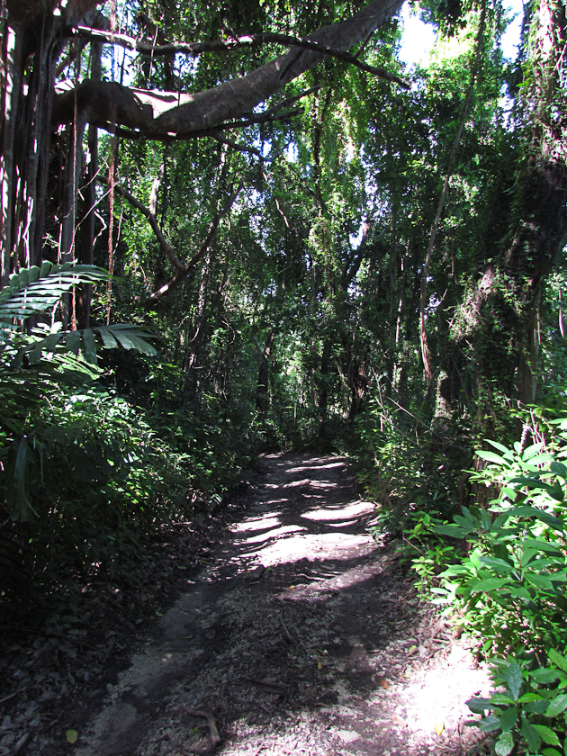
The ship was late (1&1/2 hrs) leaving Ft. Lauderdale because of a late delivery of 18 pallets of food; it was again late leaving the Barbados because the truck bringing the pallets of victuals was in an accident and all the supplies had to be transferred into another truck.
Enough for now. Ocean a bit bluer and rougher than the Pacific. Average depth around 2500 ft. Air temp about 75 degrees, quite windy and humid; ocean temp about 72 degrees. Usually white caps and a bit of a swell. Few birds…occasional seagulls. Tomorrow we visit Devil’s Island.
Hope all goes well at home. So sad to be away on both Emma’s and Olivia’s birthday! Move to Beaumont is a million miles away! Joanie joins with me in sending hugs and much love to all! Bumpa/Father/Pops

