CC #5

Dear Family & Friends, January 20, 2012

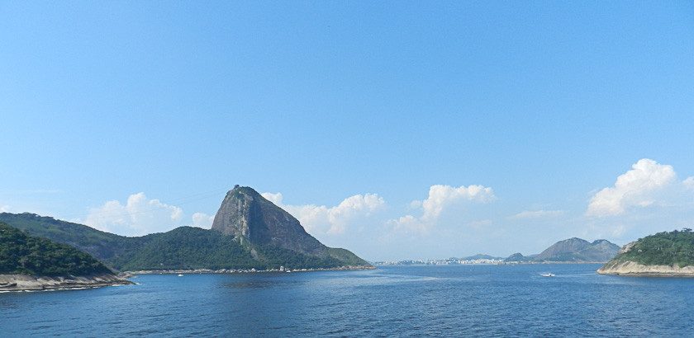
The only way to start a brief (“in the eye of the beholder”) and wholly inadequate encounter with Rio de Janeiro is with my phonetic French exclamation: ehn – kred – EEB – luh! Let us begin with a brief lift from the local guide book. “Visitors to Rio might be forgiven for feeling a touch of jealousy towards its inhabitants. Clustered around the deep blue waters of several bays, with the scenic Sugar Loaf Mountain standing sentinel at the harbors entrance and the famous statue of Christ looming high on the tallest peak across from Sugar Loaf, this city is quite simply the most breathtaking in the world. Add to this the superb white beaches fringed with palm trees, an average temperature that rarely dips below 68 degrees F, a carnival atmosphere and the style and sassiness of the people, one can only stand back and agree with the over 12 million in Greater Rio that it is indeed a Marvelous City.”
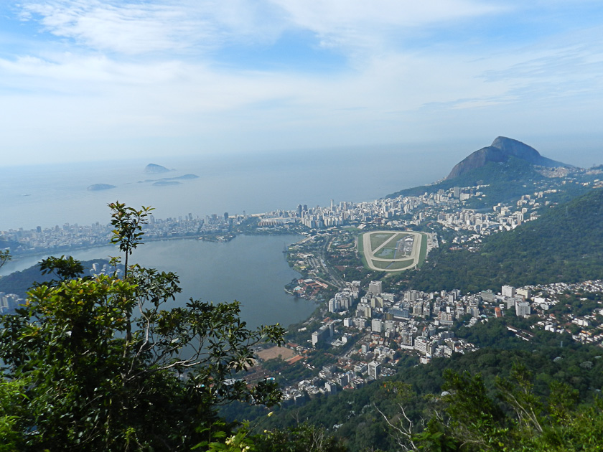
Rio is Brazil’s second largest city, and the third largest metropolitan area in South America. It has the second largest GDP in the country. Brazil is BIG: the largest land mass in South America…larger than the USA in size, with over half the population of all of South America. And Rio is rich in culture and architecture.
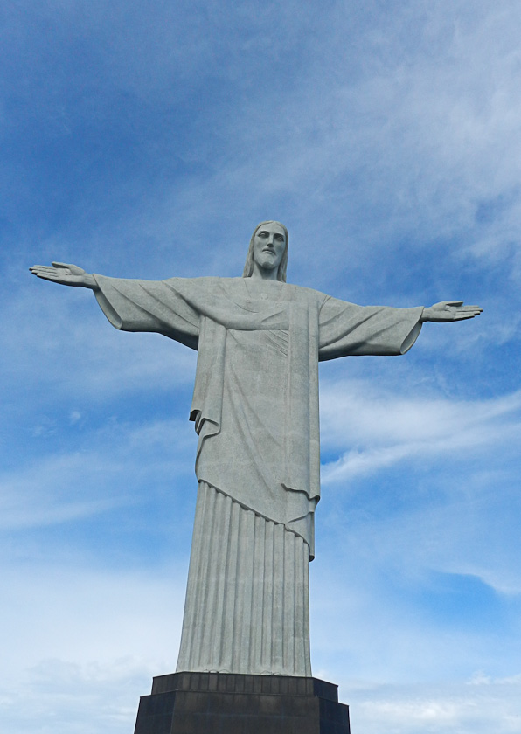
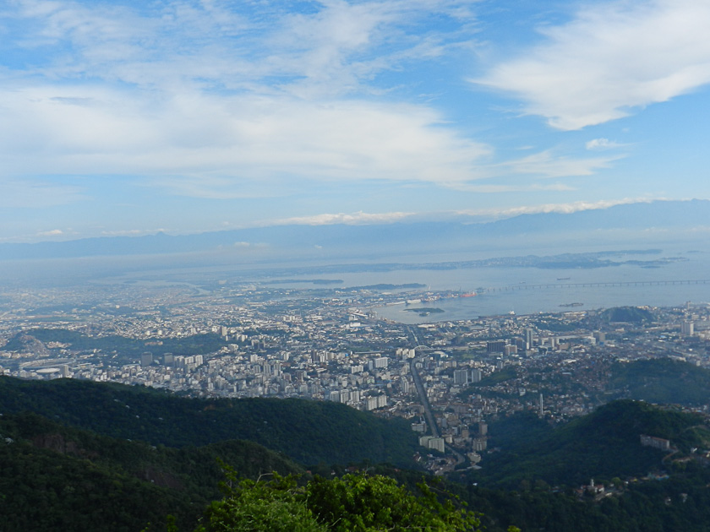
With the above under our belt let us begin our journey. Our ship approached the harbor – with the Pilot safely on board – around 5:45pm. What a sight! Towering mountains, smooth, brownish vegetation-free rock rising in a band of about 25 feet above the shorelines, topped by thick vegetation and trees of many different varieties. Lovely curved bays ending in brilliant white sandy beaches with famous names we all know: Copacabana, Ipanema, Flamengo & more. We docked in front of two other cruise ships. The next morning we boarded our tour bus at 7:45 am for our 4 hr journey to some of the high spots of this incredible metropolitan marvel. With ongoing, not overpowering, instructional comments from a superb lady guide our first stop was the Corcovado (name of the mountain peak, 2400 ft) and Christ the Redeemer. To reach the Christ – a concrete and soapstone behemoth – is a three part journey: a 20 minute cog railway, a 2 minute 6 passenger elevator, and a 1 minute escalator plus a short walk to the top and the statue. As we travelled up the steep and curvy rail tracks through quite heavy jungle abloom with colorful flowers, we passed trees with large coconut sized fruit growing right out of the trunks of the trees…most unusual. The Christ is strikingly beautiful with a lovely, peaceful face looking down with graceful outstretched arms on his visitors and the city below. The view is panoramic and breathtaking. The entire city of Rio, the beaches and harbors, the surrounding mountains, a green flowering sloping cornucopia of bright colors all stretched out below in every direction almost overwhelm one’s senses. Happily we were about the first two car train up – an amazing ride in itself! – as the crowds and waiting lines quickly build awaiting the train. Our visit went off without a hitch and allowed us to spend almost an hour around the foot of this extraordinary statue. 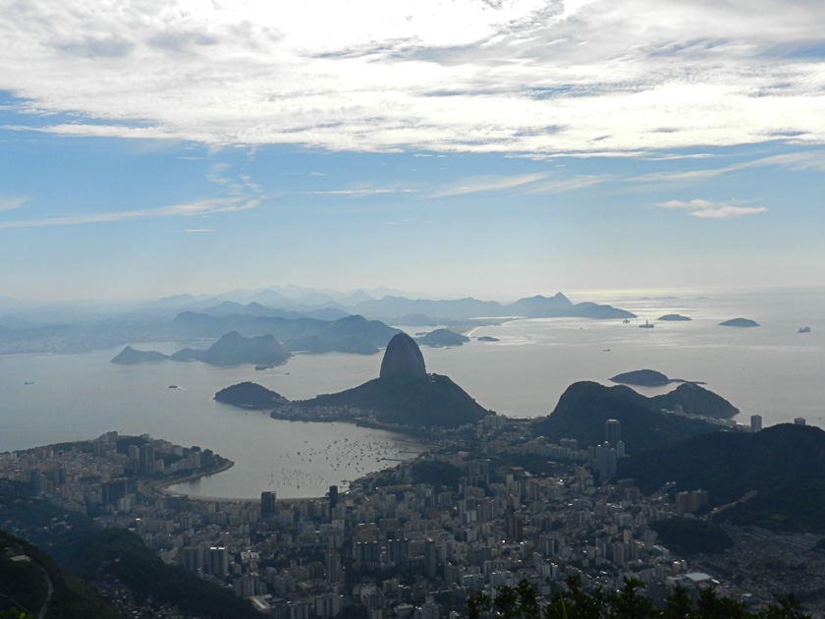
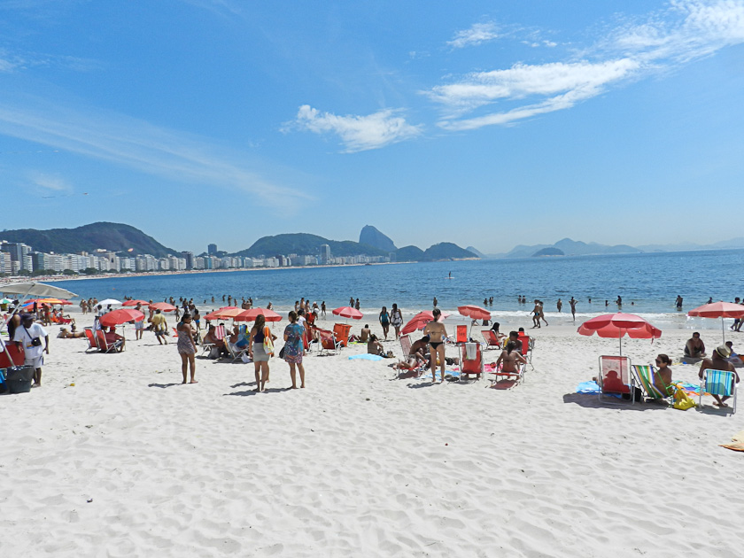
After our never-to-be forgotten trip to the Christ (blessed by the Pope’s visitation, I believe, in 1976) and astonishingly made of very soft sandstone, we returned to our motor coach for a leisurely, guided return through the city to our ship. Compared to my comments re our previous city stops, what immediately strikes the visitor to Rio is its neatness, orderliness and thriving modernity…at least those parts of the city we travelled through! Normal sidewalks, wide macadam streets with working traffic lights, the orderly placement of buildings and stone houses, a feeling much like a large city in the US. Vehicle tunnels through the mountains (not as well lit as Holland/Lincoln tunnels) sparkling beaches always almost “just around the corner”, packed with sun worshipers, kite fliers and bathers…and a pleasing number of well formed females showing off their shapely endowment and/or construction, a delightful, large lagoon in the heart of the city with scullers keeping fit as they gracefully glide their shells across its tranquil surface, palm trees and other lovely vegetation and parks create a very beautiful and livable environment.
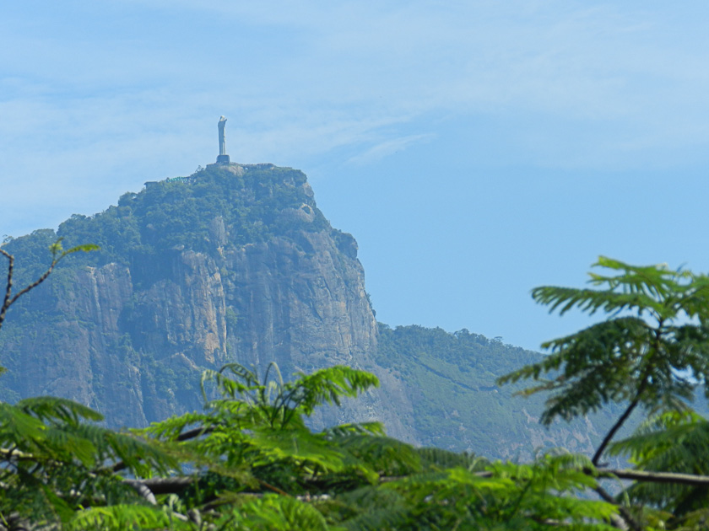
And so you do not think I was made totally intoxicated by what I have described here, yes, there is another side to Rio. It is called favelas or “shanty towns”. More than 2 million people live in rickety, disease prone shacks perched precariously on Rio's steep hillsides. This crime and drug soddened area is in the process of an attempted clean up…especially as Rio is the official city selected to host the Olympic Games of 2016. Traffic jams are everywhere. Omnipresent construction attests to the zeal with which Rio is doing everything possible to brighten even further its face for this world famous sporting event.
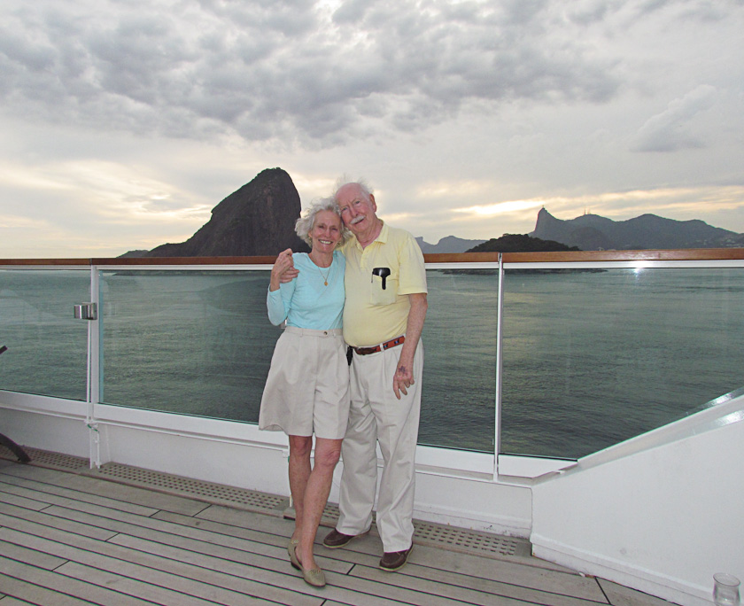
And so the time arrived – 1800 hrs – for Seabourn to depart this remarkable city. As custom, Joanie and I joined others on the upper open deck and partook in champagne, caviar and a music/singer small group as the gangway was raised and, with the help of thrusters, our ship slowly moved away from the pier. Leaving Rio fills one with mixed emotions: genuine sadness in leaving this unique place coupled with the joy of having seen it nourished by the hope of one day returning to spend more time in a fuller exploration of its countless, amazing attributes. As we left the harbor we looked back on a city somewhat shrouded in evening mist giving the whole gorgeous picture a feeling of looking at a magical Brigadoon.
I am now concluding this Bulletin the following morning, as we start on our 5 day trip (“at sea”) across the Atlantic to our landfall at Jamestown, St. Helena, where Napoleon is buried.
Today’s Final Factum: scattered clouds in a pale blue sky; 8 ft swells with white caps causing the most motion so far to ship; speed 18.5 kn; humidity 68%; air temp 79 F; water temp 72 F; water depth 12,100 ft; wind 17 kn from NE; 318 nm from Rio; 1868 nm to Jamestown; 4947 nm voyaged to date. Joanie more beautiful than ever and far and away the most popular lady passenger on the entire ship (not surprising!).
All for now. Awaiting results of election and tomorrows football games…I think the Giants will be in the Super Bowl (compare Coughlin to Reid!) I will write more in a day or so…perhaps on “reflections”. Sorry you are having cold and bad weather. Miss you all. Joanie joins with me in sending hugs and much love.

Peter/Pops
