CC#17

Dear Family and Friends, March 9, 2012

House Arrest on Our 650’ Yacht

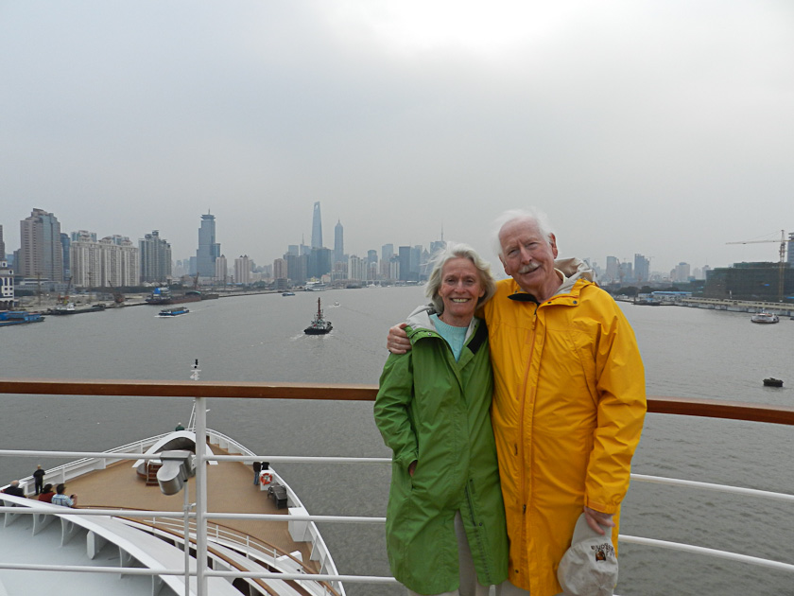
Our Magic Voyage took an unexpected turn upon our arrival in Shanghai. First, a little background. When Joanie and I started planning our trip a year ago we decided to end our journey at Singapore and fly home. After further discussion we added the next segment of Seabourn’s “World Cruise” so that we could see Shanghai…always near the top of a “fascinating stop”.
So the ship arrives yesterday afternoon and we join all passengers in a mandatory disembarkation to have the required walk through immigration. After moving slowly through a large line taking us about 40 minutes we arrive at the unsmiling lady immigration inspector who carefully examines our passports and visas. Whamoo! The surprise of the trip when immigration points out that our Chinese visa has expired…and we cannot leave the ship while it is in Shanghai.
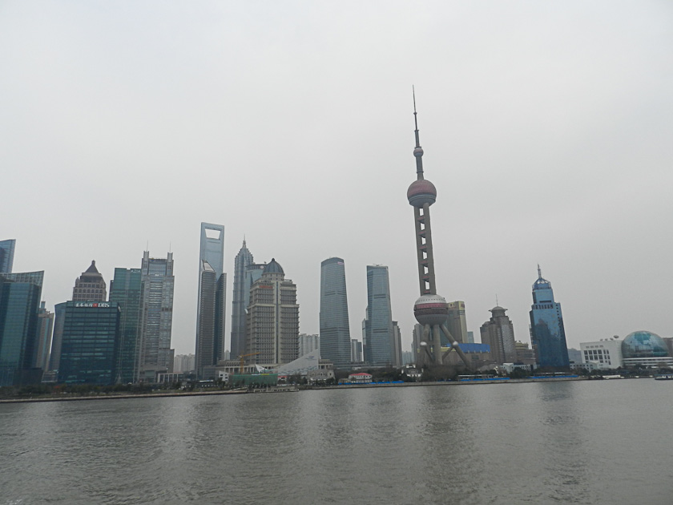
Background. When planning for our trip Seabourn informed us that we would need visas for Brazil and Shanghai. The visa “agent” in NYC was recommended by Seabourn (before this Joanie had always through the years gotten required visas through her own people at her travel agency: Travel Answers, who use a different service). So we spent a week in November filling out long and complicated forms for China and Brazil…the only two ports of call requiring visa (Brazil was easier), and sent our $900 to ZVS in NYC who are the experts specializing in getting visas. In December we received our visas. To get same we had to put down the exact days we would be in the country requiring the visa…for Shanghai March 8, 9, and 10. Visas would be issued to cover the specific dates for Brazil and Shanghai. (Picture above of Oriental Pearl Tower…3rd highest in world, directly opposite our “parked” veranda.)
Lo and behold when we get off the ship here immigration points out that in small print on the Visa it reads “Expires 16 February 2012”, and not 16 March 2012. The Chinese Consulate in NYC who issued our Visa had made an error and typed in the wrong month! No amount of pleading, conjoling or tears could move any of the Chinese authorities! No sympathy whatsoever that it was the Chinese government who made the mistake. No interest in the fact that the only reason we had our visa was because of our 3 specific days in Shanghai…which had been given to the Chinese Consulate in NYC in order for us to get a visa specifically to visit Shanghai. No concern for the obvious argument “why issue a visa for March 8, 9, & 10 and then stamp an expiration date of February 16!” No sympathetic smiles from any Chinese officials. There was, however, interest in what our trip cost from our “Chinese security companions”.
After another ½ hour with the participation of the ship’s authorities to no avail we were escorted by stern faced officials and two police back to the gangway to make sure we got back on the ship. We arrived at the gangway just as Mrs. Conover (former CEO of Seabourn and now the Cruise Line’s beloved “Ambassador”) and her husband arrive to join the ship for its next leg to Hong Kong…and beyond. She was greeted by the Captain (who is giving Joanie a hug in hopes of staunching the flow of tears that were about to gush), his first officers and other ship brass while Joanie and I are standing at the gangway with police officers on both sides…who after the “Conover Arrival Ceremony” escort us across the gangway back onto the ship where we are put in the hands of our friends with Ship’s Security (who computer record all passengers as they leave or return to the ship). An amazing occasion as Joanie and I introduced ourselves to the surprised and curious Mrs. Conover, and told her that we had first met her last year in New Zealand on the Seabourn Sojourn. Back to our cabins and more tears as we go to an almost empty dining room for dinner and salubrious wine…most of the passengers ashore for their evening “ship shore trip” into Shanghai for a tour and dinner in a fancy restaurant.
So today and tomorrow – rather than seeing Shanghai on 3 planned shore trips - we are the “Ship’s Prisoners” confined to remain on our “Private Yacht”, virtually empty, until it departs Sunday evening for Hong Kong. Tears are pretty much gone and wondrous Joanie and I are now trying to find as much humor as possible from this dreadful experience during our remaining time in our totally unjust confinement.

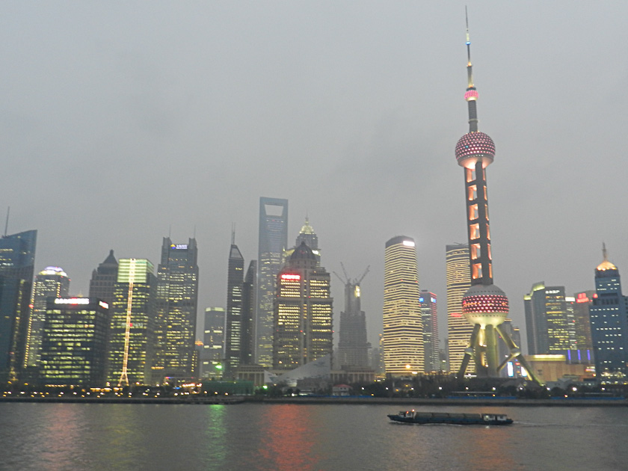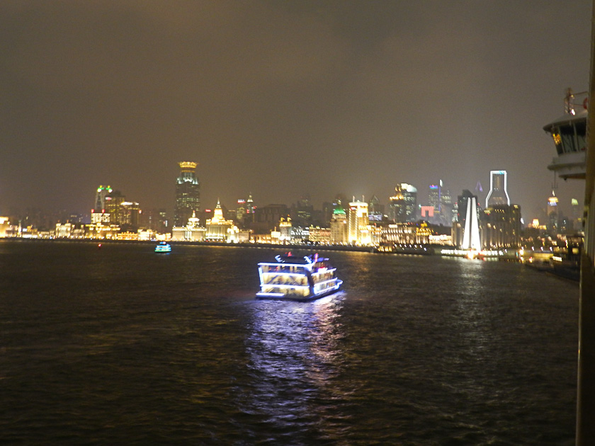

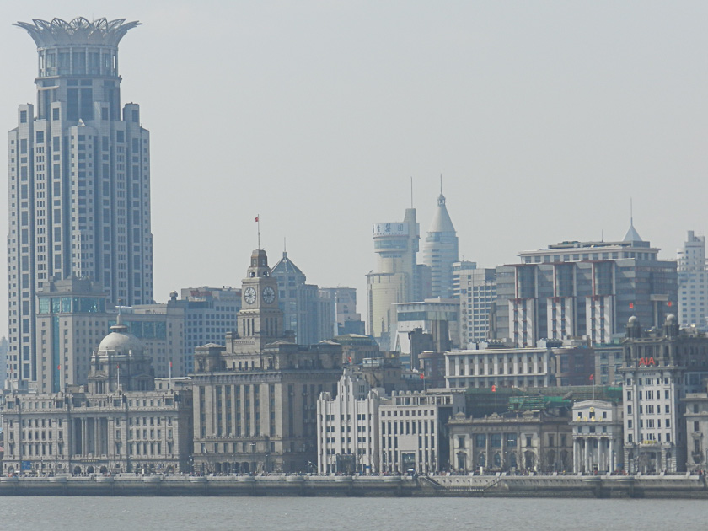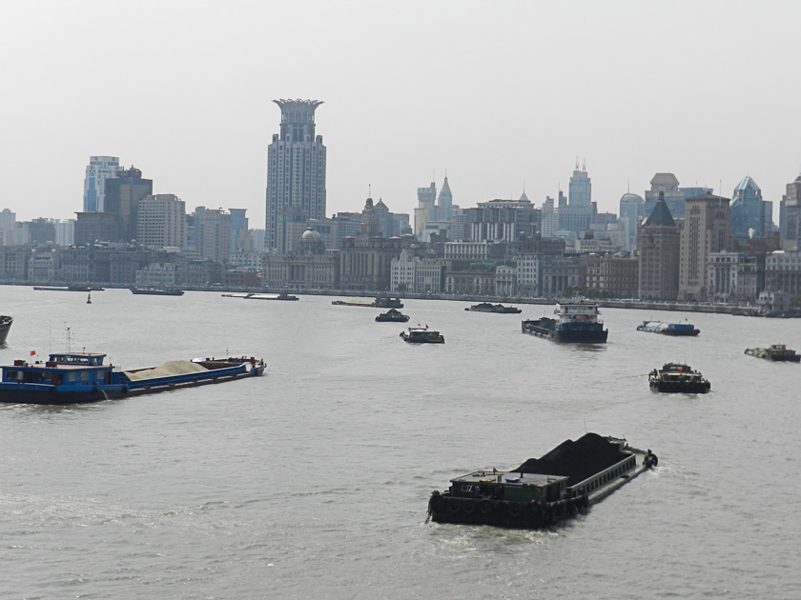

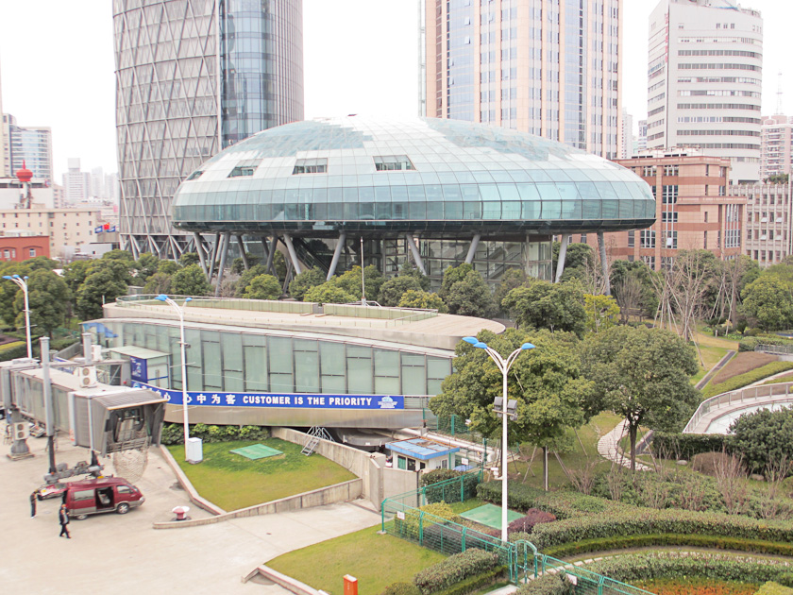

On the good side everyone on the ship from the Captain down has gone out of their way to offer their shock, sympathy and support…along with a growing number of passengers who now are learning about our plight. I cross my wrists when I recount our “prisoner” status to our kind supporters. On the bright side, our veranda is right on the main river and directly across is the major new high rise skyline of the city center. An extraordinary sight…especially when lit up at night with endless neon sparkling boats plying up and down the river. The other docking side of the ship faces new construction and a large sign welcoming new visitors reading “Customer is the Priority!” What irony! The morning sun is on our veranda as I write and the river traffic is astonishing… counting the barges, like counting railway cars, (so far almost 200 full of coal and dirt!), tankers, tourist boats of all shapes and sizes. Not what we hoped for…but a small consolation and interesting while in our “prison”
Quite a change from what we planned for and dreamed of! Sorry for a very different Bulletin with few pretty countryside pictures, but you are now all up to date. We will survive…but not before a few more tears and a great deal of wine and laughter.
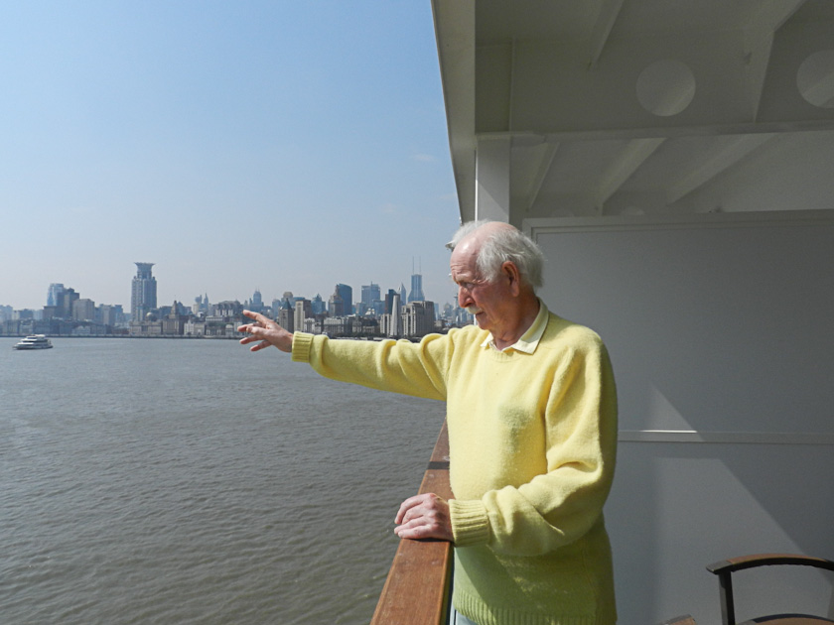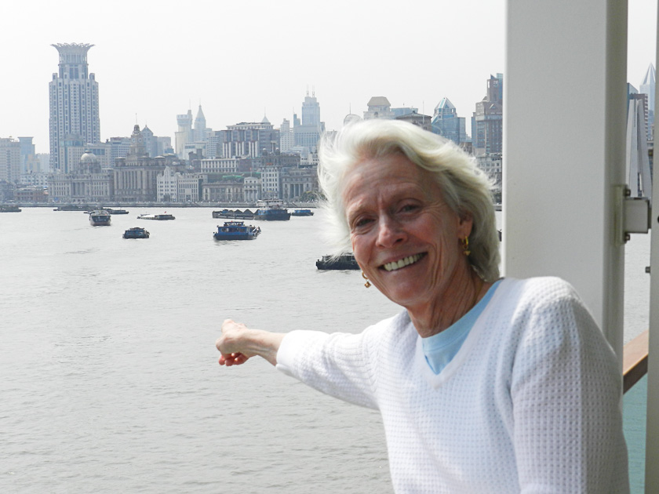

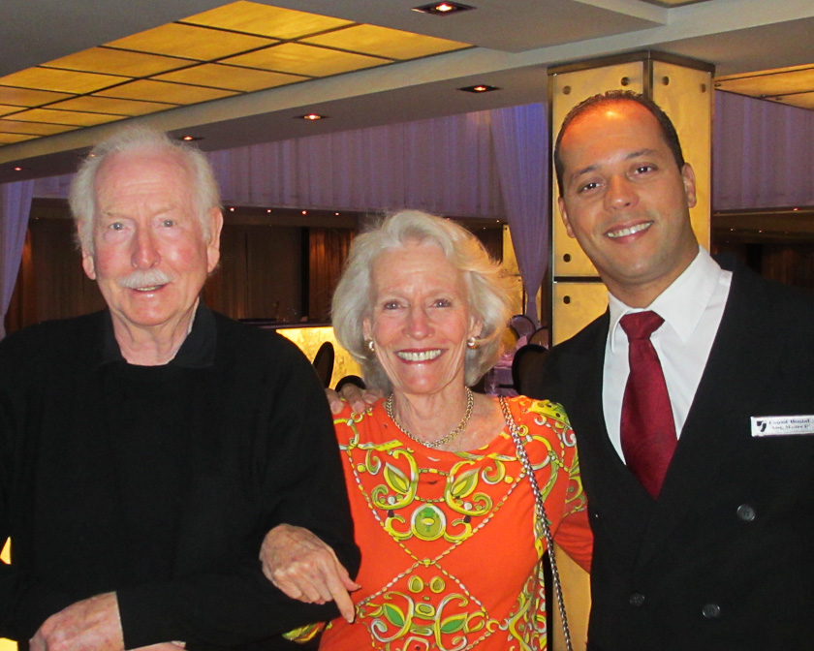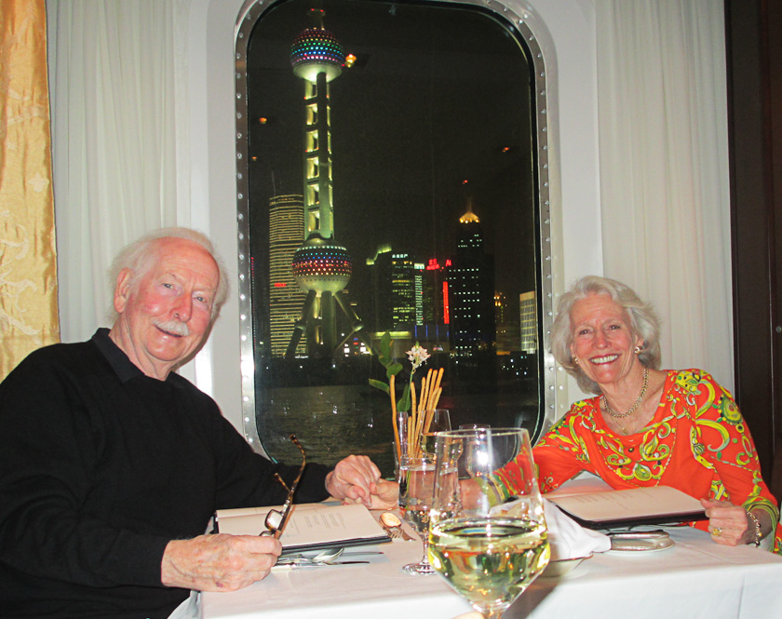

Joanie and I, as always, send our hugs and love to all. It is what it is!
Peter/Bumpa/Pops/Joanie/ Pumba

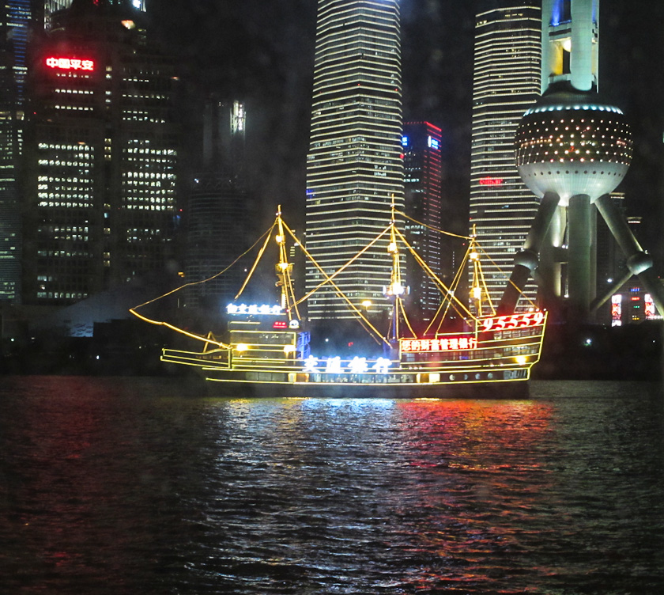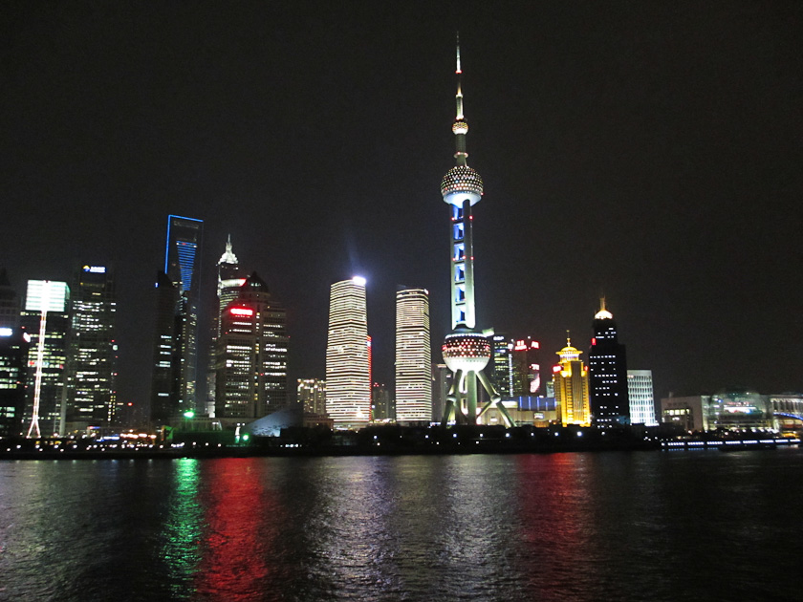

P.S. 13 of the crew have been mugged and a growing number of passengers have had very bad and frightening experiences!

